

**Figure 1:** PRISMA-ScR flowchart of the search and inclusion process

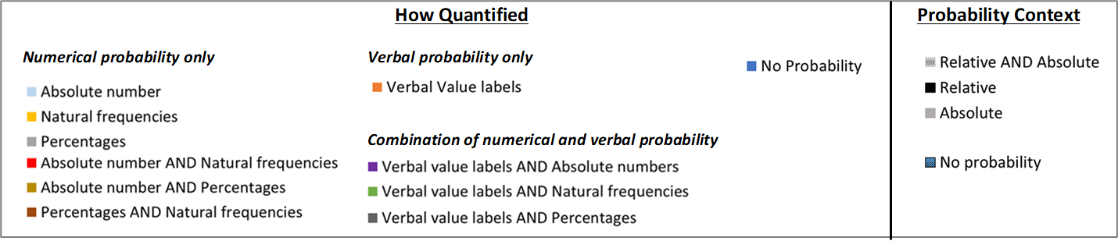

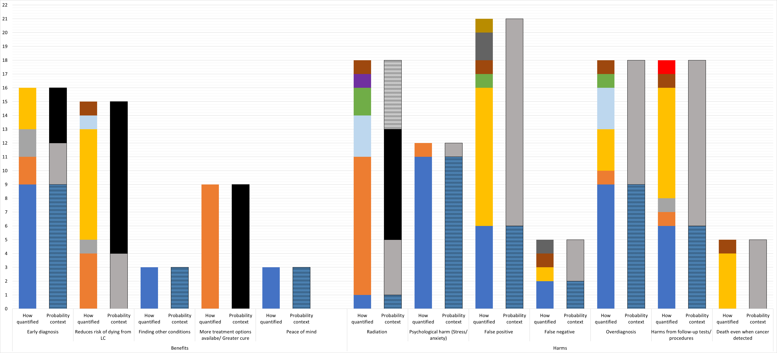

[Grab your reader’s attention with a great quote from the document or use this space to emphasize a key point. To place this text box anywhere on the page, just drag it.]

Number of DSTs

**Figure 2:** Frequency of methods used to quantify the probability of each benefit and harm of LDCT lung cancer screening across the DSTs

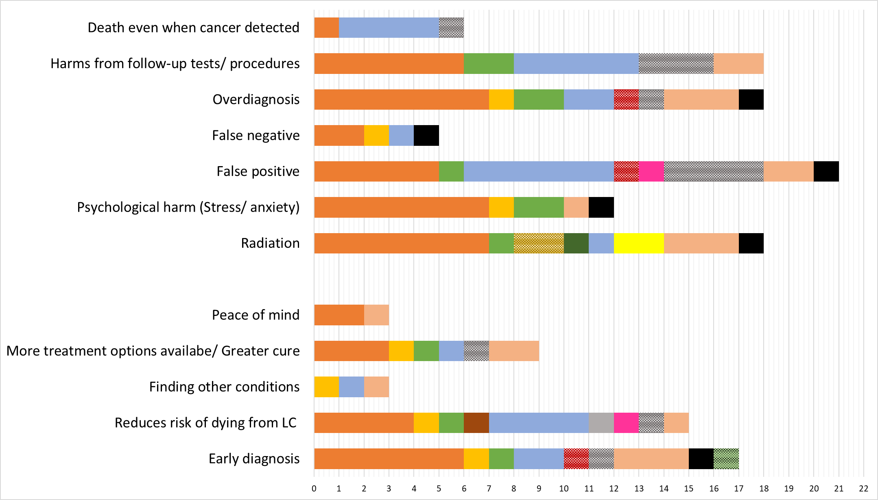

Number of DSTs



**Figure 3:** Frequency of methods used to present each benefit and harm of LDCT lung cancer screening across the DSTs

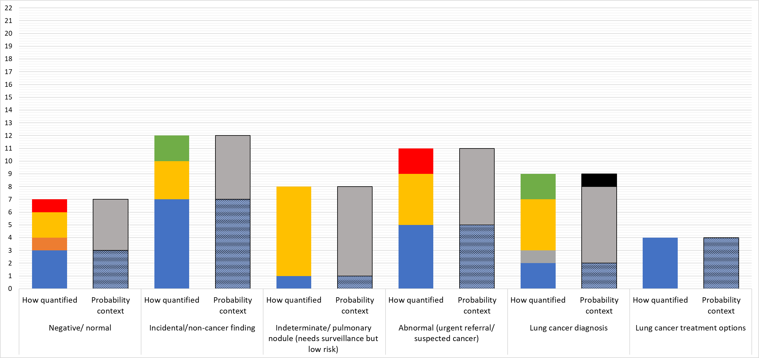

Number of DSTs

**Figure 4:** Frequency of methods used to quantify the probability of each type of LDCT lung cancer screening result

**Figure 5:** Methods used to present each type of LDCT lung cancer screening result

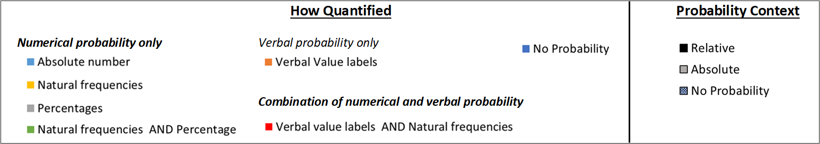

**Figure 4:** Frequency of methods used to quantify the probability of each type of LDCT lung cancer screening result across the DSTs

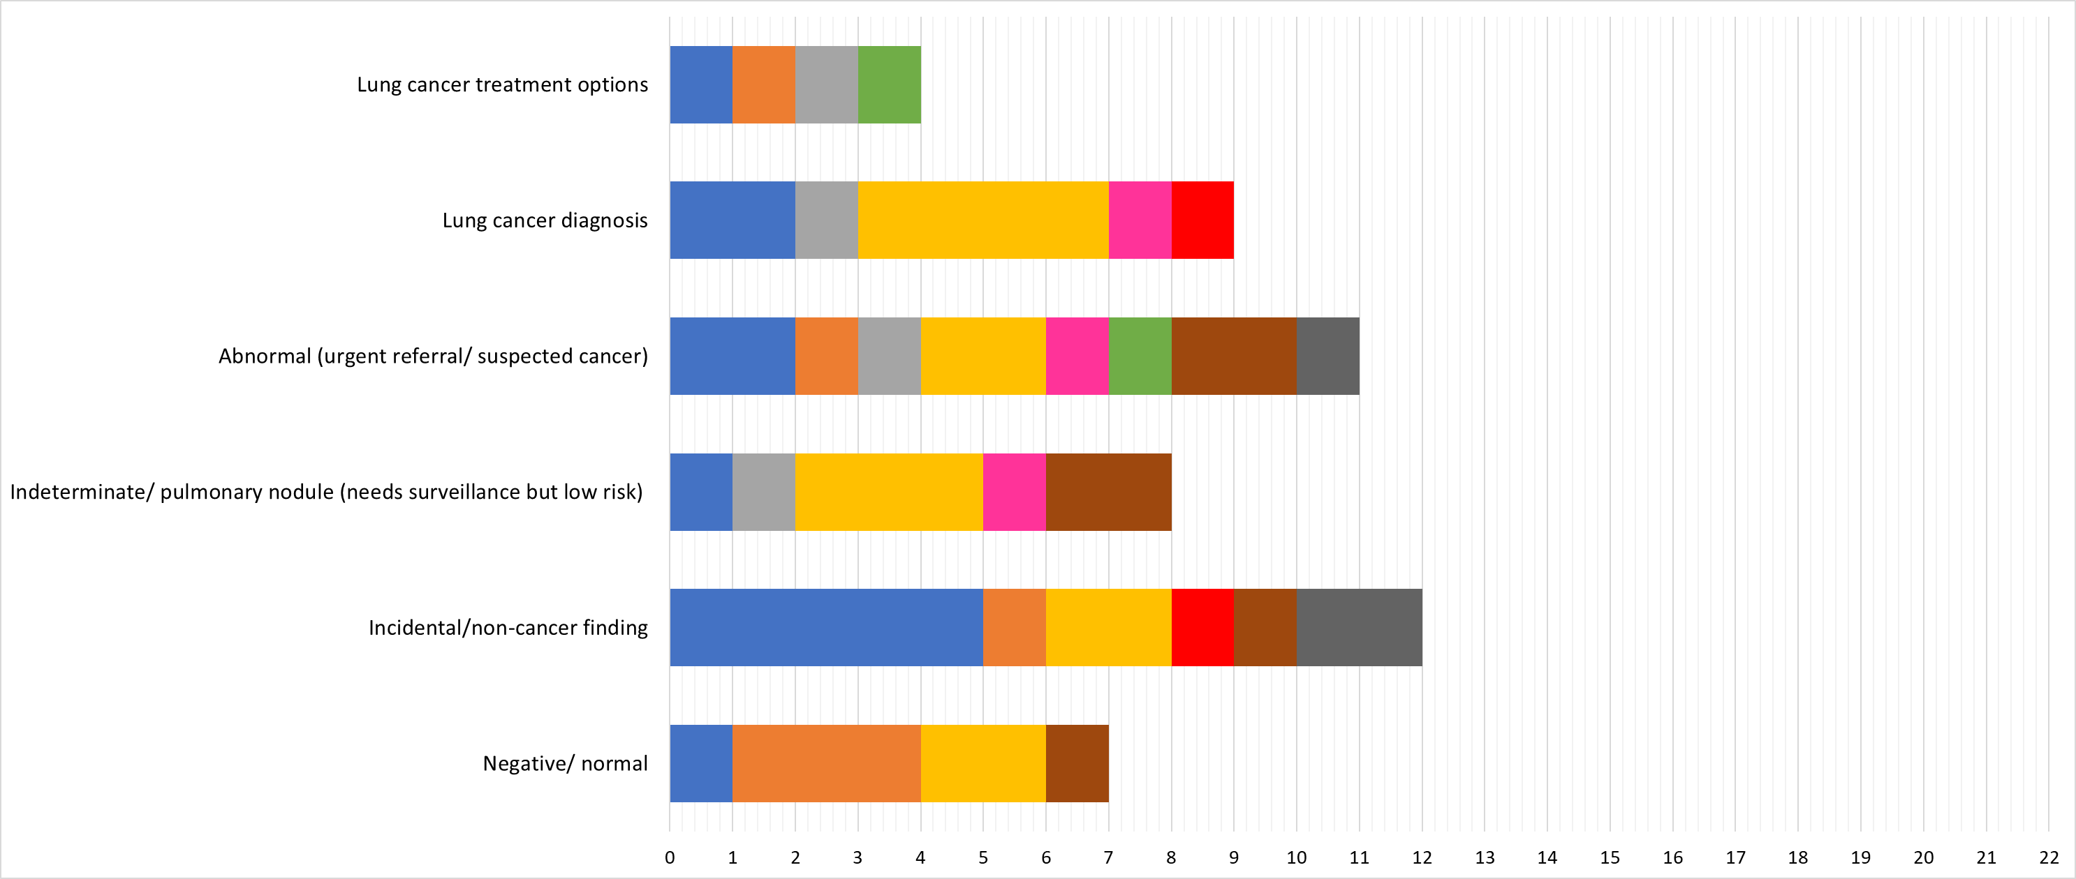

Number of DSTs



**Figure 5:** Frequency of methods used to present each type of LDCT lung cancer screening result across the DSTs

**Table 1:** Peer reviewed article characteristics

|  |  |
| --- | --- |
| Article characteristics | (N=26) |
| Year of publication, n (%) |  |
| 2014 | 2 (7.7) |
| 2015 | 1 (3.8) |
| 2016 | 2 (7.7) |
| 2017 | 3 (11.5) |
| 2018 | 4 (15.4) |
| 2019 | 9 (34.6) |
| 2020 | 2 (7.7) |
| 2021 | 3 (11.5) |
|  |  |
| Country of origin, n (%) |  |
| USA | 24 (92.3) |
| UK | 1 (3.8) |
| Australia | 1 (3.8) |
|  |  |
| Study design, n (%) |  |
| RCT | 6(23.1) |
| Development & Evaluation | 2 (7.7) |
| Qualitative (Focus group/interviews) | 4(15.4) |
| Evaluation only (quantitative survey) | 3(11.5) |
| Quasi-experimental design: a before-after study | 4 (15.4) |
| Mixed methods | 2 (7.7) |
| Pragmatic/ feasibility | 3(11.5) |
| Observational survey | 2(7.7) |
|  |  |
| Sample characteristics* |  |
| Age, mean (range) | 63.2 (55-80) |
| Current smokers, n (%) | 1906 (46) |
| Former smokers, n (%) | 2238 (54) |

*Based on 20 studies

**Table 2:** Characteristics of decision support tools

|  |  |
| --- | --- |
| DST Characteristic | (N=22) |
| Target population, n (%) | |
| Individual only | 17 (77.3) |
| Either individual or health care professional | 5 (22.7) |
| Mode of use, n (%) | |
| Paper (only - information sheet/ brochure/ leaflet) | 4 (18.2) |
| Paper (face-to-face with healthcare professional) | 3 (13.6) |
| Paper (telephone coaching) | 2 (9.1) |
| Paper (face-to-face and telephone) | 1 (4.5) |
| Classroom presentation | 1 (4.5) |
| Video (only) | 4 (18.2) |
| Video (face-to-face with healthcare professional) | 2 (9.1) |
| Web-based interactive tool (only) | 3 (13.6) |
| Web-based interactive tool and video (only) | 2 (9.1) |
| Context for use, n (%) |  |
| Individual decision-making | 4 (18.2) |
| Shared decision-making | 13 (59.1) |
| Both (individual or shared) | 5 (22.7) |
| Timing in study, n (%) a | |
| Prior to consultation | 9 (34.6) |
| During consultation | 9 (34.6) |
| Before and during consultation | 2 (7.7) |
| During study | 6 (23.1) |
| Guidelines/ standards used, n (%) b |  |
| IPDAS | 5 (22.7) |
| IPDAS and National Quality Forum certification criteria for PDAs | 2 (7.7) |
| Not specified | 19 (73.1) |
| Used theoretical frameworks, n (%) b |  |
| Health Belief Model36  Theories in cognitive psychology and decision making37 | 1 (3.8)  1 (3.8) |
| Not specified | 24 (92.3) |

NOTE: see Supplementary Table 3 for further details about each individual decision support tool

a Based on the timing of administration within the 26 studies for which some used the same DST

b Referenced in article (n=26)