**SIZE SEGREGATED PM10 AT AN URBAN TRAFFIC HOTSPOT: REAL-TIME PARTICLE NUMBER CONCENTRATION (PNC) DATA**

*H.D. Price (1), T.P. Jones (2), K.A. BéruBé (3)*

*(1) Centre for Atmospheric and Instrumentation Research (CAIR), University of Hertfordshire, College Lane, Hatfield, Hertfordshire, AL10 9AB, UK*

*(2) School of Earth and Ocean Science, Cardiff University, Park Place, Cardiff, CF10 3YE, UK*

*(3) School of Biosciences, Cardiff University, Museum Avenue, Cardiff, CF10 3US, UK*

*Presenting author email:* [*h.price2@herts.ac.uk*](mailto:h.price2@herts.ac.uk)

**ABSTRACT**

Human exposure to airborne PM10 (particulate matter below 10 μm) is not a recent problem, however industrial, mechanical and electronic developments over the last 150 years have meant that levels of airborne pollutants have been at unparalleled levels. Exposure to atmospheric PM10 is linked with adverse health effects including asthma and cardiovascular complaints.

Particulate matter between 7 nm and 10 μm was collected using the Dekati™ Electrical Low Pressure Impactor (ELPI) at a traffic canyon in Swansea (flow rate of 16,000 vehicles/day). Sampling was semi-continuous for a year (2008/2009). Available meteorological data included wind speed, wind direction, temperature, and rainfall. In addition, vehicle counts and speeds were available at the site.

The mean particle number concentration (PNC) at the traffic site was 40,600 particles cm-3 (32,000 cm-3 median), averaged over the year-long semi-continuous sampling period. Clear diurnal and weekday-weekend cycles were identified in the data. A principal components analysis identified that increases of PNCs below ~600 nm were associated with reduced temperatures, relative humidity, wind speed and vehicle speed, in addition to increased vehicle volumes. In contrast, increases in PNCs of particles over 1.6 μm were associated with reduced rainfall.

This study has shown that PNCs of size-segregated PM10 at an urban site were extremely variable through time, and that this variation is heavily contributed to by the particles below 100 nm. These particles contribute little to the mass, meaning that current legislation, which monitors PM10 concentrations by particle mass are unlikely to be representative of the numbers of particles which people are exposed to at this traffic site.

**1. INTRODUCTION**

Respiration is a major portal of PM10 (particulate matter with a diameter below 10 μm) entry into the body. The adult human inhales 16-20 m3 of air per day (Baeza-Squiban et al., 1999), resulting in the lung being exposed to a variety of xenobiotics Exposure to fine atmospheric particles has been linked to adverse health effects, including asthma and cancers, and have been linked with reduction of life expectancy of 6 months for UK residents (COMEAP, 2010).

Traffic is a main contributor to PM10, and therefore PNCs are often high in urban areas where there are complex traffic networks. However at urban sites there are a number of different particle sources which contribute of the “urban cocktail”, including industrial, geogenic and biological.

PM10 has traditional been measured using the particle mass metric, however recent studies have shown that the number or surface area of particles may be a more appropriate metric to link particle exposure to adverse health effects. In this study, size-segregated PM10 was analysed at a street canyon during a year-long semi-continuous sampling campaign. Changes in PNC were compared with vehicle and meteorological variables to investigate the influence of different variables on PNCs.

**2. METHODOLOGY**

Sampling took place at a traffic corridor in Swansea, south Wales, UK. The street is a main commuting road for the city, and had a traffic loading of approximately 16,000 per day during the sampling period. A complex valley network can funnel particles to the site and has been linked with the generation of inversion layers (Figure 1).

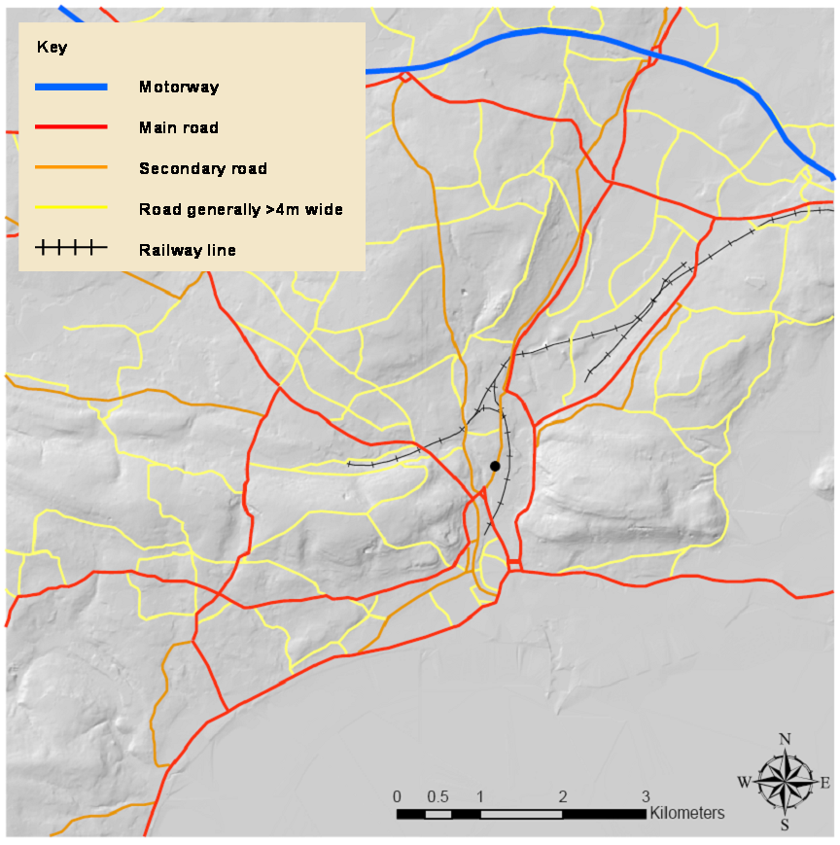

**Figure 1: Topographical map of the area surrounding the sampling site (the site is indicated by the black circle). From Price, 2011.**

The sampling point was 2m from the road edge horizontally, and 5m above the ground. The Electrical Low Pressure Impactor (ELPI; Dekati, Finland) was used for particle counting in twelve size fractions between 7 nm and 10 μm, at a resolution of only a few seconds. Data was averaged to 15 or 60 minutes depending on the analysis required. Vehicle, meteorological, and particle mass data for the site was provided by City and County Council of Swansea.

A principal components analysis (PCA) was used to test for underlying relationships between the different variables and particle fluctuations. The analysis was completed in SPSS (version 16) using orthogonal transformation combined with varimax rotation. Principal components with eigenvalues greater than one were retained.

**3. RESULTS AND DISCUSSION**

The median PNC when averaged across the year was 32,200 cm-3 with a corresponding mean of 40,600 cm-3 (Figure 2). Three main peaks were identifiable in the ultrafine to fine fraction at approximately 09:00, 16:00 and 23:00. The largest peak was identified in the morning rush hour. Morning and afternoon peaks are in response to commuting, and therefore, traffic patterns. The afternoon PNC peak was always lower than the morning peak, probably in response to the increased wind speeds which improve vertical mixing. This prevents particles from building up as effectively as during the morning rush hour. The 23:00 peak may be related to leisure traffic or be a domestic heating signal. A unimodal PNC pattern was generally identified during the weekend, and total PNCs were lower, except for late evening/early morning when leisure traffic was higher.

F:\D drive 01_07_2011\THESIS\Chapters\Ch5 figs\SwanseaAverage\Weekallsizes2.emf

**Figure 2: PNC averages for each measured size fraction (size shown in key in nm). Data averaged from twelve months of semi-continuous data (all-season data). Y axis shown on log scale. From Price, 2011.**

The highest PNCs were identified in Autumn and Winter (mean: 44,347 cm-3, and 44,826 cm-3 respectively), in comparison to Spring and Summer (mean: 43,272 cm-3, and 32,004 cm-3), and a Kruskal-Wallis test showed that there was a statistically significant difference between the total PNCs measured in different seasons (H= 62.256 (3 d.f.), p<.01). Pollutant dispersion is enhanced by atmospheric mixing, and this is generally poorer during the winter months (Harrison and Jones, 2005). Additionally, the lower temperatures during winter lead to greater supersaturation of exhaust gases, encouraging nucleation, and some natural sources have strong seasonal signals, such as sea spray increases during Winter. Social factors, such as increased domestic heating in Winter and reduced commuting traffic during Summer (due to holiday periods and improved weather conditions) will also affect PNCs.

A PCA was used to elucidate relationships between size-segregated particles and vehicle and meteorological variables (Table 1). Six components were identified; three explained relationships between the particles and vehicle/meteorological variables, and three explained the relationships between the meteorological/vehicle variables only and are therefore not discussed (Wang et al., 2010). The first component (PC 1) explained 20.2% of the variance and was associated with particles <615nm, temperature (-), relative humidity (-), global radiation, wind speed (-), vehicle volume, and vehicle speed (-). The second component (PC 2) explained 16.5% of the variance and was associated with fine particles, wind speed (-), vertical wind (-), wind direction (-). The fifth component explained 11.1% of the variance and was associated with coarse particles, rainfall (-), vertical wind, and wind direction.

|  |  |  |  |  |  |  |
| --- | --- | --- | --- | --- | --- | --- |
| **Variable** | **Component** | | | | | |
|  | **1** | **2** | **3** | **4** | **5** | **6** |
| **N7-27** | **.892** |  | .176 |  | -.126 |  |
| **N28-55** | **.934** |  | .134 |  | -.159 |  |
| **N56-93** | **.932** | .115 | .161 |  | -.129 | -.102 |
| **N94-155** | **.913** | **.263** | .133 |  |  | -.101 |
| **N156-262** | **.794** | **.495** |  |  |  |  |
| **N263-383** | **.526** | **.770** |  |  |  |  |
| **N384-615** | **.306** | **.912** |  | -.154 |  |  |
| **N616-952** |  | **.955** |  | -.117 |  |  |
| **N953-1609** |  | **.894** |  |  | **.271** |  |
| **N1610-2399** |  | **.440** |  | .185 | **.832** |  |
| **N2400-4009** | -.143 | **.189** |  | .191 | **.911** |  |
| **N4010-10,000** | -.124 | -.108 |  |  | **.850** |  |
| Temperature | -.119 |  | .577 | .388 |  |  |
| Relative Humidity | **-.156** |  | -.766 | .332 |  |  |
| Global Radiation | **.154** |  | .826 |  |  | .107 |
| Rainfall |  |  | -.314 | .373 | **-.201** | .368 |
| Wind Speed (5m) | -.106 |  | .163 | -.110 |  | .917 |
| Wind Speed (10m) | -.100 | **-.164** | .391 |  |  | .802 |
| Vertical Wind |  | -.103 | .156 | .917 | **.164** |  |
| Wind Direction (5m) |  |  | .112 | .899 | **.163** | .104 |
| Wind Direction (10m) |  | **-.177** | .200 | .676 | **.225** | -.328 |
| Vehicle Count | **.232** |  | .802 | .220 |  | .142 |
| Mean Speed | **-.264** |  | -.781 | -.231 |  | -.137 |
| % Variance (Cumulative) | 20.2% | 36.7% | 51.2% | 63.2% | 74.3% | 82.3% |

**Table 1: An investigation of the correlations between PNC data and meteorological/vehicle variables using data from all seasons; PCA results. From Price, 2011.**

**4. CONCLUSION**

This study has shown the large variability in particle sources contributing to particles at a site, and how different processes after origination affect the PNCs. Also, importantly, how this changes between different size fractions. The nanoparticles were found in the highest number concentrations, which has important implications for health effects as these can reach furthest into the lung during respiration. This study has shown the importance of sampling over longer timescales, as short studies do not capture the seasonal differences in PNC.

**5. REFERENCES**

Baeza-Squiban, A., Bonvallot, V., Boland, S. and Marano, F. 1999. Airborne particles evoke an inflammatory response in human airway epithelium. Activation of transcription factors. Cell Biol. Toxicol. 15(6), pp. 375-380.

COMEAP, 2010. The mortality effects of long-term exposure to particulate air pollution in the United Kingdom. A report by the committee on the medical effects of air pollutants.

Harrison RM, Jones AM. 2005. Multisite study of particle number concentrations in urban air. Environ Sci Technol 39: 6063-6070.

Price, H. Investigations into airborne particulate matter in south Wales, UK. PhD thesis, Cardiff University.

Wang F, Costabile F, Li H, Fang D, Alligrini I. 2010. Measurements of ultrafine particle size distribution near Rome. Atmos Res 98: 69-77.

Acknowledgements: Many thanks to Swansea City Council for providing meteorological and traffic data.