I was invited to present the keynote address and a workshop at Truro and Penwith College’s annual Learning Technology conference on the 7th March. My address, entitled The Tech Commandments, set out to give teaching staff uncomfortable with the notion of embedding technology into their practice guidance and common sense approaches to make their lives easier. The ‘commandments’ were as follows:

1. IF YOU BUILD IT THEY WILL NOT COME!
I have been involved in, and made aware of, many projects that have been funded with sums of between 10 – 10 000 pounds. The ideas behind the projects are reasonably sound: to provide a digital space for students to gather and form a community of practice…to form a site identical to Facebook for students to use that is protected from unwanted stalkers or trolls. These beautiful follies look great, but inevitably, there is little or no engagement from the intended audience. Why?
- Because this is just another space that does something that they already do elsewhere. So it's another site to learn to navigate, another username and password to set up and remember.
- The lesson here is simply to go to where students are already, but to also be aware that there are limits. If your students are on Facebook, go to Facebook…but if you insist on then using Facebook as a replacement VLE, then don’t be surprised if your students flee to Snap Chat. Because they will allow you to have a foot in their digital door…but don’t want teachers / adults to start taking over their space sand telling them how to use it.
- Also – how can students learn digital literacy skills if they are being protected or ‘nannied’ by being asked to use a ‘gated community’?
- Think of all of those thousands of pounds you will be saving – money that can go on other stuff.

2. DON’T LET THE TAIL WAG THE DOG and Keep it simple, stupid!
- If you can’t think of anything that improves the student experience...don’t use technology. Using it for the sake of using it does not enhance learning and can actually do damage.

- Use what you are comfortable with. It doesn’t need to be all singing and dancing – in fact, the more elaborate the set up, the more chance of something going wrong, the more chance of it taking up too much time, feeling out of your depth and then deciding that you never want to use technology again.

3. LOOK AT TOOLS LIKE A BOX OF CHOCOLATES
- For any one thing you want to do there are probably half a dozen sites that will do the job. Want to use a film? Try YouTube, Vine, Vimeo, TED…etc. Want to make a presentation? You could use PowerPoint, Prezi, SlideIdea, Animoto, SlideRocket, ClearSlide…you get the picture.
- The sheer number of tools that do the same thing is enough to give anyone a headache. Think of the tools that are just ‘out there’ (and that new ones are added every day and others are being taken down regularly) and the headache becomes a migraine. I find it all too much and my job is solely based around technology. So yeah – I empathise totally.
- So what to do? Think of the vast array of tools out there as a box of chocolates. And treat them exactly the same way you would treat a box of chocolates. I love the toffee pennies in a tin of Quality Street. But I am not a fan of the purple caramel and brazil nut thingies, nor am I overly keen on the noisette triangles. So I avoid them. I like PowerPoint and am quite fond of Prezi…but avoid SlideIdea and rarely use Animoto. Not because they are bad tools, but because I would rather stick to one or two tools and use them fluently than know enough about 6 versions of the same thing to give me a headache and ensure that whatever I produce looks average.

4. POWERPOINT IS NOT EVIL!
The people who use it badly are evil (!) and have given it a bad name. PowerPoint is actually rather lovely, and, if used properly, can enhance any session or meeting. Ever used PechaKucha? 20 slides, 20 seconds per slide, little – or preferably NO text, so the presenter is forced to make their point in 6 minutes and 40 seconds.

RULES OF POWERPOINT:
- No more than 12 slides (unless it’s PechaKucha - www.pechakucha.org)
- Keep text to a minimum – bullet points of clear, concise information should be a cue for the narrator – not a script
- Use more imagery and fewer words
- Oh-and keep the text large, sans serif (plain) and in blue or black. Avoid green and red text – the rods and cones in our eyes don’t see these colours as ‘well’

5. WHEN YOU FEEL READY…THEN BE BRAVE
- A lot of people shy away from using technology in the classroom because if it goes wrong they’ll look stupid. If they need to get one of their students to look at it, they’ll look stupid and lose their ‘power’.
- This doesn’t contradict the KISS message I gave earlier, but when you feel comfortable with something, and when you feel confident about using it…don’t be afraid to THEN push yourself a little further.

6. RECYCLE WHAT IS ALREADY THERE!
Look at these sites. They all have one thing in common. Other people have made things, uploaded them and then allowed them to be shared freely with anyone. So they can be used as they are, downloaded to your machine and tweaked or tinkered with, and save you from doing what teachers do so often: reinventing the wheel. Examples on my accompanying PowerPoint Presentation are:
- Scribd
- SlideShare
- Prezi
- Jorum
- NLN

7. REMEMBER THAT TECHNOLOGY WILL GO WRONG
- But you won’t lose your job and nobody will die because of this.
- Have a Plan B in case it all goes wrong
- Only use stuff you feel confident using and have used before.
- BUT if you need help or it does go wrong, use the situation to your advantage and get students involved in trying to make things work. Helps communication, collaboration and problem solving skills, and deflects attention from your sweating palms
The workshop I delivered before lunch was called Quick Wins and looked at some free, easy to use, web-apps that could enhance learning and not only improve students’ collaboration, collation and digital literacy skills, but also engage them and enhance their experience in the classroom. The apps that were looked at and ‘played with’ by workshop participants were as follows:
- TED
- Pinterest
- Tagxedo
- VoiceThread
- Augmented Reality (using a site called Layar)
- PechaKucha (a style of presenting using 20 slides timed at 20 seconds per slide, meaning that presentations go on for no longer than 6 minutes and 40 seconds)
- Kahoot
- Padlet (formerly Wallwisher)
Padlet was used as a way of gathering feedback after the session. A screen shot of responses can be seen below. Furthermore, there are links to both PowerPoint presentations (currently housed on SlideShare). Click here to access the Doctor Who PechaKucha authored specifically for delivery at the conference.
- The Tech Commandments on SlideShare
- Quick Wins on SlideShare

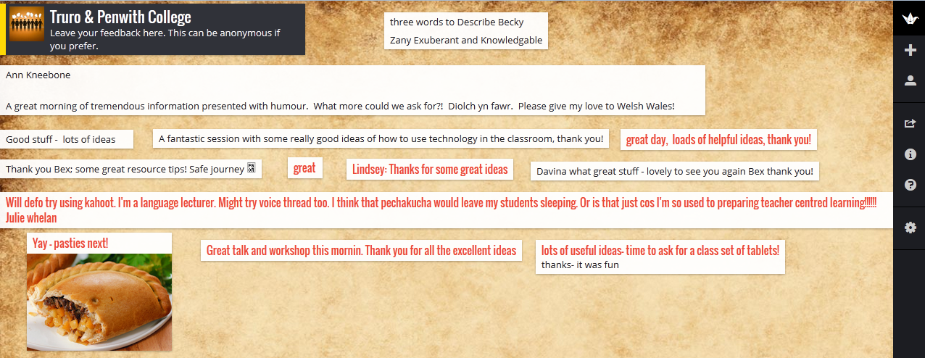
Figure 1: Screen shot of feedback collected using Padlet

