**Combustion characteristics of biodiesel saturated with pyrolysis oil for power generation in gas turbines**

Kurji Hac, Valera-Medina A a*, Runyon J a, Giles A a, Pugh D a, Marsh R a

Cerone N b,d, Zimbardi F b, Valerio V b,

*aCardiff University, Queen’s Building, Cardiff CF24 3AA, United Kingdom*

[*\*valeramedinaa1@cardiff.ac.uk*](mailto:*valeramedinaa1@cardiff.ac.uk)

*b ENEA, Rotondella, Italy*

*c Kerbela University ,College of Engineering , Mechanical Department ,Kerbela, Iraq*

*d Università degli studi di Napoli "Federico II"*

*Abstract*

There is a perceived need for multi-fuel burner geometries capable of operating with variable composition fuels from diverse sources to achieve fuel flexibility in gas turbines. The objective of the research covered herein is a comparison study between two liquid fuels, a biodiesel (in a pure form) and the biodiesel as a saturated mixture with a pyrolysis by-product; these two fuels were compared against a standard kerosene as a baseline. The research methodology involved two stages: firstly atomization patterns and injection regimes were obtained using a high speed imaging method, secondly a combustion test campaign was undertaken using a swirl burner to quantify the operational behaviour, species production and exhaust gas compositions of the fuels. Emissions, flame stability trends and power outputs were measured at gas turbine relevant equivalence ratios. Excess oxygen and atomization trends in the biodiesel seem to be playing a major role in the production of emissions and flame stability when compared to kerosene. Also, heavy organics seem to be acting as catalytic substances for OH production close to the burner mouth. In terms of stability and combustion, it is proposed that the saturated blend would be a viable candidate for power generation.

Keywords: Atomization, combustion, Gas Turbine, Biodiesel

© 2014ElsevierLtd.Allrightsreserved.

**I. INTRODUCTION**

Reliable and economically viable alternatives to current fossil fuel products are continually being sought as pressures from fuel cost, security and environmental impact act on the fuel and energy industry [1]. In terms of liquid fuels, Diesel is largely utilized in commercial, domestic and industrial applications for power and heat generation; it is also used as backup fuel in gas turbines. There has been recent interest in using bio-derived liquid fuels such as biodiesels for gas turbine operation, but naturally there are concerns as to the operability and reliability of using less synthetic, more heterogeneous substances for fuels in such high value assets. Biodiesel products are often highly oxygenated fuels and have been used as an alternative source of fuel for diesel engines to improve combustion performance. Biodiesel can be considered a more environmentally benign fuel (when compared to fossil-based fuels) in terms of sulphur content, flash point, aromatic carbon content and biodegradability, provided this fuel could be used in gas turbines without major modifications [2].

Modern gas turbines will typically operate at lean equivalence ratios, which are between 0.5 and 1.0, depending on operational load and emissions reduction across a range of power outputs. Biodiesel has demonstrated a reduction of un-burnt hydrocarbons (UHC), carbon monoxide (CO) and particulate matter (PM) without reducing the power output significantly [3]. Experiments have shown a reduction of 12% for both CO and PM emissions and 20% for UHC emissions by co-firing 20% biodiesel in diesel fuel blends. Emissions reduction was about 48% for CO and PM and 68% for UHC when using 100% biodiesel. However, some research has seen a marginal increase in NOx (1–6%) [4]. The presence of extra (fuel-bound) oxygen has been shown to result in overall slightly leaner combustion, which has the resulting benefit of increasing the thermal efficiency [5]. Emissions such as Polycyclic Aromatic Hydrocarbons (PAH) were also found to be less prevalent during biodiesel combustion. CO2 emissions aside, biodiesel can be considered a cleaner fuel than fossil-derived diesel because it has almost no sulphur content (typically less than 15 ppm), no aromatics, and contains about 10% oxygen, which can improve the overall combustion process. Biodiesel also has a comparatively high lubricity and can hence be used as a lubricating agent for traditional diesel blends [1].

Work in the area of biofuels testing has often shown promising results where emissions are comparable to control studies using fossil-based Diesel [6]. Panchasara et al. [7] studied the combustion performance of pure biodiesel against diesel–vegetable oil blends in a simulated gas turbine combustor. These experiments were performed at atmospheric pressure with air-assisted injector/atomisers in swirling flows. The results showed that fuel chemistry effects were minimal since combustion emissions for a given fuel were largely dependent on the atomisation process. Campbell et al. [8] studied alternative fuels that had been deemed suitable for gas turbines focussing on vegetable oils. They highlighted several properties of vegetable oils that would require special consideration such as transportation, storage, delivery and injection into industrial gas turbines. Hashimoto et al.[9] compared the emissions of palm derived biodiesel with those of fossil derived diesel in a gas turbine burner. The result indicated that NOX emissions for palm biodiesel were consistently lower compared to those of diesel as a function of excess air ratio, average droplet diameter, atomizing air pressure and viscosity. These results indicate that biodiesel has the potential to produce lower NOX emissions than diesel under gas turbine conditions, contrary to the higher NOX emissions measured in reciprocating compression-ignition engine experiments [10].

Biodiesel and diesel have notable differences in physical properties, and it is therefore necessary to study the spray characteristics of biodiesel in relation to its application in internal combustion engines and gas turbines - more so given that atomization behaviour has a significant effect on emissions. Senatore et al. [11] analysed results of an experimental study fuelling a common-rail diesel engine with 100% rapeseed biofuel, comparing their findings with a blend of rapeseed and Used Fried Oil (UFO), showing good correlation between fuels. Zhao et al. [12] observed that the spray penetration and spray cone angle of biodiesel were larger than those of diesel. Similarly, Lee et al. [13] examined the atomization characteristics of biodiesel-blended fuels using a spray visualization system and phase Doppler particle analyser. They deduced that the biodiesel blended fuels had comparable spray tip penetrations to conventional diesel but higher Sauter Mean Diameter because the viscosity and surface tension of the biodiesel were higher than the conventional diesel fuel. Being a crucial topic for the improvement in burnout and a key factor in emissions, advanced laser-based spray quantification techniques have been used and developed to understand atomization patterns for diesel and biodiesel [14, 15].

The biodiesel used in the work in this paper is a by-product from a biomass gasification process; specifically a liquid condensate from the product gas cleaning process. This is a crucial stage in the thermal conversion of biomass, especially where the main product gas components CO and H2, are used for Fischer–Tropsch synthesis or as high purity fuel [16]. Biodiesel is widely used for scrubbing the raw syngas as it efficiently removes the condensable (heavier) hydrocarbons produced from biomass pyrolysis. Experimental investigations have been carried out on similar post-scrubbing liquids where combustion of blends of pyrolytic oil, biodiesel or ethanol in engines and boilers [17, 18] have proved the suitability of the approach. This has included large-scale applications and highlighted a need to standardize the trade of this product [19]. Cappelletti et al. redesigned a micro gas turbine to permit stable combustion of pyrolysis oil showing that the combustion is only stable in the combustor’s secondary zone [20]. However, further works concerning the use of pyrolysis oil as fuel for gas turbines are scarce at the time of writing.

The research questions to be addressed include measurement of the physical properties, atomization behaviour, combustion characteristics, and emissions of the new biodiesel blend and how this compares with a standard kerosene. Therefore, the aim of this study is to demonstrate the potential of this saturated biodiesel for power generation as a backup fuel for Integrated Gasification Combined Cycles (IGCC) and compare its combustion behaviour with kerosene and unsaturated biodiesel. Atomization patterns and injection regimes were obtained using high-speed imaging. Calorific values, density, and surface tension were measured and proximate analyses were performed to act as a comparison between the fuels. Knowing the properties and atomization behaviour, these fuels were fired into a generic swirl burner capable of simulating real gas turbine conditions. Exhaust gas emissions, OH* chemiluminescence and combustion stability were measured at similar flow rates, providing evidence of the potential for and constraints to using this saturated biodiesel as an alternative fuel for gas turbines.

## II. Experimental Setup

1. **Characterisation**

Experiments were conducted at Cardiff University, UK, and ENEA, Italy. The surface tension and density were experimentally obtained using a temperature controlled LAUDA TVT 1 Drop Volume Tensiometer. The viscosity was experimentally obtained using a U–Tube Viscometer‎. The Higher Heating Value (HHV) was determined by a Parr 6100 calorimeter bomb and an IKCA C4000 calorimeter using benzoic acid as reference. An ultimate analysis was carried out by using an elemental analyzer, a Perkin Elmer CHN/O according to UNI EN 15104. Ash was analyzed to determine the elemental content according to the methods CEN 343 or CEN 345 by using an ICP-OES Agilent 720ES. Oxygen was calculated by difference of species. Gas Chromatography (GC) was employed by using an Agilent HP 6890 GC.

Three test fuels were used in the experimental campaign, including unsaturated and saturated biodiesels, and kerosene. Their properties are given in Table 1, with the GC analysis of the methyl esters in Table 2. The unsaturated biodiesel is derived from cooking oil, giving a composition similar to that obtained for methyl ester. The fraction of biodiesel that is included in the saturated sample has almost the same elemental composition (C 76.28%, H 12.55%, O 11.04 %) as that of the unsaturated biodiesel. However, since the biodiesel has been used to clean up the gas stream from a gasification process, the saturated biodiesel represents less than half of the total mass of the final sample. Besides water, the remaining 36.8% is a complex mix of organic molecules including formic acid (molecular mass 46 g/mol) and aromatic compounds (molecular mass 200 g/mol). This scrubbing process has been carried out to improve the quality of gases in a biomass gasification system at ENEA, Italy [21].

**TABLE 1. Fuel Properties.**

|  |  |  |  |
| --- | --- | --- | --- |
| Property | Kerosene | Unsaturated Biodiesel | Saturated Biodiesel |
| Viscosity [m2/s] 20°C | 3 x 10-6 | 7.40 x 10-6 | 7.60 x 10-6 |
| Viscosity [m2/s] 40°C | 2.00 x 10-6 | 4.49 x 10-6 | 4.68 x 10-6 |
| Density [kg/m3] | 820 | 859 | 879 |
| Surface Tension [mN/m] | 28 | 29.1 | 32.1 |
| HHV [MJ/kg] | 46 | 38.9 | 29.4 |
| Water content [wt%] | 2.6 | 0.7 | 19.0 |
| Methylesters [wt%] | --- | 95.0 | 44.2 |

**TABLE 2. Analysis of methyl esters by GC, relative abundance as wt%.**

|  |  |  |
| --- | --- | --- |
| Molecule | Unsaturated Biodiesel | Saturated Biodiesel |
| C14:0 | 1.07 | 0.92 |
| C16:0 | 32.10 | 24.60 |
| C16:1 | 0.00 | 0.00 |
| C18:0 | 3.36 | 3.25 |
| C18:1 | 47.50 | 47.60 |
| C18:2 | 12.80 | 19.60 |
| C18:3 | 3.07 | 3.90 |
| TOT | 100 | 100 |

**B. Atomization Experiments**

A Delavan 0.23mm-60°A WDB nozzle atomizer was used as the fuel injector. Atomization characterization was performed in a spray chamber located at Cardiff University, Figure 1. This rig offers independent control of the ambient (chamber air) pressure (up to 15 bar) and temperature (up to 150 °C), such that the chamber air conditions can range from simulated intake stroke to late compression stroke injection for characterization of automotive applications. Reading uncertainty of the pressure gauges was ±0.5 bar.

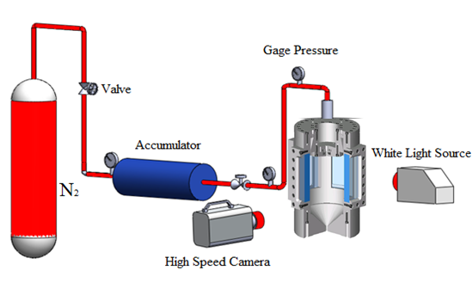

FIG 1. Spray rig and imaging setup diagram.

High-speed imaging was used to detail the atomization parameters, namely spray angle. The spray angle was defined as the angle formed by the cone of liquid leaving the nozzle orifice where two straight lines were wrapped with the greatest outer side of the spray [22]. A Photron Fastcam APX-RS high-speed camera operating at 1000 frames/s was also used with a 105 mm, 1:2.8 Nikon lens. A 50W straight projector bulb was used as a light source, accessing the chamber through one of its 3 quartz windows and placed at a 90° angle to the high-speed camera. The atomizer nozzle was placed in the top of the experimental test rig to spray the fuel at operating pressures from 8 to 26 bar absolute, collecting the bulk volume of the spray at the bottom of the rig. The injector pressure was adjusted within the range of 8-26 bar using compressed nitrogen, passing into a liquid accumulator as shown in Figure 1. The resulting images were analysed using Photron FASTCAM PFV ver 2.4.1.1 software and MATLAB [R2013a](https://www.google.co.uk/url?sa=t&rct=j&q=&esrc=s&source=web&cd=5&cad=rja&uact=8&ved=0CEEQFjAE&url=http%3A%2F%2Fmatlab-r2013a-student-version-32-bit.software.informer.com%2F&ei=WRBaVZe6Dsev7AaP0YII&usg=AFQjCNG4wack0_oXP7sL9oCtZRAix7wlbQ&bvm=bv.93564037,d.ZGU).

**C. Gas Turbine Burner Trials**

Experiments were performed at the Gas Turbine Research Centre (GTRC), which is a Cardiff University facility located at Port Talbot [23]. The rig used herein was the High Pressure Optical Chamber (HPOC), capable of delivering 5 kg/s of air at 900K and 16 bar absolute, thus allowing combustors to be operated at conditions applicable to use in a power generation derivative gas turbine engine. Coriolis mass flow meters were used to achieve precise measurement of flowrates with an accuracy of ±0.5% RD plus ±0.1% FS. In this particular research, the HPOC rig was fitted with a generic pre-mixed swirl burner, Figure 2. The generic swirl burner consists of a main body that receives both the premixed (gaseous) fuel and oxidizer plus a central lance that is used for liquid injection. The burner body includes a premixing chamber where most of the gas premixing takes place upstream of the swirl chamber. Finally, the burner is confined by a quartz tube fitted to the system to simulate the appropriate expansion ratio from the burner into the engine’s combustion chamber; in this case an expansion ratio of 4 was used.

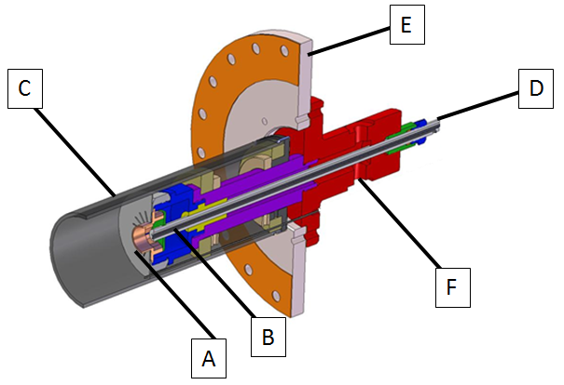

FIG 2. Generic swirl burner with lance attached. A - swirler head; B – liquid fuel lance with atomizer; C – quartz confinement tube; D – liquid fuel inlet; E – pressure casing wall; F – main combustion air inlet.

Combustion trials were conducted at both atmospheric and pressurised conditions. Pressures of up to 2.9 bar absolute were studied for all fuels, allowing for thermal power conditions ranging from 30 to 60kW. Video cameras were used to capture images of the flame from radial and axial positions. Documented results included flame shape, appearance and stability of the flame, with emphasis on how these parameters affect the combustion behaviour, plus the measured exhaust gas composition of the fuels.

OH* chemiluminescence measurements were taken using all fuels at various equivalence ratios. A Dantec Dynamics Hi Sense Mk II CCD camera with a 1.3 megapixel resolution was coupled to a Hamamatsu C9546-03L image intensifier. A specialty 78 mm focal length lens (F-stop = f/2.8) capable of capturing light in the UV wavelength range was installed on the image intensifier along with a narrow band pass filter centered at 307 nm (FWHM = 10 nm). Two hundred images were taken at 10 Hz at each test condition using Dantec’s DynamicStudio software, while the image intensifier gain was selected via remote control. All images were taken through the top window of the HPOC at a 90° angle to the direction of flow. Abel inversion of the resulting time-averaged images was used to provide better recognition of the OH* distribution across the flame [24, 25]. Abel inversion was performed on the temporal average of 200 images taken at 10 Hz (20 seconds of run time), and then used the resulting image intensity values in the normalization process.

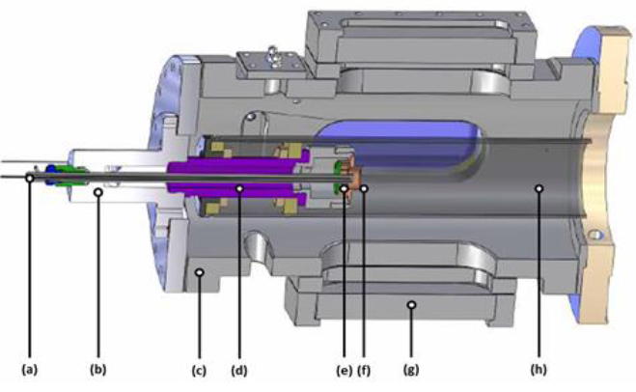

FIG 3. Schematic diagram of the HPOC showing (a) liquid fuel lance, (b) inlet plenum, (c) HPOC outer casing, (d) air plenum, (e) radial-tangential swirler insert, (f) exit nozzle, (g) quartz window for OH* visualization, and (h) quartz confinement. Flow goes from left to right.

Two pieces of equipment were used to characterise combustion emissions. An integrated system developed by Signal Instruments comprising several analysers: a Flame Ionisation Detector (FID), employed within a Signal 3000HM analyser to detect total hydrocarbons (THCs), calibrated with propane in the range 0-890 ppmV. A heated vacuum chemiluminescense analyser (Signal 4000VM), simultaneously employed to quantify NOx concentrations, calibrated to full scale of 37.1 ppmV NO and 1.9 ppmV NO2. The system also contains a multi-gas analyser (Signal MGA) containing an infrared cell for measurement of CO (calibrated for 0-900 ppmV) and CO2 (0-9%V), in addition to a paramagnetic O2 sensor (up to 22.5%V). A standalone Rosemount NGA 2000 multi-gas analyser provided secondary readings of CO, CO2 and O2 all calibrated to the same concentrations previously stated. Relative accuracy of these gas analysis methods after calibration shows a ±5% reading error.

Combustion equilibrium analyses were carried out utilizing GASEQ [26] under stoichiometric conditions in order to provide a better understanding of the evolution of some of the species that participate in the process and the final flue gas concentrations. The methyl-formate reaction mechanism developed by Fisher et al. [27] has been used as a surrogate for biodiesel. Methyl-formate was chosen as a surrogate molecule in order to obtain a reaction close to the one expected from biodiesel. Although methyl-formate mechanisms have shown differences to biodiesel [27], the results provide the basis for the discussion on exhaust gas composition.

## III. Results – (a) Spray Characterisation

Characterisation studies (Table 1) showed that the calorific value for the saturated biodiesel is lower than that of kerosene and the unsaturated biodiesel. Although this was expected, it is still a promising result which shows that the energy content of the saturated sample is high enough to be considered a viable option for liquid fuel energy applications. Nevertheless, this calorific value is dependent on the gasification process, scrubbing and aging, factors that need to be considered when using it as a backup fuel [21].

|  |  |  |  |  |  |
| --- | --- | --- | --- | --- | --- |
| Pressure (bar) | Kerosene | Unsaturated Biodiesel | Pressure (bar) | Kerosene | Unsaturated Biodiesel |
| 8 | C:\Users\c1223684\AppData\Local\Microsoft\Windows\Temporary Internet Files\Content.Word\1.bmp | C:\Users\c1223684\AppData\Local\Microsoft\Windows\Temporary Internet Files\Content.Word\1.bmp | **20** | C:\Users\c1223684\AppData\Local\Microsoft\Windows\Temporary Internet Files\Content.Word\2.bmp | C:\Users\c1223684\AppData\Local\Microsoft\Windows\Temporary Internet Files\Content.Word\2.bmp |
| 11 | C:\Users\c1223684\AppData\Local\Microsoft\Windows\Temporary Internet Files\Content.Word\2.bmp | C:\Users\c1223684\AppData\Local\Microsoft\Windows\Temporary Internet Files\Content.Word\2.bmp | **23** | C:\Users\c1223684\AppData\Local\Microsoft\Windows\Temporary Internet Files\Content.Word\2.bmp | C:\Users\c1223684\AppData\Local\Microsoft\Windows\Temporary Internet Files\Content.Word\2.bmp |
| 14 | C:\Users\c1223684\AppData\Local\Microsoft\Windows\Temporary Internet Files\Content.Word\2.bmp | C:\Users\c1223684\AppData\Local\Microsoft\Windows\Temporary Internet Files\Content.Word\2.bmp | **26** | C:\Users\c1223684\AppData\Local\Microsoft\Windows\Temporary Internet Files\Content.Word\2.bmp | C:\Users\c1223684\AppData\Local\Microsoft\Windows\Temporary Internet Files\Content.Word\2.bmp |
| 17 | C:\Users\c1223684\AppData\Local\Microsoft\Windows\Temporary Internet Files\Content.Word\2.bmp | C:\Users\c1223684\AppData\Local\Microsoft\Windows\Temporary Internet Files\Content.Word\2.bmp |  |  |  |

FIG 4. High-speed imaging at different pressures for fossil and biofuels blends. Average results out of 1000 images.

Spray angle results showed that the unsaturated biodiesel consistently has a narrower spray angle than kerosene, Figure 4, thus requiring more pressure to achieve an effective droplet breakup prior to evaporation; this data is shown graphically in Figure 5 as a plot of spray angle vs injection pressure for the 3 fuels tested as studied by others [7, 28]. Similar results were obtained for the saturated biodiesel, Figure 5, which showed a smaller spray angle linked to the presence of solid matter (from the particulate matter contaminants present in the saturated fuel) and resultant greater viscosity. Narrower spray angles are a known issue for higher viscosity biofuels which can result in combustion problems such as high smoke emission. Spray angle is also known to be a function of the ratio between the ambient density and the sprayed fluid density, hence the results in Figure 5 are logical given the properties discussed herein. The likely outcome for attempts to burn this fuel under similar conditions as a fossil fuel is that there may be no combustion if the pressure used in the fuel line is not high enough to produce a well-atomized spray. Suggested solutions to this issue include biofuel preheating to provide lower viscosity and hence improve atomisation, along with higher injection pressures to be used for spraying the saturated biodiesel.



FIG 5. Effect of fuel injection pressure on spray angle

## III. Results – (b) Combustion behaviour in the HPOC

**Flame appearance**

For kerosene, the flame was stable and sufficiently radiative to show the production of soot that would be expected with the lack of oxygen for complete burnout under rich conditions. Under comparable air to fuel ratios, the unsaturated biodiesel showed a visibly lower quantity of exhaust soot, presumably due to the larger quantity of oxygen bound into the fuel. The saturated biodiesel also burnt with a stable flame, but it was evident that the amount of soot coming from the saturated biodiesel was the highest of all the fuels tested, as shown in Figure 6 and expected from previous literature [29]. Soot formation was so high that the quartz confinement tube was stained with black soot deposits after only a few seconds of operation under rich (ϕ ~ 1.2) conditions. This behaviour also correlated with the considerable THC emissions (shown later) as a consequence of its saturated constituents. Also, there was visible evidence that the atomization of the fuel was incomplete, with the appearance of several glowing (presumably fuel-rich) projections in the flame. This correlated with the spray visualisation experiments, which showed that the saturated biodiesel formed into small droplets at a noticeably slower rate than the other fuels. The ensuing larger spray droplets require more time to evaporate and hence thermal decomposition of the hydrocarbons will be impeded, resulting in incomplete burnout, hence the observed soot.

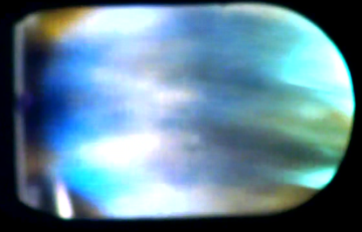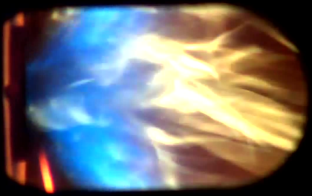

1. B. C.

FIG 6. Visible flame at equivalence ratios 0.6. A) Saturated biodiesel, high soot glowing. B) Unsaturated biodiesel, and C) Kerosene.

It can be said that overall the saturated biodiesel blend under lean conditions (i.e. ϕ < 1) behaved favourably in terms of flame stability and burning processes compared to the other fuels tested. As the subsequent gas analysis will show, if the flame can be stabilised at low equivalence ratios, the CO formation will be lower with more CO2 produced, thus reflecting a higher measured combustion efficiency. Total unburned hydrocarbons will be lower although NOX will increase as a consequence of the additional (fuel bound) nitrogen and comparably higher temperatures than the other fuels tested. Nevertheless, if equivalence ratios of ~0.55 are attained, then measured outlet concentrations of NOx will be in the same order of magnitude to those observed in kerosene flames.

**Exhaust gas analysis**

Figure 7 shows THC emissions as a function of equivalence ratio for the kerosene and biofuels tested under atmospheric conditions. A log scale has been used since the THC emission above stoichiometry was orders of magnitude higher than the values measured below. It can be seen that the saturated biodiesel mostly produced higher concentrations of unburnt hydrocarbon products, especially at higher equivalence ratios, which corresponds to the physical observations in the preceding section. There was some evidence to suggest that increasing the HPOC pressure had reduced net THC emissions, but more data would be required to verify this. Kerosene did not show any measurable concentrations of THC in the exhaust, demonstrating complete burnout of the fuel under the conditions studied. This correlates well with the spray results given that the kerosene spray was noticeably more atomized [30].

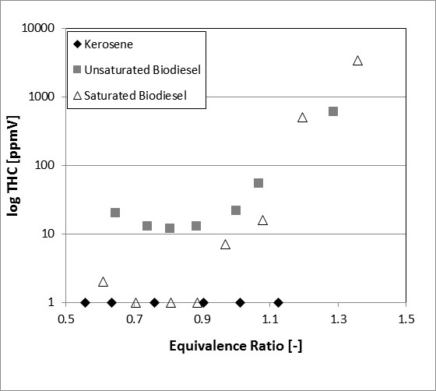

FIG 7. THC exhaust gas concentration (dry) as a function of equivalence ratio for kerosene and the two biofuels at atmospheric pressure.

Figure 8 shows O2 concentration as a function of equivalence ratio under atmospheric conditions. This value is based on the measured fuel and air flow rates through the burner, and the gas analysis. The measurement of oxygen and CO allowed for the identification of the near stoichiometric operating point. Different trends can be seen between all fuels, with the unsaturated blend showing the highest O2 concentrations due to the presence of oxygen in the bio-blend. However, the saturated biodiesel showed the lowest trend, which has been attributed to the presence of solid carbon-based particles in the liquid fuel; hence more oxygen being required per unit mass of fuel burn due to a much greater average carbon composition [1, 31].

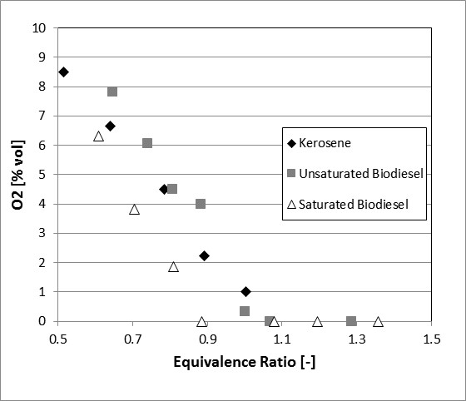

FIG 8. O2 exhaust gas concentration (dry) as a function of equivalence ratio for kerosene and the two biofuels at atmospheric pressure.

Figure 9 shows CO2 emissions as a function of equivalence ratio for the kerosene and biofuels tested under atmospheric conditions. There is a difference in the behaviour of the biofuels in comparison to the kerosene, demonstrated by the peak CO2 values at higher concentrations for the bio-blends. It is apparent that the biofuels produced marginally more CO2 than the kerosene under identical air flow rates, which is likely given the higher carbon to hydrogen ratio in the heavier fuels [5]. As expected, there is greater exhaust CO2 concentration from the saturated fuel as a consequence of further reactions of the solid particles; at higher pressures this was also the case. It should be noted that these differences are comparatively very small, so under these circumstances the results can be considered to be within the experimental uncertainty of the measurement.

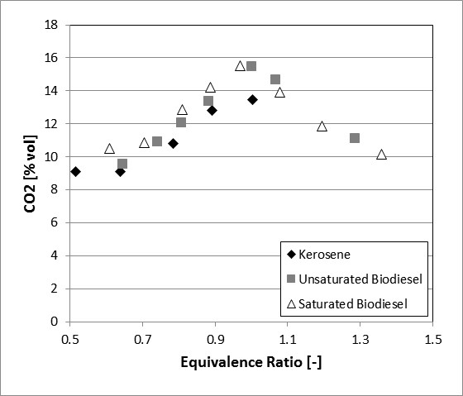

FIG 9. CO2 exhaust gas concentration (dry) as a function of equivalence ratio for kerosene and the two biofuels at atmospheric pressure.

Figure 10 shows CO emissions as a function of equivalence ratio for the kerosene and biofuels tested under atmospheric conditions; the production of CO is due to incomplete combustion. At atmospheric and elevated pressure, results showed that CO emissions generally decreased with the biodiesels, most likely as a consequence of the fuel-bound oxygen in the molecule which starts reacting further downstream than the oxygen contained in the air flow [5]. The saturated biodiesel also showed comparatively lower CO concentrations, in all cases lower than the unsaturated biodiesel. Although lower emissions were expected under lean equivalence ratios, there were 3 distinctive points in Figure 10 that showed a peak production of the CO molecule whilst using Kerosene and unsaturated biodiesel. Experimental trials exhibited highly fluctuating patterns for these conditions, denoting a lean blue flame zone close to the nozzle followed by a red-orange crown at the end of the flame, Figure 6. It is believed that the particular fluid conditions at these equivalence ratios cooled the flame to a point at which some of the droplets were not entirely consumed during the combustion process, thus reaching the end of the flame partially unburned and producing CO. Contrary to these cases, the saturated biodiesel seems to be burning with low CO production at these conditions, likely a process related to the saturated particles that enhance heat transfer at the base of the flame. It is recognised that these conditions will not be similar under higher pressures as the flame would retreat, and faster reactions would occur at the base of the flame.

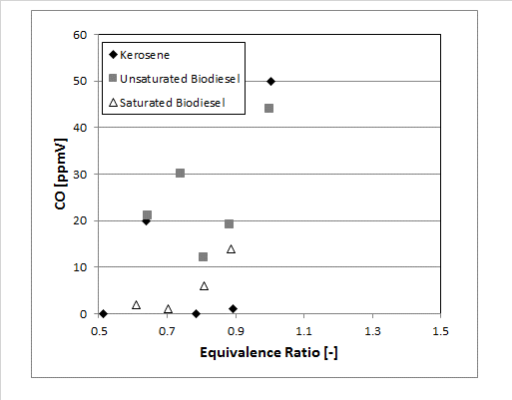

FIG 10. CO exhaust gas concentration (dry) as a function of equivalence ratio for kerosene and the two biofuels at atmospheric pressure.

Figure 11 shows NOX emissions as a function of equivalence ratio for the kerosene and biofuels tested under atmospheric conditions. The results denote that NOX emissions augment with increasing equivalence ratio towards stoichiometric conditions. The saturated and unsaturated biodiesels produced higher NOX emissions than kerosene at all pressures. It is believed that higher NOX emissions from the biodiesels were related to a greater CH formation, leading to prompt NOX via CH+N→HCN reactions as observed by others [33] and discussed later herein. Moreover, the higher temperature of the reaction produced by the excess oxygen and improved combustion in the saturated biodiesel could also lead to higher Zeldovich emissions (thermal NOX). Contrary to the experimental results, atomization behaviour was thought to be a parameter that would control the resultant NOX concentrations for the bio-blends, as decreased spray angle and bigger droplet size [34] would result in the fuel remaining unburned for longer periods of time and greater axial distances, reducing NOX by a decrease in the combustion efficiency, burning further downstream to complete the reaction.

When compared with the saturated blend, both kerosene and the unsaturated biodiesel produce lower NOX emissions, a phenomenon that could be linked to the content of nitrogen in the organic matter carried by the saturated blend [29]. The presence of solid particles also shows traces of a more efficient combustion regime, i.e. lower CO and higher CO2, thus higher temperatures and increased Zeldovich NOX. When considering the effect of pressure on NOX concentration, it was also observed that NOX emissions are considerably reduced at higher pressures, with a peak of 120 ppm under atmospheric conditions, reducing to 25ppm at 2.9 bar for the saturated biofuel blend. Since the power conditions for all cases are similar at 40 kW, it is believed that the high pressure forces the flame to retract towards the burner, compacting it and improving combustion and reactivity.

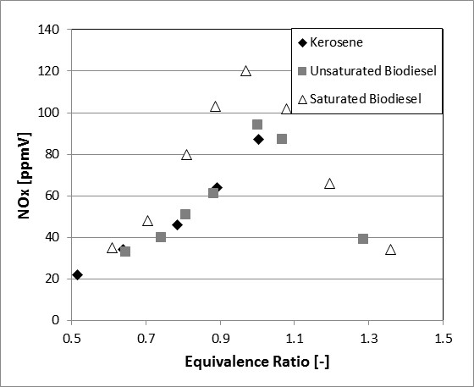

FIG 11. NOx exhaust gas concentration (dry) as a function of equivalence ratio for kerosene and the two biofuels at atmospheric pressure.

**Chemical equilibrium calculations**

The measured gas compositions were correlated with chemical equilibrium calculations using GASEQ, Table 3. Pressures used for the analysis were 1, 10 and 100 bar in order to clearly show progression of species with increment of pressure. Methyl-formate (C2H4O2) was used as a surrogate molecule related to larger methyl esters [21, 35]. From the results, the OH radical has decreased at higher pressures. The greatest changes were observed in the evolution of hydrogen and oxygen towards the formation of complete combustion molecules such as CO2 and H2O. NO shows an acute decrease at higher pressures. Although temperatures are higher, lack of oxygen in the blend limits the production of NO. Moreover, it is believed that OH radical formation is inhibited by pressure, as discussed in the following section.

TABLE 3. GASEQ equilibrium analyses. Molar fraction and adiabatic temperature of the flame.

|  |  |  |  |
| --- | --- | --- | --- |
| Molecules | Pressure 1 bar | Pressure 10 bar | Pressure 100 bar |
| N2 | 0.64381 | 0.64698 | 0.64927 |
| H2O | 0.16593 | 0.16904 | 0.17109 |
| CO2 | 0.15452 | 0.16165 | 0.16674 |
| CO | 0.01704 | 0.01071 | 0.00617 |
| O2 | 0.00779 | 0.00456 | 0.00239 |
| OH | 0.00416 | 0.00256 | 0.00142 |
| H | 0.000481 | 0.000159 | 0.0000459 |
| O | 0.000372 | 0.000127 | 0.0000365 |
| H2 | 0.00332 | 0.00196 | 0.00109 |
| NO | 0.00258 | 0.00223 | 0.00176 |
| Adiabatic Flame Temp | 2272K | 2331.6K | 2372.4K |

**OH* Chemiluminescence Analyses**

OH* chemiluminescence studies were carried out for all conditions. Comparisons between biofuels were performed to observe the progression of OH radicals at different pressures, Figures 12 and 13. Abel inversion was applied to produce intensity maps normalized on the basis of the most intense luminosity value. Hence, of all the images shown herein, the highest pixel level is used to set a nominal maximum luminosity and all of the results are scaled with respect to this, which allows for a more realistic comparison of global intensity. Results clearly show a large amount of OH radicals at low pressure in the region where the swirling flame is positioned.



FIG 12. Abel inversion for OH* chemiluminescense for the Unsaturated biodiesel E.R. 0.550 at a) 1.9 bar; and b) 2.9 bar. The burner outlet is denoted as the grey rectangle at the bottom of the figure.

Considerable variation between blends was observed at high pressure, as shown in Figures 12b and 13b. The unsaturated biodiesel has decreased its OH* production, reducing the reaction zone length of this radical and thus chemiluminescence intensity, a phenomenon caused by the retraction of the flame and greater density as a consequence of increased downstream pressure. However, the saturated blend kept showing OH* intensity profiles similar to those observed at lower pressure, as shown in Figure 13. Some conclusions can be drawn from these results; it seems as if oxygen from the biodiesel was reacting faster than oxygen from air when solid matter was present in the fuel.



FIG 13. Abel inversion for OH* chemiluminescense Saturated blend E.R. 0.581 at a) 1.9 bar; and b) 2.9 bar.

This assertion comes from the changes in OH* intensity in the unsaturated biofuel at various pressures. Higher pressures mean greater densities, thus more air adjoining the flame leading to greater OH* dilution of a process driven by the surrounding atmosphere. However, since the OH* intensity in the saturated flame is similar at various pressures, it is evident that the OH* production has been kept almost constant from a source independent of downstream conditions, i.e. pressure, with minor dilution impacts at the OH* release location.

Further comparison was performed between the different fuels at the same pressure, Figures 14 and 15. The unsaturated blend shows considerable increase in the OH* projections to those observed in the saturated biodiesel. These differences emphasize the evolution of other species overtaking OH* production in the saturated blend further downstream of the burner nozzle. From other works [33] it can be deduced that CH production has been enhanced for the saturated blend which shows the greatest NOx formation.

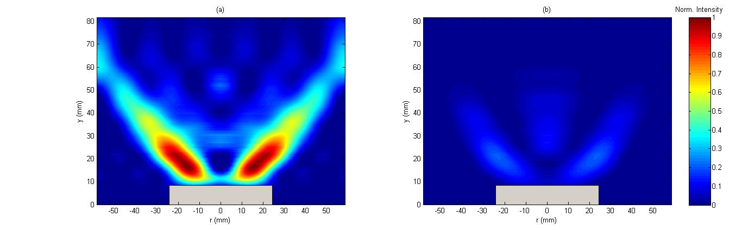

FIG 14. Abel inversion for OH* chemiluminescense at same pressure (1.9 bar) and stoichiometry (~0.58). a) Unsaturated blend; b) Saturated blend.

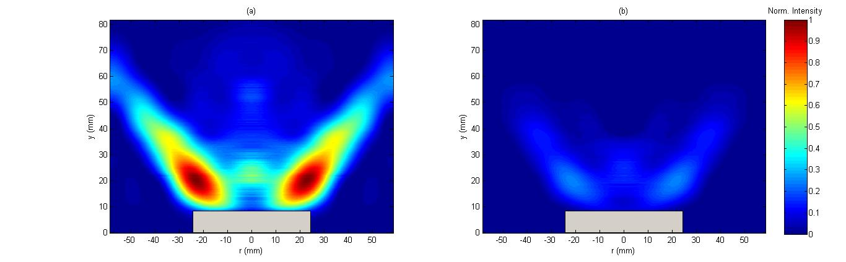

FIG 15. Abel inversion for OH* chemiluminescense at same pressure (2.9 bar) and stoichiometry (~0.59). a) Unsaturated blend; b) Saturated blend.

Therefore, it can be concluded that solid matter in the fuel also acts as a catalytic substance for the production of other radicals. Although the particles keep forming CH radicals downstream of the flame zone that enhance NOx formation, at low equivalence ratios the use of these catalytic particles also enhances fuel-bound oxygen reactions that remain almost unaltered at higher pressure. These properties could contribute to the improvement of combustion systems, thus leading to a good fuel candidate at lean conditions.

Unfortunately, visual observations showed that saturates will tend to produce higher soot emission at the present concentrations, reducing the applicability of this particular fuel for gas turbines. However, if the appropriate amount of particles in the bio-fuel to considerably diminish impacts on materials and components could be met, these particles could be a feasible mechanism to enhance gas turbine combustion at low cost.

**IV. Conclusions**

Three fuels, kerosene and a biofuel in unsaturated and saturated form, were tested to compare the relative performance of the saturated biodiesel for gas turbine applications. It was observed that injection patterns are less likely to provide effective droplet breakup and atomization due to higher viscosity and surface tension in the saturated biodiesel. Results indicated that use of the saturated blend will result in higher NOX concentrations in the exhaust with less oxygen and CO emissions. Moreover, the saturated solid organic compounds appear to have a catalytic effect to increase radical production downstream of the flame zone, thus increasing prompt NOX formation. These compounds also appear to be enhancing the production of OH radicals through reactions with the oxygen embedded in the fuel, thus increasing temperature even further with an associated production of nitrogen oxides. As a consequence, the increase of operating pressure had the effect of increasing combustion efficiency. It has been shown that the ideal operability region for the saturated biodiesel is at very lean conditions, and that under these conditions its measured exhaust gas concentrations are comparable with the unsaturated biodiesel fuel. However, visual observations showed that saturates at these concentrations will tend to produce higher soot emission, reducing the applicability of the fuel for gas turbines.

**Acknowledgements**

The authors gratefully acknowledge the support from the Biofuels Research Infrastructure for Sharing Knowledge (BRISK) 7th Framework Programme to conduct this project (ref. CFU1-28-07-13). Hayder Kurji also thanks the Iraqi government for the support of his studies through a PhD scholarship. The authors thank Steve Morris, Terry Treherne and Jack Thomas for their invaluable contributions.

**V.** **References**

[1] Basha, S. A., Gopal, K. R., and Jebaraj, S., 2009, "A review on biodiesel production, combustion, emissions and performance," Renewable and Sustainable Energy Reviews, 13(6-7), pp. 1628-1634.

[2] Demirbas, A., 2007, "Progress and recent trends in biofuels," Progress in Energy and Combustion Science, 33(1), pp. 1-18.

[3] Nascimento, M. A. R., Lora, E. S., Corrêa, P. S. P., Andrade, R. V., Rendon, M. A., Venturini, O. J., and Ramirez, G. A. S., 2008, "Biodiesel fuel in diesel micro-turbine engines: Modelling and experimental evaluation," Energy, 33(2), pp. 233-240.

[4] Gupta, K. K., Rehman, A., and Sarviya, R. M., 2010, "Evaluation of soya bio-diesel as a gas turbine fuel," Iranica Journal of Energy & Environment, 1(3), pp. 205-210.

[5] Habib, Z., Parthasarathy, R., and Gollahalli, S., 2010, "Performance and emission characteristics of biofuel in a small-scale gas turbine engine," Applied Energy, 87(5), pp. 1701-1709.

[6] Pereira, C., Wang, G., and Costa, M., 2014, "Combustion of biodiesel in a large-scale laboratory furnace," Energy, 74, pp. 950-955.

[7] Panchasara, H. V., Simmons, B. M., Agrawal, A. K., Spear, S. K., and Daly, D. T., 2009, "Combustion Performance of Biodiesel and Diesel-Vegetable Oil Blends in a Simulated Gas Turbine Burner," Journal of Engineering for Gas Turbines and Power, 131(3), p. 031503.

[8] Campbell, A., Goldmeer, J., Healy, T., Washam, R., Molière, M., and Citeno, J., 2008, "Heavy duty gas turbines fuel flexibility," Proceedings of ASME Turbo Expo GT2008-51368.

[9] Hashimoto, N., Ozawa, Y., Mori, N., Yuri, I., and Hisamatsu, T., 2008, "Fundamental combustion characteristics of palm methyl ester (PME) as alternative fuel for gas turbines," Fuel, 87(15-16), pp. 3373-3378.

[10] Canakci, M., 2007, "Combustion characteristics of a turbocharged DI compression ignition engine fueled with petroleum diesel fuels and biodiesel," Bioresour Technol, 98(6), pp. 1167-1175.

[11] Senatore, A. C. M., Allocca, L., Vitolo, S., and Rocco, V. , 2005, "Experimental characterization of a common rail engine fuelled with different biodiesel," SAE Paper, 2005-01-2207.

[12] Zhao, X.W., H. X. K., He C., Tan J.W., 2008, "Experimental study on spray characteristics of biodiesel oil," Chin Intern Combust Engine Eng, 1:16–9.

[13] Lee, C.S., P. S. W., Kwon, S.I. , 2005, "An experimental study on the atomization and combustion characteristics of biodiesel-blended fuels," Energy Fuels, 19, pp. 2201–2208.

[14] Grimaldi, C., P. L., 2000, "Experimental comparison between conventional and bio derived fuels sprays from a common rail injection system," SAE Paper, 2000-01-1252.

[15] Desantes, J. M., Payri, R., Salvador, F. J., and Soare, V., 2005, "Study of the influence of geometrical and injection parameters on diesel sprays characteristics in isothermal conditions," SAE Paper, 2005-01-0913.

[16] Bocci, E., Di Carlo, A., McPhail, S. J., Gallucci, K., Foscolo, P. U., Moneti, M., Villarini, M., and Carlini, M., 2014, "Biomass to fuel cells state of the art: A review of the most innovative technology solutions," International Journal of Hydrogen Energy, 39(36), pp. 21876-21895.

[17] Prakash, R., Singh, R. K., and Murugan, S., 2013, "Experimental investigation on a diesel engine fueled with bio-oil derived from waste wood–biodiesel emulsions," Energy, 55, pp. 610-618.

[18] Martin, J. A., and Boateng, A. A., 2014, "Combustion performance of pyrolysis oil/ethanol blends in a residential-scale oil-fired boiler," Fuel, 133, pp. 34-44.

[19] Lehto, J., Oasmaa, A., Solantausta, Y., Kytö, M., and Chiaramonti, D., 2014, "Review of fuel oil quality and combustion of fast pyrolysis bio-oils from lignocellulosic biomass," Applied Energy, 116, pp. 178-190.

[20] Cappelletti, A., Rizzo, A. M., Chiaramonti, D., and Martelli, F., 2013, "CFD redesign of micro gas turbine combustor for bio-fuels fueling ," Proceeding of ISABE, Busan, Korea, 1506-1513.

[21] Cerone, N., Zimbardi, F., Contuzzi, L., Alvino, E., Carnevale, M. O., and Valerio, V., 2014, "Updraft Gasification at Pilot Scale of Hydrolytic Lignin Residue," Energy & Fuels, 28(6), pp. 3948-3956.

[22] Park, S. H., Kim, H. J., Suh, H. K., and Lee, C. S., 2009, "Atomization and spray characteristics of bioethanol and bioethanol blended gasoline fuel injected through a direct injection gasoline injector," International Journal of Heat and Fluid Flow, 30(6), pp. 1183-1192.

[23] Morris, S. M., Bowen, P. J., Sevcenco, Y., Marsh, R., and Syred, N., 2015, "Preliminary Results from a High Pressure Optical gas Turbine Combustor Model with 3D Viewing Capability," AIAA Int Meeting Orlando.

[24] Göke, S., Albin, E., Göckeler, K., Krüger, O., Schimek, S., Terhaar, S., and Paschereit, C. O., 2012, "Ultra-wet combustion for high efficiency, low emission gas turbines," European Turbine Network ETN: The Future of Gas Turbine Technology, 6th IGTC, page Paper ID(17), p. 24.

[25] Runyon, J., Marsh, R., Sevcenco, Y., Pugh, D., and Morris, S., 2015, "Development and Commissioning of a Chemiluminescence Imaging System for an Optically-Accessible High-Pressure Generic Swirl Burner," Proceedings of the European Combustion Meeting.

[26] Morley, C., 2005, "GASEQ; Chemical Equilibria in Perfect Gases ", [www.gaseq.co.uk](http://www.gaseq.co.uk), .

[27] Fisher, E. M., Pitz, W. J., Curran, H. J., and Westbrook, C. K., 2000, "Detailed Chemical Kinetic Mechanisms for Combustion of Oxygenated Fuels," Twenty-Eighth Symposium (International) on Combustion at the University of Edinburgh, Scotland, pp. 1579-1586.

[28] Chong, C. T., and Hochgreb, S., 2015, "Spray and combustion characteristics of biodiesel: Non-reacting and reacting," International Biodeterioration & Biodegradation.

[29] Özener, O., Yüksek, L., Ergenç, A. T., and Özkan, M., 2014, "Effects of soybean biodiesel on a DI diesel engine performance, emission and combustion characteristics," Fuel, 115, pp. 875-883.

[30] Muralidharan, K., Vasudevan, D., and Sheeba, K. N., 2011, "Performance, emission and combustion characteristics of biodiesel fuelled variable compression ratio engine," Energy, 36(8), pp. 5385-5393.

[31] Sendzikiene, E., Makareviciene, V., and Janulis, P., 2006, "Influence of fuel oxygen content on diesel engine exhaust emissions," Renewable Energy, 31(15), pp. 2505-2512.

[32] Çelikten, İ., Mutlu, E., and Solmaz, H., 2012, "Variation of performance and emission characteristics of a diesel engine fueled with diesel, rapeseed oil and hazelnut oil methyl ester blends," Renewable Energy, 48, pp. 122-126.

[33] Chong, C. T., and Hochgreb, S., 2015, "Measurements of non-reacting and reacting flow fields of a liquid swirl flame burner," Chinese Journal of Mechanical Engineering, 28(2), pp. 394-401.

[34] Kay, P., Crayford, A., and Morris, S. M., 2011, "Laborelec Industrial Project for the usage of Fat as a substitute of Diesel," Industrial Project 505477.

[35] West, R. H., Goldsmith, C. F., Harper, M. R., Green, W. H., Catoire, L., and Chaumeix, N., 2011, "Kinetic Modeling of Methyl Formate Oxidation," 7th US National Technical Meeting of the Combustion InstituteAtlanta, GA