Powder spreading anomaly detection in laser powder bed fusion additive manufacturing using the full-scale feature adaptive UNet++ network

Min Zhuª, Quanquan Hanª*, Zhenhua Zhangª, Defan Wuª, Peng Zhaoª, Xiaodan Wang^{b}, Yue Liuª*, Ze Ji^{b}, Shoufeng Yang^{c}

ªKey Laboratory of High Efficiency and Clean Mechanical Manufacture of Ministry of Education, School of Mechanical Engineering, Shandong University, Jinan, 250061, China
^{b}Cardiff School of Engineering, Cardiff University, Cardiff, CF24 3AA, UK
^{c}Chinese Academy of Sciences, Chongqing Institute of Green and Intelligent Technology, Chongqing 400714, PR China

Corresponding authors:
Quanquan Han, hanquanquan@sdu.edu.cn, +86531-88392608
Yue Liu, liuyue@sdu.edu.cn, +86531-88392608

Abstract
Powder bed anomalies in the laser powder bed fusion (LPBF) additive manufacturing process may cause various defects, potentially reducing the mechanical properties of the fabricated components. Although deep learning methods have been successfully employed to identify various powder bed anomalies, the categorization of “powder spreading anomaly” has been oversimplified into a single class, neglecting multi-layer insufficient powder spreading conditions. The correlation between insufficient powder spreading and mechanical properties also remains unclear, and the threshold at which insufficient powder spreading leads to a decline in mechanical properties has not been investigated. This study develops a novel powder spreading anomaly detection system (PSADS) for LPBF that includes a deep learning–based segmentation algorithm, known as Full-scale Feature Adaptive UNet++ (FFA-UNet++). FFA-UNet++ addresses challenges such as brightness homogenization, texture homogenization, and boundary blurring caused by multi-layer insufficient powder spreading. The algorithm enables the detection of six types of insufficient powder spreading, achieving a mean intersection over union (mIoU) close to 57%, representing a 4%–11% improvement over six widely used segmentation networks, with a maximum IoU exceeding 90% for individual anomaly categories. The study also investigates the effects of the six types of insufficient powder spreading on the mechanical properties of LPBF-fabricated 316L stainless steel and proposes a process control guideline: The cumulative number of insufficient powder layers per part should not exceed three layers. This study provides a novel vision-based powder spreading anomaly detection method used for LPBF process and furnishes valuable insights for LPBF quality control within industrial applications.
Keywords: Additive manufacturing; Laser powder bed fusion (LPBF); Deep learning; Powder spreading anomaly; Mechanical performance

1. Introduction
Laser additive manufacturing (LAM), as a cutting-edge technology in the field of advanced manufacturing, has been widely explored in both industry and academia for the production of complex metal parts [1-5]. As one of the most promising LAM technologies, laser powder bed fusion (LPBF) achieves near-net shape fabrication of components by spreading a thin layer of powder over the substrate using a recoater [6], followed by selectively melting the powder layer by layer along the sliced paths of a 3D model using a high-energy laser beam. Renowned for its flexibility, high material utilization, and cost-effectiveness, LPBF is a favored choice in fields such as biomedical implants and precision aerospace components [7]. Despite its significant advantages over traditional metal manufacturing methods, LPBF components are typically composed of hundreds or thousands of layers, with build times ranging from several hours to days [8]. As the components are fabricated layer by layer, the powder spreading process repeats, and powder bed anomalies such as insufficient powder, warping, and spattering can arise due to inappropriate process parameters [9]. These powder bed anomalies can lead to defects such as porosity and cracks, which directly affect the quality of the current layer and can have a negative impact on subsequent build layers, thereby significantly degrading the mechanical properties of the component if not addressed [10-13]. Layer-by-layer anomaly detection during the LPBF powder spreading process is thus crucial to ensure the repeatability and quality consistency of the manufacturing process [14,15].
In recent years, deep learning (DL) methods have made significant advancements in the field of LPBF powder bed anomaly detection [16,17]. Compared to traditional machine learning (ML) methods, the use of DL can automatically extract features from data, offering better generalization [18,19]; DL has also shown exceptional performance in image segmentation tasks, providing new solutions for powder bed anomaly detection [20-22]. The aim of semantic segmentation, among the core tasks in the field of DL, is to assign a class label to each pixel in an image, enabling pixel-level understanding of the scene [23]. Common semantic segmentation models, such as U-Net [24,25], are based on encoder-decoder architecture and have been widely applied in LPBF. Scime et al. [26] proposed a dynamic segmentation convolutional neural network (DSCNN) built around a U-Net core that achieved pixel-level localization for five powder bed categories. Zhang et al. [27] introduced a semantic segmentation model based on deep transfer learning (the SS-DTF model), which performed well in post-scanning and post- spreading anomaly segmentation. Ma et al. [28] proposed an in-situ monitoring system with integrated control strategies, which was based on an improved U-Net model and achieved layer-by-layer control to produce a more uniform internal surface. Despite the substantial progress in LPBF powder bed anomaly detection, most studies have focused on identifying as many types of anomalies as possible, striving to balance high-accuracy detection with real-time performance. These studies generally classify insufficient powder spreading into a single category, but continuous multi-layer insufficient powder conditions may occur, since the field currently lacks a more detailed categorization of insufficient powder spreading.
Proposed by Zhou et al. [29] in 2018, UNet++ is a classic semantic segmentation model. The authors introduced nested dense skip connections and deep supervision mechanisms based on the classic U-Net [24], significantly improving segmentation accuracy and robustness. Deep learning models based on UNet++ have been shown to achieve good performance. Qian et al. [30] proposed UNet-sharp, which aggregates feature maps from different scales, combining the advantages of UNet++ and UNet3+, achieving higher segmentation accuracy. Shi et al. [31] proposed a novel low-light image enhancement algorithm, known as LL-UNet++, with nested skip connections, and through experimentation demonstrated the effectiveness of their proposed algorithm. Li et al. [32] improved UNet++ by incorporating channel and attention mechanisms, and their proposed CA-Unet++ addresses feature loss in long-distance skip connections and the up-sampling process. Although the above models achieve good performance, they have certain limitations in handling the LPBF powder spreading anomalies segmentation task, including insufficient full-scale feature fusion, reduced segmentation accuracy in re-melting boundary areas, feature loss caused by the single feature fusion mechanism, and the degradation of deep-layer feature resolution.
Insufficient powder spreading is among the most common powder bed anomalies, yet its impact has not been thoroughly explored to date. Local insufficient powder can cause laser remelting (LR). Yi et al. [33] investigated the effects of LR at intervals of 2, 5, and 10 layers on components through a combination of simulation and experimentation; they found that LR led to reduced residual stress and improved mechanical properties. Karimi et al. [34], who studied the relationship between remelting times and the microstructure and mechanical properties of Ti6Al4V, found that three remelting times could lead to increased mechanical strength at the expense of ductility, while both size and the number of pores decreased with increased remelting times. Wei et al. [35] found that imposing one cycle of LR led to increases in residual stress and elongation, while tensile strength was not affected.
Higher layer thickness following insufficient powder supplying may also lead to defects. Chen et al. [36] found that a local increase in powder thickness could lead to lack of fusion (LOF), and LOF could exhibit typical self-healing characteristics for over five printing layers. However, LOF could reach millimeter-scale if the layer thickness was too high, resulting in LOF that was impossible to remove through later scanning processes.
While existing studies have only explored the impact of remelting times and layer thickness on mechanical properties, the impact of different types of insufficient powder spreading on mechanical properties remains to be researched. The findings also need to be combined with process monitoring to develop dynamic process control strategies.
In this study, a powder spreading anomaly detection system (PSADS) based on a deep learning segmentation model is proposed to segment six types of insufficient powder spreading by analyzing images captured by an off-axis industrial camera; the impact of the six types of insufficient powder spreading on the mechanical properties of 316L is also examined. This study reveals the nonlinear effects of insufficient powder layers on defect evolution and mechanical properties. A process control guideline is thus proposed in which the cumulative number of insufficient powder layers per part should not exceed three layers.

2. Experimental procedure

2.1. Powder spreading anomaly detection system
Fig. 1(a-c) depicts the experimental setup for the LPBF machine and powder spreading anomaly detection system. The LPBF equipment used in this work was the Avimetal-MT170 H (Beijing, China), which was equipped with a 500 W fiber laser with a spot diameter of 70 μm. Computer-aided design (CAD) parts were first converted into slice files and then imported into the LPBF machine. The forming process was then carried out under argon atmosphere protection, maintaining an oxygen content below 0.3%, to minimize oxidation of the metal. The recoater then spread a layer of metal powder, while the laser melted the powder according to the predefined scanning path, building the part layer by layer until printing was complete.
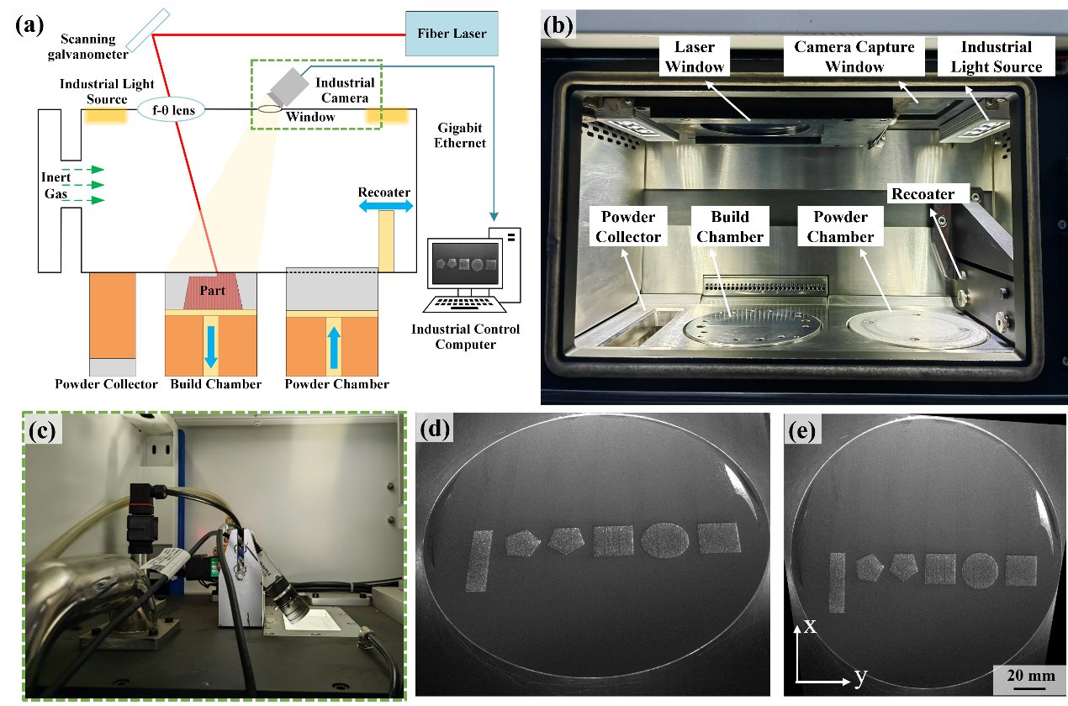
Fig. 1. Schematic of the LPBF machine, powder spreading anomaly detection system, and perspective-transformation technique: (a) powder spreading anomaly detection system and the position of the camera, (b) the chamber of the Avimetal-MT170H, (c) industrial camera A5131MG75, (d) original image, (e) perspective-transformed image.
Because the LPBF machine used in this study is not equipped with an industrial camera for powder spreading detection, a powder spreading anomaly detection system (PSADS) was developed for this research. The PSADS comprises a CMOS (complementary metal–oxide–semiconductor) industrial camera operating in the visual spectrum (IPAYPLE, China), equipped with an industrial light source and an industrial control computer (ICC) integrated with a powder spreading anomaly detection module (PSADM).
As shown in Fig. 1(c), the industrial camera was positioned externally above the chamber, capturing images via a telecentric view to avoid interference from the galvanometer and to allow for the monitoring of the entire powder bed. The image captured by the industrial camera was 1280 × 1024 pixels in size. The industrial light source was the one provided by the LPBF machine, mounted on both sides of the galvanometer. The ICC was used to collect and process data from the industrial camera, facilitating efficient machine control and monitoring. In the PSADS, the ICC serves as an essential intermediary between the LPBF machine and the industrial camera. The PSADM is integrated within the ICC and has three main functions. First, the PSADM connects to the LPBF device through the ICC. By receiving signals indicating the completion of the powder spreading and laser scanning processes, the PSADM can generate controlling signals for the industrial camera, capturing images of the post-spreading and post-scanning phases. Second, the PSADM can correct image distortions caused by the telecentric mount of the industrial camera using perspective-transformation techniques. The corrected images were approximately 767× 769 pixels in size, corresponding to a 170 × 170 mm area, as shown in Fig. 1(e). Third, the PSADM integrates the FFA-UNet++ to segment insufficient powder spreading types after image processing.

2.2. Materials and experimental details
The gas-atomized 316L stainless steel powder used in this study was supplied by Avimetal Additive Manufacturing Technology (Beijing, China). The chemical composition of the 316L powder is shown in Table 1. The morphology of the powder, shown in Fig. 2(a), was analyzed using an EM-30 Plus (COXEM, South Korea) scanning electron microscope (SEM). The particle size distribution was analyzed using a Bettersizer 2600 (Dandong, China), as shown in Fig. 2(b). The particle size of the 316L powder was determined within 15–53 μm, with D50 = 30.93 μm.
Table 1 Actual chemical composition of 316L powder used in the LPBF process.
Element | Fe | Cr | Ni | Mo | Mn | Si | C | S | P | O
Content (wt.%) | Bal. | 16.84 | 10.65 | 2.35 | 0.74 | 0.30 | 0.015 | 0.005 | 0.02 | 0.074
Two types of specimens were fabricated via LPBF in this study. The first type was designed to establish a dataset for models training; these specimens were designed to be varied in geometric shape, including square, rectangular, circular, polygonal, and triangular shapes. The second type was used to investigate the effect of insufficient powder layers on the microstructure of LPBF-fabricated 316L and their impact on the mechanical properties. Specially shaped specimens and tensile specimens, shown in Fig. 2(c), were included in the second type. To facilitate microstructure observation at the insufficient powder layers, an irregular 0.5 mm × 0.5 mm × 8 mm notch was created on one side of the specially shaped specimens. Since only one insufficient powder condition could be fabricated during each process, specimens were prepared in seven separate builds, ranging from one to six layers of insufficient powder, labeled #1–6. Specimens with sufficient powder were labeled #0 as the control specimens. Eight copies of tensile and specially shaped specimens were printed for each condition.
The specimens were fabricated using the optimal process parameters for 316L provided by MT170H, shown in Fig. 2(d). The substrate was preheated to 200°C to reduce the residual stress in the specimens [37], and a zigzag scanning strategy was used for specimen fabrication with a 67-degree rotation between the adjacent layers. The process parameters are shown in Table 2. The layer thickness was set to 30 μm, and the insufficient powder region was set at the center of the specimens. Taking the 3-layer insufficient powder specimen #3 as an example to illustrate the operation process, as shown in Fig. 2(e), after laser scanning of the nth layer, the powder supply rate was adjusted to 0%, and no powder was supplied to layers n + 1 to n + 3, simulating the condition of insufficient powder for three layers. As a result, remelting of layer n occurred when layers n + 1 to n + 3 were scanned. The powder supply rate was then adjusted to 200%, and powder spreading was completed for layer n + 4, with a layer thickness of 120 μm. The laser beam then scanned the powder bed, and normal printing continued until the end.
Table 2 LPBF process parameters used in specimen fabrication.
Parameter | Value
Power | 150 W
Scanning speed | 1000 mm/s
Hatch spacing | 80 μm
Layer thickness | 30 μm
Volume energy density | 62.5 J/mm³
Scanning strategy | ZigzagT67°
Specimens were cut from the substrate using an electrical discharge wire-cutting machine. The YOZ surfaces of the specially shaped specimens were ground and polished, and an optical microscope (OM) was used to analyze the effect of insufficient powder layers on the microstructure. Tensile tests were conducted at room temperature (25°C) using an E44.304 (MTS, China) electronic universal testing machine, with a strain rate of 1 mm/min. The original gauge length of the tensile specimens was 28 mm, and the loading direction was parallel to the specimens’ build directions. The tensile properties, including yield strength (YS), ultimate tensile strength (UTS), and elongation (EL), were obtained from analyzing the stress-strain curves. At least three specimens were tested to obtain the tensile properties and to minimize errors. The fracture morphology of the tensile specimens was examined using an SEM.
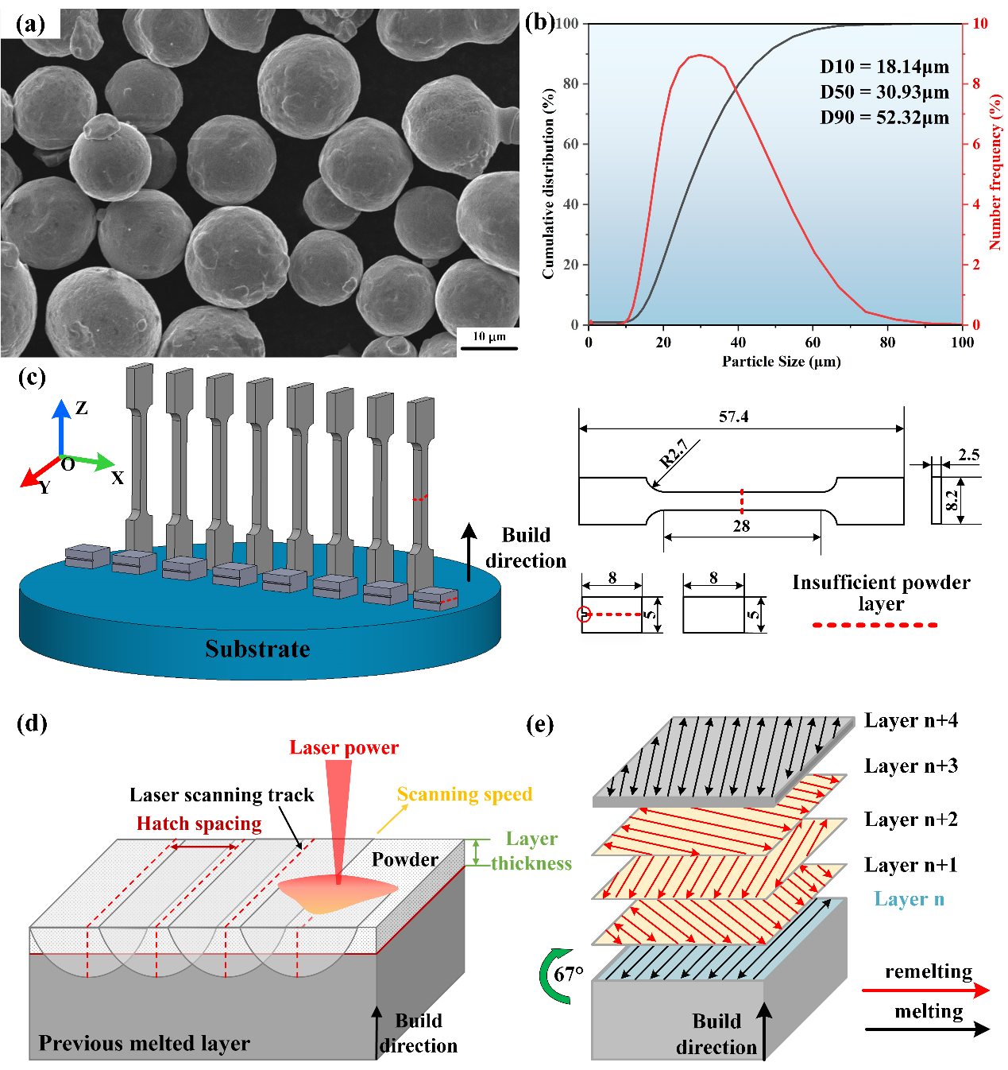
Fig. 2. Schematic of (a) SEM image of 316L powder; (b) powder particle size distribution chart; (c) tensile specimens and specially shaped specimens; (d) LPBF process parameters; (e) forming process illustration of insufficient powder supply for specimen #3 with three layers.

2.3. Dataset collection and description
The insufficient powder spreading dataset was divided into six categories for insufficient powder of 1–6 layers, labeled #1–6. During the printing process, different insufficient powder layer images were captured by adjusting the powder supply rates. Parts with various geometric shapes were fabricated to enhance the diversity of the dataset. Unlike the full-layer insufficient powder in tensile specimens and specially shaped specimens, the dataset collection was set up for localized insufficient powder supply to better reflect actual process fluctuations.
After capturing images of different categories, regions of interest (ROI) in the images were selected and cropped into slices. The original dataset contained 769 images. Pixel percentage of each category was analyzed, revealing a class imbalance which may have led the model to favor the dominant category. To address this issue, data augmentation was used to mitigate the sample class imbalance, as shown in Table 3. In this study, operations such as horizontal flipping, vertical flipping, and random rotation were applied to the original images to increase the proportion of smaller sample categories, as shown in Fig. 3(a). The augmented dataset contained 1,853 images. Data augmentation not only expanded the number of image samples but also significantly increased the diversity of the dataset. This approach allowed the deep learning model to learn more complex and discriminative features that could be generalized well to unseen data.
Table 3 Pixel distribution of ground truth for each category in the dataset.
 | background | #1 | #2 | #3 | #4 | #5 | #6
Original images | 77.39% | 11.90% | 3.57% | 3.10% | 2.31% | 1.27% | 0.46%
Augmented images | 83.03% | 5.90% | 3.40% | 3.04% | 2.40% | 1.56% | 0.67%
The augmented dataset was annotated using Labelme software to create “ground truth” labels for the insufficient powder areas. The dataset was categorized into two subsets: 85% for training and 15% for testing. Fig. 3(b) shows the annotation process for part of the images from layers 34 to 39. Based on the analysis of the LPBF process, a clear mapping relationship between the number of insufficient powder layers and the number of remelting occurrences was observed. Insufficient powder in layer 34 caused the uncovered part’s surface to undergo remelting during laser scanning, meaning remelting occurred in layer 34. If insufficient powder continued in layer 35, the part’s surface would undergo remelting again during laser scanning. As the number of insufficient powder layers increased, the number of remelting occurrences also increased, causing differences in surface morphology in terms of brightness uniformity and texture features. This study captured surface morphology changes from different remelting occurrences using an FFA-UNET++, thereby enabling the identification of the number of insufficient powder layers.
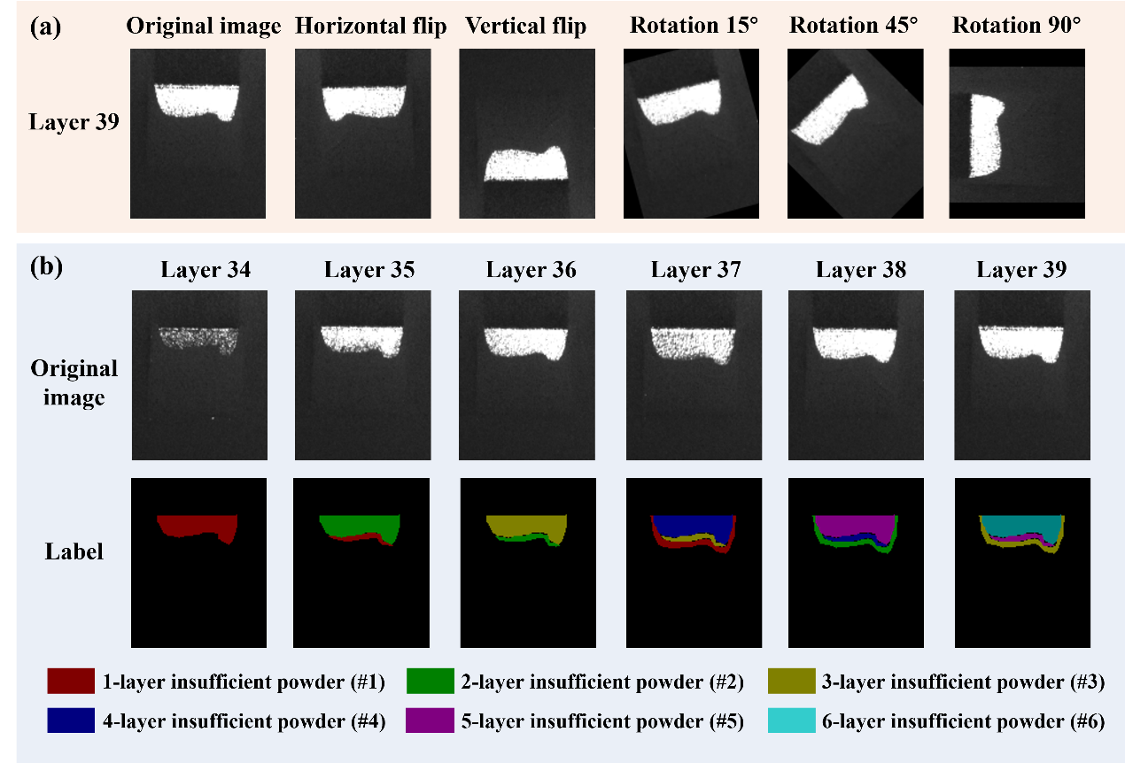
Fig. 3. Images and labels: (a) effects of different image data augmentations, (b) example of image acquisition and the annotation process for the case.

3. Deep learning–based semantic segmentation models
Inspired by the UNet++ network, this study proposes a novel structure known as Full-scale Feature Adaptive UNet++ (FFA-UNet++), which combines the advantages of UNet++ to effectively aggregates low-level details and high-level semantics from feature maps of different scales.

3.1. Overall network architecture
The structure of the FFA-UNet++ is shown in Fig. 4. The model’s core architecture includes the encoder layer, dense feature fusion layer (green nodes), and decoder layer. The encoder layer, which is represented as $X_{En}^{i,0},i∈\left[0,1,2,3,4\right]$, extracting features from the input images through stacked convolution modules and down-sampling operations. At the end of the encoder, the atrous spatial pyramid pooling (ASPP) module is introduced. The dense feature fusion layer, represented as $X_{FB}^{i,j},i∈\left[0,1,2\right],j∈\left[1,2,3\right]$, fuses feature information from different levels through dense skip connections (blue lines). The decoder layer, represented as $X_{De}^{i,j},i∈\left[0,1,2,3\right],j∈\left[1,2,3,4\right]$, gradually restores spatial resolution through up-sampling and feature concatenation, ultimately outputting high-precision segmentation results.
The original UNet++ primarily performs feature fusion through up-sampling and dense skip connections. This model incorporates a full-scale feature fusion (FFF) module, which introduces down-sampling operations in the dense feature fusion layers. This process reduces the size disparity of feature maps and enable the model to comprehensively handle multi-scale features.
Equation (1) introduces the accumulation of feature maps at each node. Let $x^{i,j}$represent the output of node $X^{i,j}$, where $i$ is the index along the encoder’s down-sampling layers and $j$ is the index along the skip path for the dense block convolution layers. The accumulation of feature maps is represented as$x^{i,j}$.
$$\begin{aligned}x^{i,j}=\left\{\begin{aligned}C_{En}\left(x^{i-1,j}\right), j=0 \\ C_{De}\left({\left[x^{i,k}\right]}_{k=0}^{j-1},u\left(x^{i+1,j-1}\right),d\left(x^{i-1,j}\right)\right), j>1 \\ C_{De}\left({\left[x^{i,k}\right]}_{k=0}^{j-1},u\left(C_{ASPP}\right),d\left(x^{i-1,j}\right)\right), j=1 \\ C_{FB}\left(\left[{\left[x^{i,k}\right]}_{k=0}^{j-1},u\left(x^{i+1,j-1}\right),d\left(x^{i-1,j}\right)\right]\right), j>0\end{aligned}\right.\#(1)\end{aligned}$$
In Equation (1), function $C\left(.\right)$denotes the convolution operation followed by the activation function, $u(.)$ represents the up-sampling layer, $d(.)$ represents the down-sampling layer, denotes the concatenation layer, and $C_{ASPP}$represents the convolution operation with the ASPP module. Fig. 4(b) demonstrates feature maps propagation via examples from Equation (1).
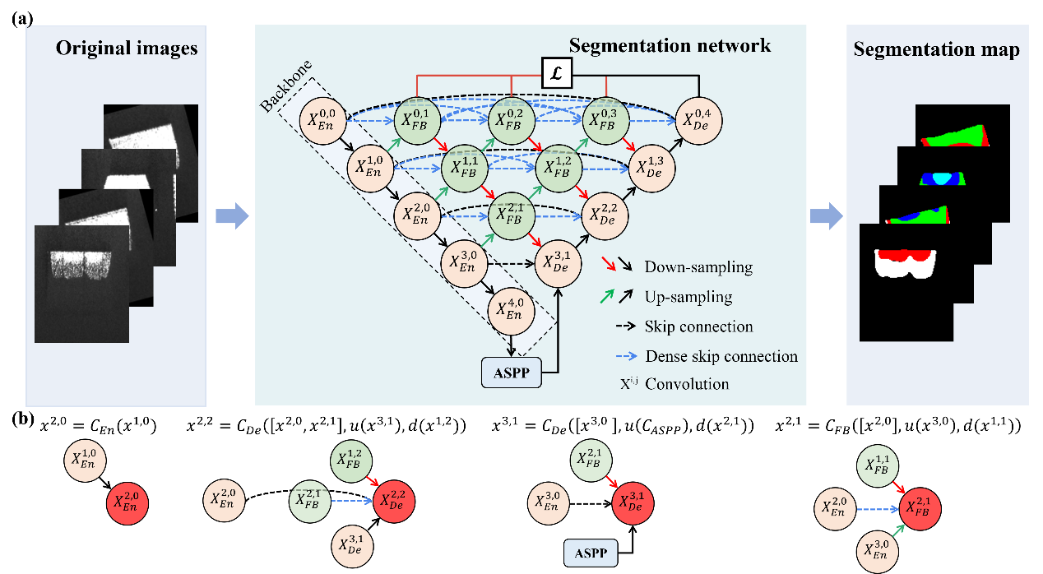
Fig. 4. FFA-UNet++ architecture feature map propagation: (a) FFA-UNet++ architecture, (b) the feature map propagation process of different nodes.

3.2. Atrous spatial pyramid pooling (ASPP) module
The bottom-most feature level $X_{En}^{4,0}$ is typically restored in resolution using conventional convolutions or simple up-sampling, which leads to insufficient resolution recovery of the low-level features in the original UNet++. To further enhance the network’s ability to model features at different scales, the ASPP module was introduced at the end of the encoder. As shown in Fig. 5, the module included 1 × 1 convolutions, multi-scale dilated convolutions (with varying dilation rates), a pooling pyramid, and other components. The core idea is to capture features with different receptive fields using dilated convolutions with varying dilation rates, enabling the parallel capture of multi-scale information. Global semantic information was then supplemented through global pooling and 1 × 1 convolutions. Finally, stacking and fusing these features improved the model’s robustness and accuracy in complex scenarios involving multi-layer insufficient powder.
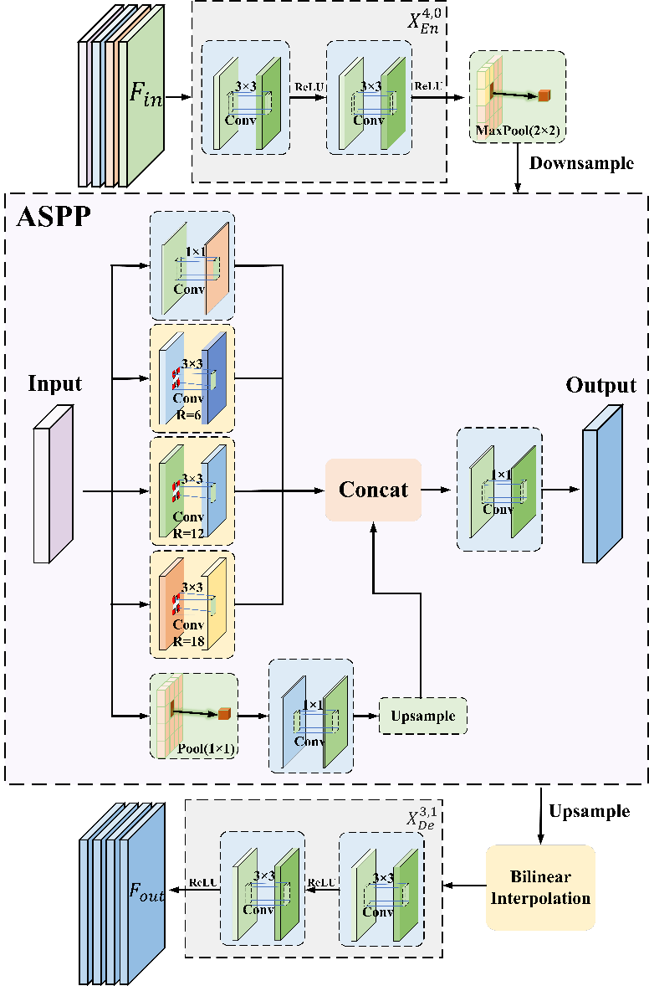
Fig. 5. Schematic diagram of the ASPP module structure.

3.3. Adaptive weighted feature fusion block
The dense feature fusion block in UNet++ uses conventional convolution operations. The fixed structure of these convolutions fails to fully capture the dependencies between multi-scale features and is unable to effectively fuse features from different levels. In this model, an adaptive weighted feature fusion block (FB module) is designed to replace the original feature fusion block. As illustrated in Fig. 6, the FB module employs a dual-gating mechanism—comprising the Dynamic Spatial Position Gated (DSPG) branch and the Global Channel Gated (GCG) branch. The adaptive weighting mechanism enhances feature fusion and improves the ability to focus on important features.

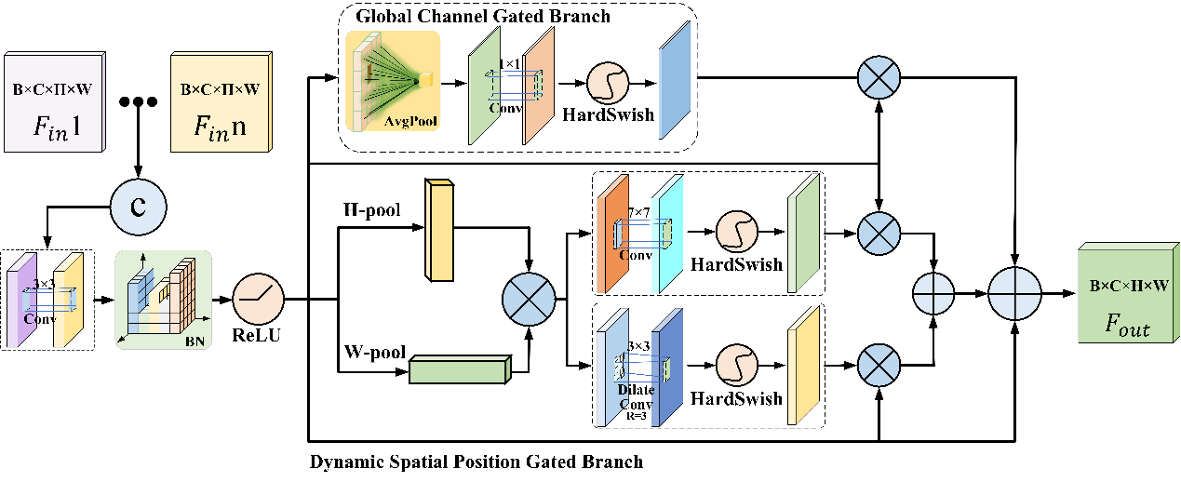
Fig. 6. Schematic diagram of the fusion block module structure.

3.3.1. Initial feature concatenation and fusion
The features that were input into the FB module were a series of multi-level context features. These feature maps were first concatenated to obtain $F_{concat}$, then underwent convolution, batch normalization (BN), and ReLU activation function operations for initial feature fusion.
$$\begin{aligned}F_{concat}=\left[F_{1},F_{2},…,F_{n}\right]\#(2)\end{aligned}$$
$$\begin{aligned}X=ReLU\left(BN\left(Conv3×3\left(F_{concat}\right)\right)\right)\#(3)\end{aligned}$$
In Equations (2) and (3), respectively, $F_{1},F_{2},…,F_{n}$ represent feature maps from different levels, and $X$ denotes the feature map after the initial concatenation and fusion.

3.3.2. Dynamic spatial position gated branch
Due to the continuous gradient variations at insufficient powder boundaries, the primary limitation of the traditional convolution operations is to effectively capture long-range spatial dependencies. To enhance the model’s perception of edge details, a cross-shaped pooling-based spatial gating mechanism was designed in the DSPG. Specifically, average pooling was applied to the feature map $X$ along the height ($H$) dimensions and width ($W$) dimensions separately, capturing direction-sensitive global semantic information. Next, an outer product operation was used to fuse the features from the height and width dimensions.
$$\begin{aligned}X_{h}=\frac{1}{H}\sum_{i=1}^{H}{X_{\left[:,:,i,:\right]} }\#\left(4\right)\end{aligned}$$
$$\begin{aligned}X_{w}=\frac{1}{W}\sum_{j=1}^{W}{X_{\left[:,:,:,j\right]}} \#\left(5\right)\end{aligned}$$
$$\begin{aligned}X_{hw}=X_{h}⊗X_{w} \#\left(6\right)\end{aligned}$$
In Equations (4-6), respectively, $X_{h}$ is the feature map pooled along the height dimension, $X_{w}$ is the feature map pooled along the width dimension, and $X_{hw}$ is the feature map after the outer product operation.
The proposed spatial gated weighting mechanism with multi-scale convolutional fusion is composed of a dual-branch collaborative structure, combining large-kernel convolution and dilated convolution. A 7 × 7 large-kernel convolution was applied to the input feature map $X_{hw}$ to capture spatial positional relationships and enhance spatial awareness. A 3 × 3 dilated convolution was introduced alongside the 7 × 7 convolution to further capture long-range spatial dependencies across regions. Finally, the outputs from the large-kernel convolution branch and the dilated convolution branch were combined with the original feature map $X$.
$$\begin{aligned}{sg}_{1}=HardSwish \left({Conv}_{7×7} \left(X_{hw}\right)\right) \#\left(7\right)\end{aligned}$$
$$\begin{aligned}{sg}_{2}=HardSwish \left({DilateConv}_{3×3} \left(X_{hw},r=3\right)\right) \#\left(8\right)\end{aligned}$$
$$\begin{aligned}Xsg={sg}_{1}⨀X+{sg}_{2}⨀X \#\left(9\right)\end{aligned}$$
In Equations (7-9), $⨀$denotes element-wise multiplication, $r$ represents the dilation rate, $sg$ represents the spatial gating weights, and $Xsg$ represents the final output feature map of the DSPG branch.

3.3.3. Global channel gated branch
The aim of GCG is to dynamically adjust the contribution weights of each channel, thereby enhancing task-relevant semantic features. First, the input feature map $X$ performed global average pooling (GAP) to capture the global information of the feature map. A 1 × 1 convolution was then applied to learn the complex dependencies, followed by HardSwish activation function to enhance the nonlinear representation of channel relationships, resulting in channel gating weights. Finally, these weights were combined with the original feature map $X$:
$$\begin{aligned}X_{GAP}=\frac{1}{H×W}\sum_{i=1}^{H}{\sum_{j=1}^{W}{X\left[:,:,i,j\right]}} \#\left(10\right)\end{aligned}$$
$$\begin{aligned}cg=HardSwish\left({Conv}_{1×1}\left(X_{GAP}\right)\right) \#\left(11\right)\end{aligned}$$
$$\begin{aligned}Xcg= cg ⨀X \#\left(12\right)\end{aligned}$$
where $cg$ represents the channel gating weights, $X$ is the input feature map, and $Xcg$ represents the final output feature map of the GCG branch.
DSPG performs dynamic feature weighting in the spatial dimension, effectively enhancing key information in space. GCG applies global gating weighting in the channel dimension to highlight the key channels. In the final output stage, the spatially gated enhanced feature $Xsg$, the channel-gated enhanced feature $Xcg$, and the original feature $X$ were fused, thus strengthening the key features while avoiding the excessive suppression of non-important features. The feature $Xout$ output by the FB module, as shown in Equation (13).
$$\begin{aligned}Xout=Xcg+ Xsg+X \#\left(13\right)\end{aligned}$$

3.4. Loss function
Benefiting from the deep supervision mechanism of the model, FFA-UNet++ generates full-resolution feature maps at multiple semantic levels, $\left\{x^{0,j},j∈\left\{1,2,3,4\right\}\right\}$ This paper employs a combination of weighted cross-entropy (WCE) and Dice coefficient as the loss function for each branch, with the weights for each category specified in Table 4. The combination helps mitigate the class imbalance, while encouraging the model to focus on the accuracy of segmentation boundaries, thus balancing classification accuracy and segmentation precision. This is described as follows:
$$\begin{aligned}L_{WCE}=-\frac{1}{N}\sum_{i=1}^{N}{\sum_{c=1}^{C}{{w_{c} y}_{i,c}}\log{{(p}_{i,c})} } \#\left(14\right)\end{aligned}$$
$$\begin{aligned}L_{Dice}=1-\frac{1}{C}\sum_{c=1}^{C}{\frac{2\sum_{i=1}^{N}{y_{i,c}p_{i,c}+ϵ}}{\sum_{i=1}^{N}{y_{i,c}+\sum_{i=1}^{N}{p_{i,c}}+ϵ}} } \#\left(15\right)\end{aligned}$$
$$\begin{aligned}L_{total}=L_{WCE}+L_{Dice} \#\left(16\right)\end{aligned}$$
$$\begin{aligned}L_{final}=\sum_{j=0}^{4}{L_{total}^{\left(j\right)}} \#\left(17\right)\end{aligned}$$
where $N$ denotes the total number of pixels in the image, $C$denotes the total number of classes, $w_{c}$ represents the weight for class $c$, $y_{i,c}∈\left\{0，1\right\}$ indicates the ground truth label of pixel $i$ for class $c$ (one-hot encoding), and $p_{i,c}$ represents the predicted probability of pixel $i$ belonging to class $c$.
Table 4 The weight configuration for each category.
 | background | #1 | #2 | #3 | #4 | #5 | #6
$$w_{c}$$ | 0.250 | 0.550 | 0.754 | 0.852 | 1.113 | 1.524 | 2.531

3.5. Model training and evaluation metrics
In semantic segmentation, various metrics are used to evaluate a model’s performance. The mean intersection over union (mIoU) refers to the average IoU across all classes, while intersection over union (IoU) measures the overlap between the predicted region and the ground truth region, providing a comprehensive reflection of the model's segmentation ability. The Dice coefficient is used to evaluate the overlap between the predicted segmentation area and the ground truth segmentation area. “Recall” refers to the proportion of true positives that are correctly predicted, measuring the model’s ability to identify true positives, while “precision” refers to the proportion of predicted true positives that are actually true positives, reflecting the reliability of the prediction results. The F1 score is the harmonic mean of precision and recall, balancing the performance of both. The evaluation metrics are as follows:
$$\begin{aligned}IoU=\frac{TP}{TP+FP+FN} \#\left(18\right)\end{aligned}$$
$$\begin{aligned}mIoU=\frac{1}{C}\sum_{c=1}^{C}{IoU_{c}} \#\left(19\right)\end{aligned}$$
$$\begin{aligned}Dice=\frac{2×\left|P∩G\right|}{\left|P\right|+\left|G\right|} \#\left(20\right)\end{aligned}$$
$$\begin{aligned}Recall=\frac{TP}{TP+FN} \#\left(21\right)\end{aligned}$$
$$\begin{aligned}Precision=\frac{TP}{TP+FP} \#\left(22\right)\end{aligned}$$
$$\begin{aligned}F1 Score=\frac{2×TP}{2×TP+FP+FN} \#\left(23\right)\end{aligned}$$
where $TP$ denotes true positive, $FP$ denotes false positive, $TN$ denotes true negative, $FN$ denotes false negative, $P$ represents the predicted region, $G$ represents the ground truth region, and $C$ denotes the number of classes.
In this study, the proposed network was trained and evaluated using the experimental setup and hyperparameters shown in Table 5. The model contains 127.19 M parameters, and the image resolution used for model training is 128 × 160 pixels. A single forward pass of the model requires 26.57 GFLOPs. With a batch size of 1, the inference time of the model is approximately 20 ms, excluding image preprocessing and data transfer processes.
Table 5 Experimental setup and hyperparameters.
Hyperparameters | Specifications
Environment | Windows 10
GPU | NVIDIA GeForce RTX 3070
Programming | PyTorch (Python 3.11.4)
Optimizer | SGD
Epochs | 100
Batch size | 4
Learning rate | 0.0001

4. Results and discussion

4.1. Comparative results with other models
To verify the comprehensive performance advantages of FFA-UNet++ in the insufficient powder spreading segmentation task, six mainstream segmentation models were selected in this study for comparison: DeepLabv3+ [38], SegFormer [39], TransUNet [40], SegNeXt [41], UNet++ [29], and UNet3+ [42]. All models adopt an encoder-decoder architecture and optimize segmentation performance for complex objects through a multi-scale feature fusion mechanism. All models were trained under the same experimental setup.
Figure 7(a) showed a comparative analysis of the global performance metrics across different models. FFA-UNet++ achieved the best results in all key metrics, improving by 3.479%, 4.173%, 4.038%, 3.633%, and 0.051 in recall, precision, F1, mIoU, and Dice, respectively, compared to the second-best model, UNet++. Figure 7(f) provided a detailed category-wise analysis based on the IoU, with the specific IoU values for each category listed in Table 6. All models performed well on 1-layer insufficient powder (#1), with IoU values above 80%. The FFA-UNet++ model achieved the highest IoU of 90.202%, indicating its sensitivity to significant brightness differences. As the number of insufficient powder layers increased, however, the IoU of all models showed a downward trend, and the IoU for six-layer insufficient powder (#6) generally falled below 20%. It was worth noting that FFA-UNet++ substantially outperformed the other models in categories #5 and #6, surpassing SegFormer by approximately 10%. However, the low values of IoU for #6 led to a decrease in overall segmentation accuracy. The main reason for this finding may be attributable to the more uniform brightness and texture features as the number of insufficient powder layers increased, which made it difficult for the algorithm to distinguish subtle differences between adjacent classes. The sample size for multi-layer insufficient powder was also relatively small, leading to a decline in segmentation performance.
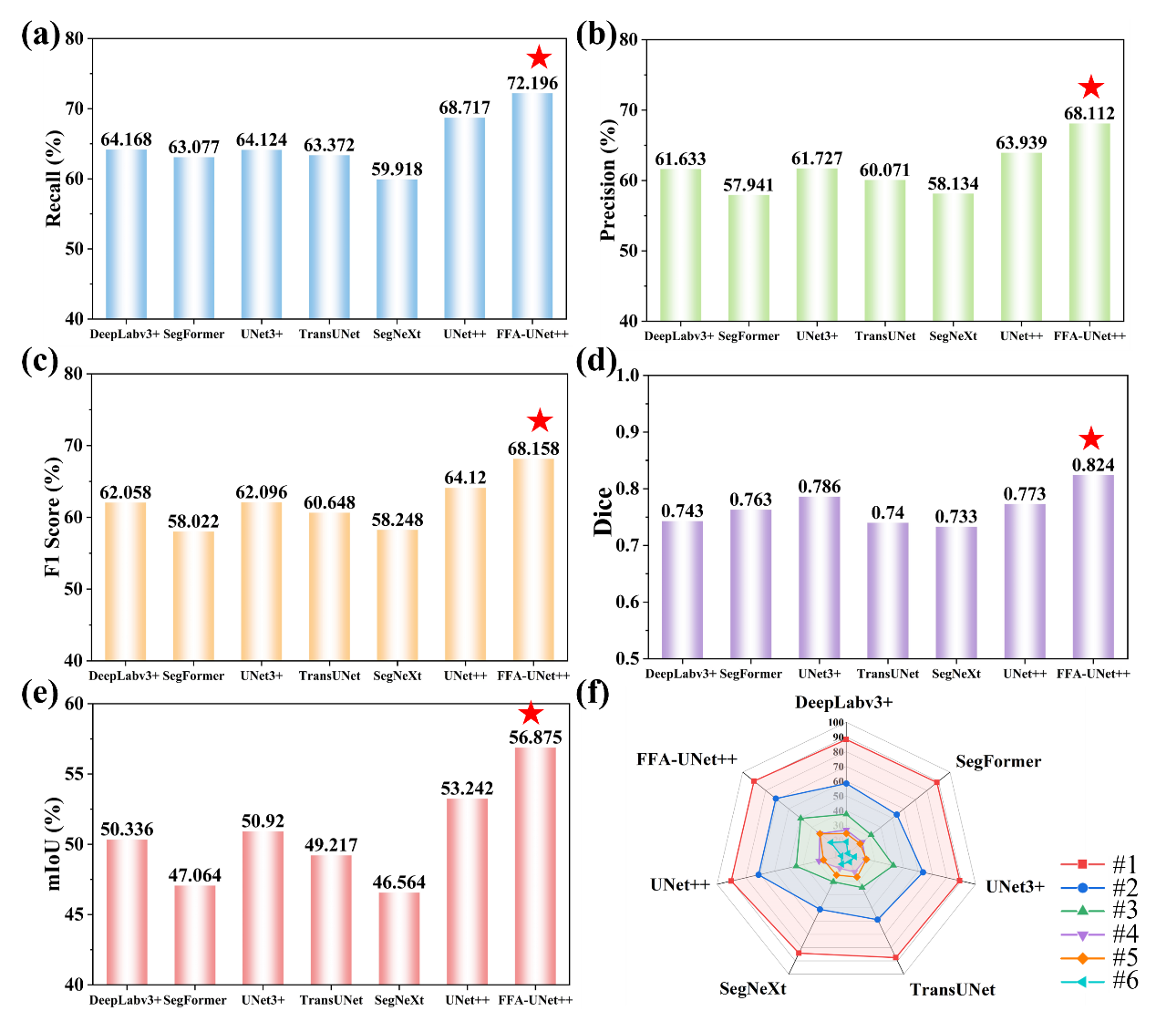
Fig. 7. Performance comparison of FFA-UNet++ and different deep learning models: (a) recall, (b) precision, (c) F1 score, (d) Dice, (e) mIoU, (f) comparison of IoU for each category between FFA-UNet++ and other models.
Fig. 8, which presents a visual comparison of FFA-UNet++ and the other six models on typical insufficient powder samples, demonstrates the advantages of FFA-UNet++. The results show that the proposed model achieved the highest accuracy in segmentation. For low insufficient powder layer counts, most models achieved precise segmentation. As the number of insufficient powder layers increased, however, the difficulty of detection also increased, and the misdetection rate of most algorithms rose significantly. In contrast, FFA-UNet++ improved segmentation accuracy in complex scenarios through its full-scale dynamic fusion mechanism and adaptive dual-gating weighting.

Table6 Comparison of IoU values for each category between FFA-UNet++ and different deep learning models.
Model | mIoU /% | IoU per category /%
Model | mIoU /% | Background | #1 | #2 | #3 | #4 | #5 | #6
DeepLabv3+ | 50.336 | 97.977 | 88.306 | 58.400 | 37.552 | 26.870 | 24.423 | 18.824
SegFormer | 47.064 | 98.031 | 88.721 | 53.815 | 31.570 | 23.802 | 21.998 | 11.513
TransUNet | 49.217 | 98.081 | 87.522 | 58.917 | 34.742 | 22.990 | 26.790 | 15.475
SegNeXt | 46.564 | 97.561 | 84.186 | 51.184 | 30.387 | 20.208 | 25.326 | 17.096
UNet3+ | 50.920 | 98.068 | 88.978 | 63.410 | 42.754 | 23.401 | 23.979 | 15.851
UNet++ | 53.242 | 98.175 | 90.150 | 71.115 | 44.834 | 29.068 | 25.878 | 13.476
FFA-UNet++ | 56.875 | 97.850 | 90.202 | 71.260 | 49.608 | 32.996 | 32.871 | 23.337
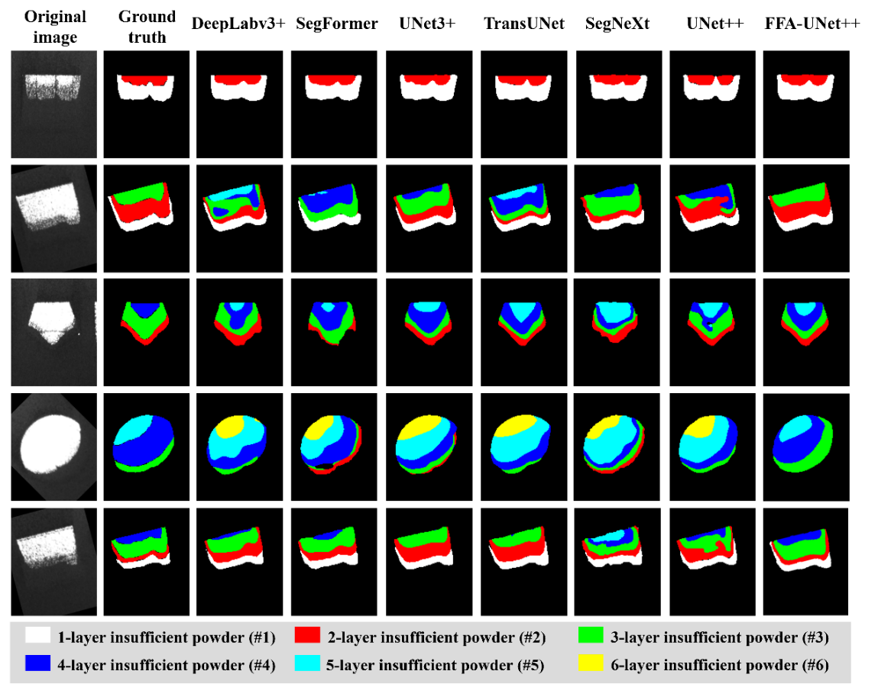
Fig. 8. Visualization comparison of segmentation results between FFA-UNet++ and other models.

4.2. Cross-Validation experiment
This study employed five-fold cross-validation to further verify the effectiveness of the FFA-UNet++. The dataset was partitioned into five subsets based on part geometry, with each subset containing a comparable number of samples. In each fold, one subset was sequentially used as the test set, while the remaining four sets were combined to train the model. Evaluating the model performance on each of the individual folds demonstrates the generalization of the proposed model. As shown in Table 7, the average mIoU obtained from cross-validation is 54.419%, which is close to the performance achieved on the original dataset. However, the model achieved the lowest result, with an mIoU of 52.595%, on polygonal parts. This is likely attributable to their complex structures, which may lead to insufficient feature learning.
Table7 Result of five-fold cross-validation.
Fold | Test set | mIoU /% | IoU per category /%
Fold | Test set | mIoU /% | Background | #1 | #2 | #3 | #4 | #5 | #6
1 | Square | 55.488 | 96.219 | 85.441 | 69.774 | 42.887 | 31.212 | 33.437 | 29.446
2 | Rectangular | 55.571 | 96.966 | 80.434 | 70.624 | 44.468 | 37.379 | 31.578 | 27.548
3 | Circular | 53.338 | 96.571 | 77.321 | 68.164 | 40.749 | 33.902 | 29.974 | 26.686
4 | Polygonal | 52.595 | 98.576 | 85.176 | 65.28 | 43.229 | 31.343 | 26.115 | 18.446
5 | Triangular | 55.103 | 98.532 | 84.280 | 67.844 | 41.014 | 33.964 | 32.271 | 27.818
Average | - | 54.419 | 97.373 | 82.530 | 68.337 | 42.469 | 33.560 | 30.675 | 25.989
- | Original | 56.875 | 97.850 | 90.202 | 71.260 | 49.608 | 32.996 | 32.871 | 23.337
In terms of per-class performance, the IoU for the dominant classes (#1-#3) decreased when evaluated on unseen geometries, reflecting a slight degradation in the model's segmentation capability for these classes when operating outside the original data distribution. In contrast, the accuracy for classes #4 and #5 remained largely consistent with the results on the original dataset. Notably, the average IoU for class #6 in cross-validation was 25.989%, which is higher than that on the original dataset. This phenomenon can be explained by the highest loss weight assigned to class #6 to mitigate class imbalance. This strategy has been more fully utilized within the cross-validation training sets, encouraging the model to learn more generalized features for this class and consequently improving its recognition performance on unseen geometries.

4.3. Confusion matrix
The confusion matrix [43] metric is commonly used to evaluate DL algorithms. For the segmentation task, the confusion matrix was used in the present work to compare the classifications made by FFA-UNet++ and UNet++ for each pixel with the ground truth classifications made by humans. Specifically, ground truth labels were generated through pixel-wise manual classification of 200 representative images. These ground truth classifications were then compared, pixel by pixel, with the classifications predicted by the algorithm. The images used to generate the confusion matrix were drawn from data not previously seen by the algorithm. As shown in Fig. 9, the values along the diagonal of the confusion matrix represent the proportion of correctly classified pixels by the model. Higher values indicate better model performance (with the ideal value being 100%). Diagonal values lower than 100% reflect the degree of misclassification for specific classes, indicating the model’s confusion between classes with similar features.
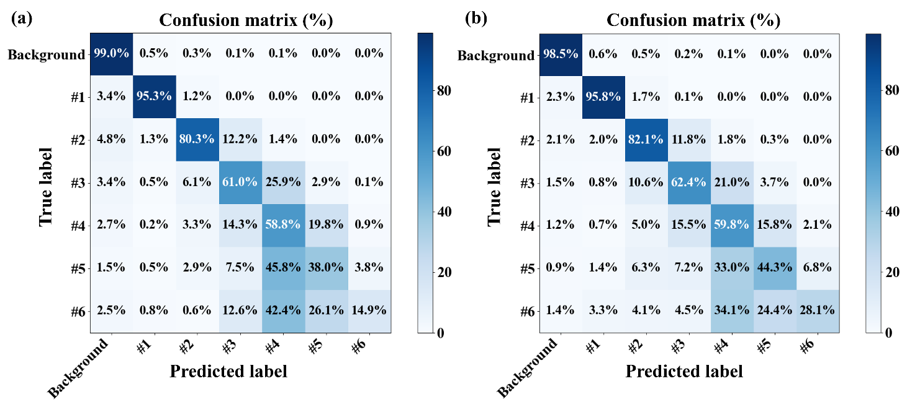
Fig. 9. Confusion matrices developed from the testing dataset: (a) UNet++, (b) FFA-UNet++
FFA-UNet++ outperformed UNet++ in classification accuracy for each class. As the number of insufficient powder layers increased (#1–6), the classification accuracy of both algorithms decreased, with #6 being the most difficult class to detect. FFA-UNet++ performed excellently in detecting classes #1–4, but the recognition accuracy for #5 (44.3%) and #6 (28.1%) still showed room for improvement. As shown in Fig. 8, the similarity in brightness and texture features between adjacent insufficient powder layers led to significant misclassification. Specifically, #4 was mainly misclassified as #3 (15.5% of misclassified samples) or #5 (15.8% of misclassified samples). Misclassifications of #5 were mostly categorized as #4 (33.0% of misclassified samples), while #6 was primarily misclassified as #4 (34.1% of misclassified samples) or #5 (24.4% of misclassified samples).

4.4. Ablation experiment
The proposed model consists of three key components: ASPP, FFF, and FB. To validate the contributions of the three modules introduced into FFA-UNet++, ablation experiments were conducted to compare the segmentation performance differences resulting from adding or removing different modules. To ensure the fairness and credibility of the ablation experiment, each model was trained five times, employing a different random seed. In every experiment, the same random seed was applied to all models. All models were trained under the identical experimental setup, as detailed in Table 5. Finally, the mean (μ) and standard deviation (σ) were calculated from the five experimental runs for each model.
Fig. 10 shows the performance under different module combinations, while Table 8 shows the values of the structure and performance metrics of each model. The results show that all three modules contributed varying degrees of improvement in the algorithm. The FB module improved mIoU, F1, and Dice by 1.936%, 2.819%, and 0.049 (respectively), validating that the dynamic spatial-channel gating mechanism not only enhanced global segmentation ability but also enabled fine-grained segmentation of complex remelting boundaries. The ASPP module improved mIoU and F1 by 1.382% and 1.465% (respectively), indicating that full-scale feature fusion significantly enhanced the model’s ability to portray the gradual feature changes of insufficient powder layers. The combined use of FB, FFF, and ASPP greatly improved the performance of the model in mIoU, F1, and Dice, making the values reach the maximum among the models tested in this study. This result indicates that the joint optimization of the three modules effectively alleviated the semantic confusion caused by multiple insufficient powder layers. Overall, the results of ablation experimentation showed that the three key components in FFA-UNet++ achieved a breakthrough in performance for the LPBF insufficient powder segmentation task.
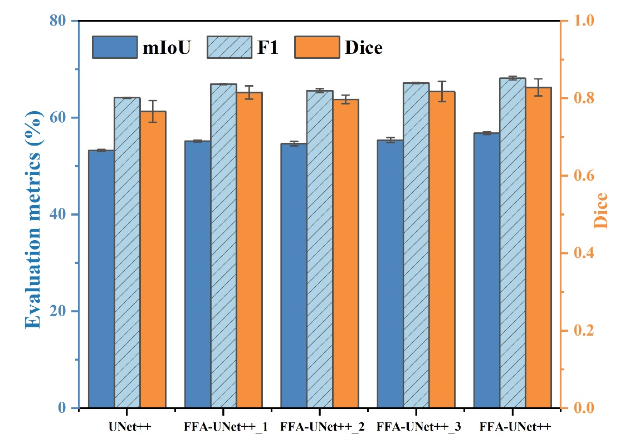
Fig. 10. Performance of each model in ablation experiments.
Table 8 Structure and performance metrics of each model.
Model | FB | ASPP | FFF | mIoU | F1 | Dice
UNet++ | × | × | × | 53.231±0.208 | 64.099±0.107 | 0.766±0.028
FFA-UNet++_1 | √ | × | × | 55.167±0.175 | 66.918±0.093 | 0.815±0.017
FFA-UNet++_2 | × | √ | × | 54.613±0.445 | 65.564±0.415 | 0.797±0.011
FFA-UNet++_3 | √ | √ | × | 55.348±0.528 | 67.132±0.095 | 0.817±0.026
FFA-UNet++ | √ | √ | √ | 56.784±0.278 | 68.153±0.395 | 0.828±0.022

4.5. Analysis of insufficient powder spreading
The impact of insufficient powder on the microstructure and mechanical properties of LPBF-fabricated 316L stainless steel was studied after identifying different insufficient powder layers through algorithms via metallographic analysis and tensile testing. An analysis of the correlation between defects and mechanical properties was also performed to determine the critical threshold for insufficient powder.

4.5.1. Microstructure
Fig. 11 illustrates the impact of the number of insufficient powder layers on the microstructure of LPBF-fabricated 316L. Fig. 11(a) represents the condition without insufficient powder (#0), where the structure was uniform and dense with no apparent gas porosity. Fig. 11(b–g) corresponds to the metallographic images of specimens with 1 to 6 insufficient powder layers (#1–#6). Little gas porosity appeared in specimens #1–3, while no instances of LOF were found. The main reason for this finding could be that the thickness of the powder caused by insufficient powder was low and could be compensated by thermal conduction from the previous fabricated layers and the melt pool penetration depth [44], which in general covers some of the insufficient powder areas and maintains metallurgical bonding between layers. LOF began to appear in the insufficient powder regions when the insufficient powder layer reached four. This behavior occurred because of continuous insufficient powder areas hindering the vertical transfer of heat. Owing to the self-healing characteristics [36] exhibited by the LOF, however, only a minimal amount of LOF was observed. For sample #5, LOF increased significantly due to the larger deposition layer thickness (150 μm) caused by insufficient powder. Since the LOF self-healing mechanism was still present, however, most of the LOF defects were discrete. In sample #6, LOF increased significantly both in size and quantity, and the LOF trend was to form strip-shaped irregular areas across layers. At this point, the LOF self-healing mechanism failed.
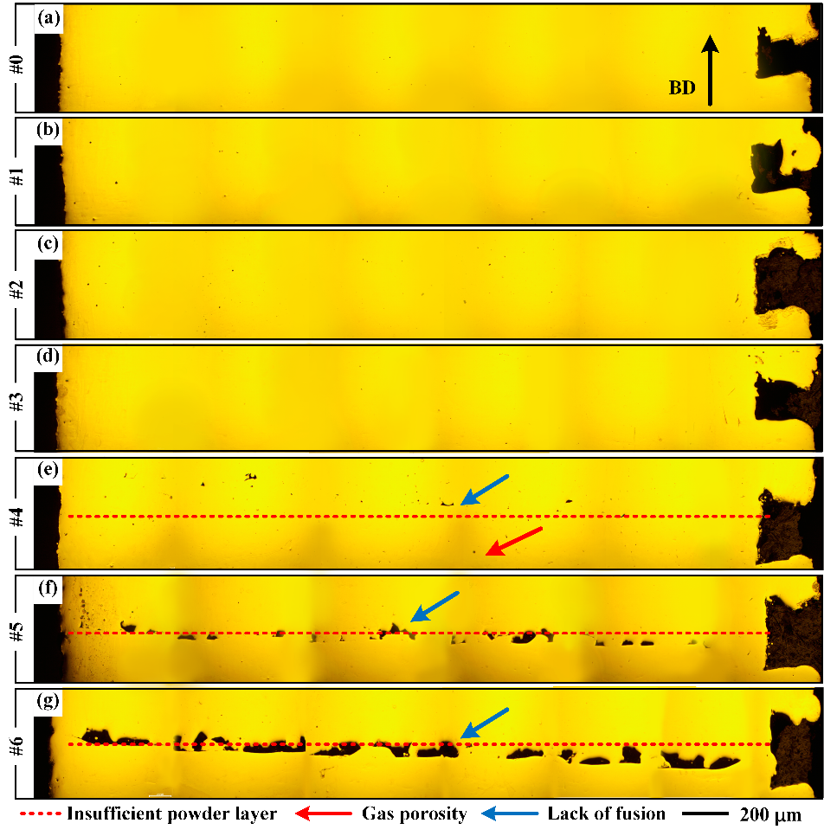
Fig. 11. Optical microscopy (OM) images of different numbers of insufficient powder layers: (a) without insufficient powder, (b-g) 1–6 layers (respectively).
Fig. 12(a) shows the forming process of #0. With appropriate laser energy input and the thermal conduction from the previous layer, each layer of powder was fully melted and uniformly manufactured, forming a dense structure. #0 had overlapping melt pool boundaries; the melt pool shape was semicircular, with a width of 140–170μm, and a depth of 75–95μm [45]. Fig. 12(b) shows the forming process of #6. Due to insufficient powder, the deposition layer thickness (180μm) exceeded the melt depth and the laser energy density decreased, causing the melt pool depth to shrink [46]. Due to insufficient laser energy penetration, the melt pool was unable to reach the fabricated parts in the lower layers [47,48]. The manufactured layer formed a thermal conduction barrier, preventing the heat from the already melted material in the lower layers from transferring to the upper layers. For 6-layer insufficient powder, the melt pool width was 145–175 μm, with a reduced melt depth [49] of 65–75μm.
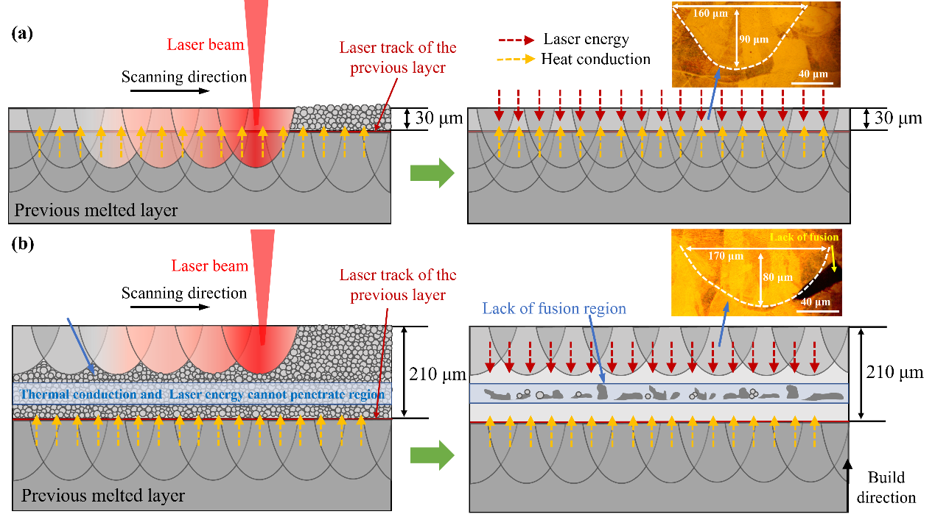
Fig. 12. Schematic diagrams of the LPBF process under different conditions for 316L: (a) forming without insufficient powder (#0), (b) lack of fusion with six layers of insufficient powder (#6).

4.5.2. Mechanical properties
Fig. 13 presents the room temperature tensile test results of 316L specimens with different numbers of insufficient powder layers. The insufficient powder layers exhibited a significant nonlinear impact on the mechanical properties. Specimen #0 exhibited excellent tensile performance, with YS, UTS, and EL values of 520 MPa, 570 MPa, and 70%, respectively. For specimens with 1 to 4 layers of insufficient powder (#1–#4), the tensile performance remains close to #0, with reductions in both YS and UTS not exceeding 5%, and the reduction in EL within 8%. For the specimen with 5-layer insufficient powder (#5), although the reductions in YS (504 MPa) and UTS (548 MPa) remain below 5%, the EL drops sharply to 44%. Specimen #5 showed accelerated fracturing after plastic deformation; it still exhibited some ductility but was clearly affected by insufficient powder. For the specimen with 6-layer of insufficient powder (#6), the tensile properties decrease significantly, with YS reduced to 440 MPa (a 15% decrease), UTS to 480 MPa (a 16% decrease), and EL to 10% (an 86% decrease).
Fig.13(a) shows the images from testing tensile specimens #0–6. As the figure shows, specimens #1–4 did not fracture in the insufficient powder regions, while specimens #5 and #6 did fracture in the insufficient powder regions. As the tensile properties show, the elongation significantly dropped when the insufficient powder layers reached 5, while the UTS and YS values dropped when the number reached 6. Therefore, tensile specimens #0, #4, #5, and #6 were selected for the use of fracture surface analysis according to the results of tensile testing, as shown in Fig. 14. The fracture surfaces of specimens #0 and #4 were uneven, and significant necking was found in both specimens, indicating substantial plastic deformation during tensile testing. The necking significantly lightened in specimen #5, with a flat central region and uneven edges. LOF areas with a few un-melted powders were also present. Specimen #6 displayed almost no necking, a flat fracture surface, no significant ductile features, abundant LOF, and many powder particles observed on the surface of the LOF.
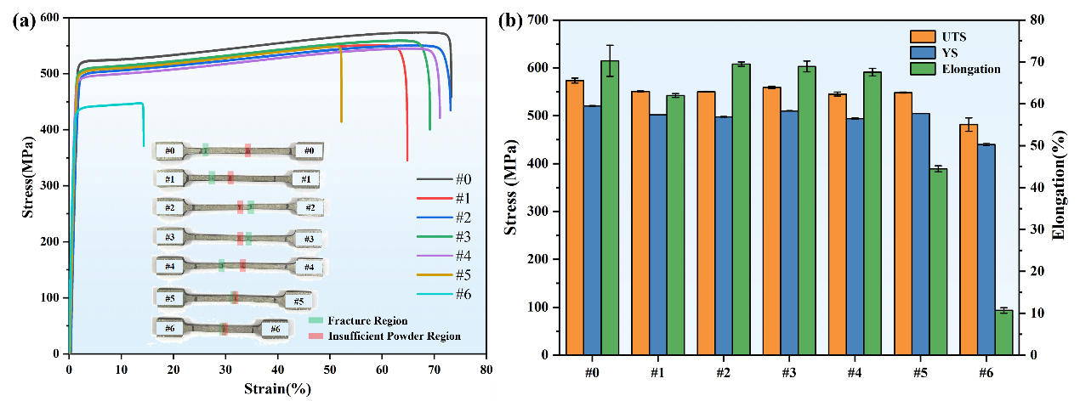
Fig. 13. Results of ambient temperature tensile testing of 316L specimens with different insufficient powder layers: (a) stress-strain curve and images of the tensile specimens. (b) statistics of yield strength (YS), ultimate tensile strength (UTS), and elongation of the tensile specimens
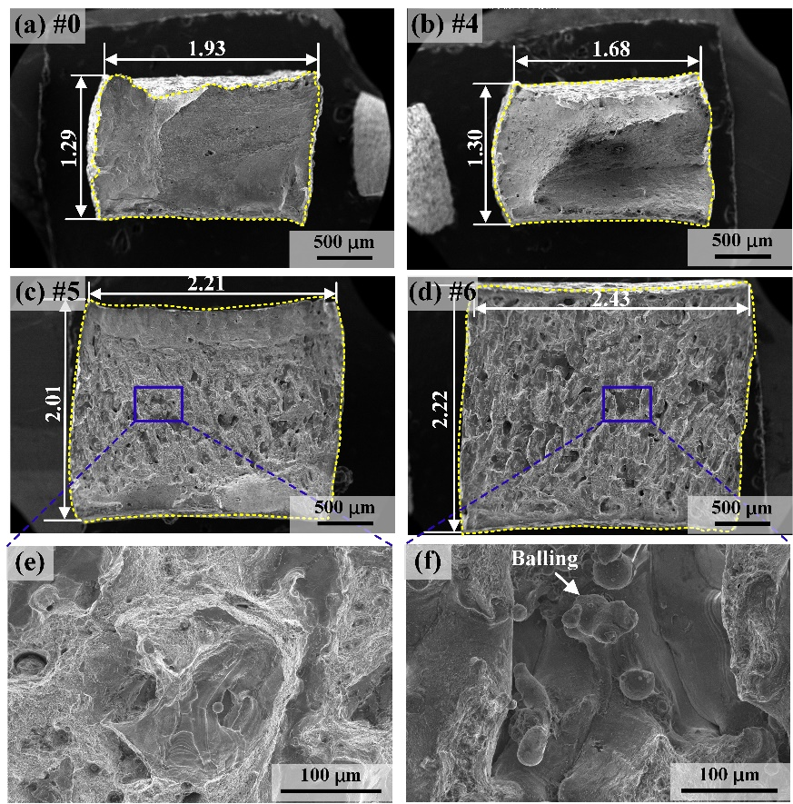
Fig. 14. SEM morphology of fracture surfaces of tensile specimens with different numbers of insufficient powder layers: (a-d) specimens #0, #4, #5, and #6 (respectively), (e) local magnification of (c), (f) local magnification of (d).

4.5.3. Defect–property correlations
To quantitatively study the impact of insufficient powder on mechanical properties, the porosity was statistically analyzed using ImageJ software, and the average values were obtained, as shown in Fig. 15(a). As the figure shows, with an increased number of insufficient powder layers, gas porosity exhibited a low-level stable distribution. In contrast, the LOF values showed a nonlinear increase. For specimens #1–3, LOF increased slowly. When the number of insufficient powder layers exceeded three, LOF sharply rose from 0.4% (#4) to 2.25% (#6). After three layers of insufficient powder, the LOF deviated from the linear trend, indicating that at this point, the thermal conduction and melt pool overlap mechanisms began to fail, resulting in a nonlinear surge in LOF. Therefore, 3-layer insufficient powder may be considered the critical threshold for the loss of energy transfer and interlayer bond stability.
The impact of LOF on mechanical properties is significantly greater than that of gas porosity, primarily due to the fundamental differences in stress concentration effects caused by their geometric shapes [50]. Gas pores are typically spherical or nearly spherical and have a small area, making it difficult to create significant stress concentrations under tensile loads, thus impeding crack initiation and propagation. In contrast, LOF offers irregular shapes, and during tensile testing, larger LOF defects act as stress concentrations. Cracks are more likely to initiate and propagate from these LOF defects, leading to specimen failure.
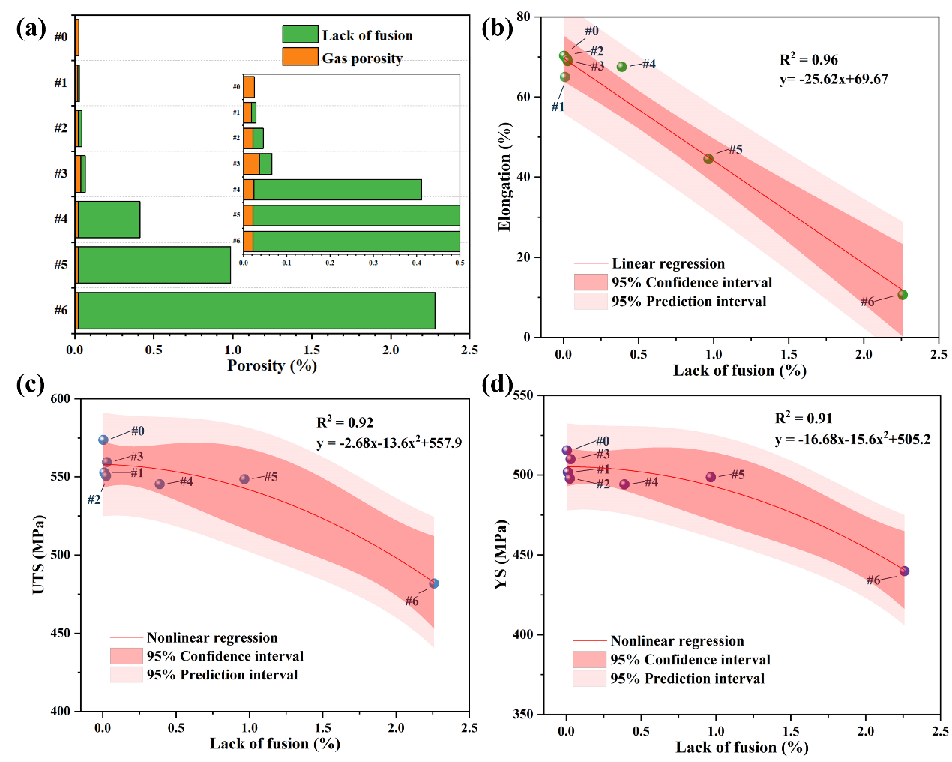
Fig. 15. Analysis of the correlation between porosity and tensile properties of LPBF 316L: (a) Variation of porosity with the number of insufficient powder layers, (b) Correlation between the number of insufficient powder layers, LOF and elongation, (c) Correlation between the number of insufficient powder layers, LOF and UTS, (d) Correlation between the number of insufficient powder layers, LOF and YS.
To investigate the relationship between LOF and tensile properties, regression analysis was conducted on LOF against UTS, EL, and YS, respectively, as shown in Fig. 15(b)-(d). The results demonstrate a strong correlation between LOF and tensile properties. For specimens #1-#3, the increase in LOF was slow, and the decrease in YS, UTS, and EL was all less than 5%. As illustrated in Fig. 15(b), there is a very strong negative correlation between LOF and EL. A ductility inflection point was observed between #4 and #5, indicating a transition in the ductility failure mechanism, which was consistent with the fracture surface analysis. Four-layer of insufficient powder was considered to the critical threshold for elongation failure.
As shown in Fig. 15(c)-(d), although there is a significant rise in LOF from #4 to #5, with #5 exhibiting a substantial amount of LOF, the reductions in YS and UTS were both less than 5%. This indicates that elongation is much more sensitive to the accumulation of LOF than YS and UTS [51-54]. This is because YS and UTS primarily represent the material's initial resistance to deformation and its maximum load-bearing capacity. Since the defects do not form through-channels, the specimen can still bear load. In contrast, EL is directly related to the material's uniform plastic deformation capacity. LOF defects act as stress concentration points, promoting the premature initiation of microcracks during the uniform plastic deformation stage, thereby drastically shortening this stage and causing a sharp decline in EL before a significant decrease in strength [55].
The sharp increase in LOF porosity from #5 to #6 coincided with a significant drop in performance. This finding occurred because, during #1 to #5, isolated defects reduced the load-bearing area only locally, whereas the through-thickness LOF in #6 drastically reduced the effective load-bearing area, resulting in abrupt drops in YS and UTS. Five-layer of insufficient powder could be considered the critical threshold for the failure of YS and UTS, which was further validated by the regression analysis.

5. Conclusions
This study has proposed a deep learning–based powder spreading anomaly detection system (PSADS) for LPBF that has successfully identified six types of insufficient powder spreading. The study also investigated the influence of insufficient powder layers on defect evolution and the mechanical properties of 316L stainless steel. The main conclusions are as follows:
1) A novel FFA-UNet++ architecture was developed, integrating the FFF, FB, and ASPP modules to effectively address challenges such as brightness, texture homogenization, and blurred boundaries in multi-layer insufficient powder regions. Utilizing a low-cost off-axis industrial camera, a six-class insufficient powder dataset was constructed. The model achieved mIoU values close to 57%, representing a 4%–11% improvement over six widely used segmentation models, with the highest IoU for a single class exceeding 90%.
2) The experimental results demonstrated that the number of insufficient powder layers had a nonlinear effect on LOF and tensile properties. With 1–3 layers of insufficient powder, no LOF was induced, and tensile performance remained comparable to the condition with no insufficient powder; at 4-layer insufficient powder, LOF appeared (area ratio < 0.5%), but tensile performance remained close to that of the non- insufficient powder condition; at 5-layer insufficient powder, abundant LOF formed, leading to a 37% drop in EL, while YS and UTS remained close to normal; at 6-layer insufficient powder, the LOF area surged to 2.25%, with YS, UTS, and EL dropping by 15%, 16%, and 86%, respectively.
3) The critical threshold for energy transfer and inter-layer bonding stability was found to be 3-layer insufficient powder; the ductility failure threshold was 4-layer insufficient powder, and the strength failure threshold was 5-layer insufficient powder. Based on these findings, for practical industrial applications, the cumulative number of insufficient powder layers in a single part should be controlled to within three layers.
This study focused on six types of insufficient powder spreading. However, other anomalies, such as recoater stripes, warping, and black spots, also occur during the LPBF printing process. Future research will investigate the intrinsic relationships between these anomalies, defects, and mechanical properties. Additionally, deep learning techniques will be employed to identify multiple anomalies, enabling the development of a closed-loop production process encompassing “detection–decision–action”.

CRediT authorship contribution statement
Min Zhu: Writing – original draft, Software, Formal analysis, Data curation, Investigation. Quanquan Han: Writing – review & editing, Funding acquisition, Conceptualization, Supervision, Resources. Zhenhua Zhang: Writing – review & editing, Investigation, Formal analysis. Defan Wu: Writing – review & editing. Peng Zhao: Writing – review & editing, Visualization. Xiaodan Wang: Software. Yue Liu: Methodology. Ze Ji: Writing – review & editing. Shoufeng Yang: Writing – review & editing.

Acknowledgments

The authors appreciate the financial support from the Shandong Provincial Natural Science Foundation (Grant No. ZR2022ZD08, ZR2023YQ053, ZR2022ME175).

References
[1] D. Gu, X. Shi, R. Poprawe, D.L. Bourell, R. Setchi, J. Zhu, Material-structure-performance integrated laser-metal additive manufacturing, Science 372(6545) (2021) eabg1487, https://doi.org/10.1126/science.abg1487.
[2] Y. Liang, Q. Han, Z. Sui, Z. Zhang, H. Zhang, H. Gu, D. Wu, L. Wang, H. Liu, R. Setchi, Laser powder bed fusion of high-strength crack-free al7075 alloy with the in-situ formation of TiB2/al3ti-reinforced phases and nucleation agents, Compos. Pt. B-Eng. 289 (2025) 111940, https://doi.org/10.1016/j.compositesb.2024.111940.
[3] Z. Zhang, Q. Han, Z. Liu, L. Wang, H. Zhang, P. Zhao, G. Zhu, C. Huang, R. Setchi, Cracking behaviour and its suppression mechanisms with TiB2 additions in the laser additive manufacturing of solid-solution-strengthened ni-based alloys, Compos. Pt. B-Eng. 266 (2023) 111023, https://doi.org/10.1016/j.compositesb.2023.111023.
[4] D. Wu, Q. Han, M. Wu, H. Zhang, Y. Wang, K. Lu, H. Fan, R. Setchi, Laser powder bed fusion of a composition-modified in738 alloy based on thermodynamic calculations, Mater. Sci. Eng. A-Struct. Mater. Prop. Microstruct. Process. 922 (2025) 147605, https://doi.org/10.1016/j.msea.2024.147605.
[5] B. Liu, G. Fang, L. Lei, X. Yan, Predicting the porosity defects in selective laser melting (SLM) by molten pool geometry, Int. J. Mech. Sci. 228 (2022) 107478, https://doi.org/10.1016/j.ijmecsci.2022.107478.
[6] G. Miao, W. Du, Z. Pei, C. Ma, A literature review on powder spreading in additive manufacturing, Addit. Manuf. 58 (2022) 103029, https://doi.org/10.1016/j.addma.2022.103029.
[7] L. Xiao, X. Xu, G. Feng, S. Li, W. Song, Z. Jiang, Compressive performance and energy absorption of additively manufactured metallic hybrid lattice structures, Int. J. Mech. Sci. 219 (2022) 107093, https://doi.org/10.1016/j.ijmecsci.2022.107093.
[8] W. Gao, Y. Zhang, D. Ramanujan, K. Ramani, Y. Chen, C.B. Williams, C.C.L. Wang, Y.C. Shin, S. Zhang, P.D. Zavattieri, The status, challenges, and future of additive manufacturing in engineering, Comput. Aided Des. 69 (2015) 65-89, https://doi.org/10.1016/j.cad.2015.04.001.
[9] J.P. Oliveira, A.D. Lalonde, J. Ma, Processing parameters in laser powder bed fusion metal additive manufacturing, Mater. Des. 193 (2020) 108762, https://doi.org/10.1016/j.matdes.2020.108762.
[10] S.R. Narasimharaju, W. Zeng, T.L. See, Z. Zhu, P. Scott, X. Jiang, S. Lou, A comprehensive review on laser powder bed fusion of steels: processing, microstructure, defects and control methods, mechanical properties, current challenges and future trends, J. Manuf. Process. 75 (2022) 375-414, https://doi.org/10.1016/j.jmapro.2021.12.033.
[11] Z. Snow, A.R. Nassar, E.W. Reutzel, Invited review article: review of the formation and impact of flaws in powder bed fusion additive manufacturing, Addit. Manuf. 36 (2020) 101457, https://doi.org/10.1016/j.addma.2020.101457.
[12] J. Fu, H. Li, X. Song, M.W. Fu, Multi-scale defects in powder-based additively manufactured metals and alloys, J. Mater. Sci. Technol. 122 (2022) 165-199, https://doi.org/10.1016/j.jmst.2022.02.015.
[13] X. Peng, S. Wu, W. Qian, J. Bao, Y. Hu, Z. Zhan, G. Guo, P.J. Withers, The potency of defects on fatigue of additively manufactured metals, Int. J. Mech. Sci. 221 (2022) 107185, https://doi.org/10.1016/j.ijmecsci.2022.107185.
[14] L. Chen, G. Bi, X. Yao, J. Su, C. Tan, W. Feng, M. Benakis, Y. Chew, S.K. Moon, In-situ process monitoring and adaptive quality enhancement in laser additive manufacturing: a critical review, J. Manuf. Syst. 74 (2024) 527-574, https://doi.org/10.1016/j.jmsy.2024.04.013.
[15] R. Mccann, M.A. Obeidi, C. Hughes, $\acute{\text{E}\text{.}}$ Mccarthy, D.S. Egan, R.K. Vijayaraghavan, A.M. Joshi, V. Acinas Garzon, D.P. Dowling, P.J. Mcnally, D. Brabazon, In-situ sensing, process monitoring and machine control in laser powder bed fusion: a review, Addit. Manuf. 45 (2021) 102058, https://doi.org/10.1016/j.addma.2021.102058.
[16] F.G. Fischer, M.G. Zimmermann, N. Praetzsch, C. Knaak, Monitoring of the powder bed quality in metal additive manufacturing using deep transfer learning, Mater. Des. 222 (2022) 111029, https://doi.org/10.1016/j.matdes.2022.111029.
[17] G. Chebil, D. Bettebghor, Y. Renollet, P. Lapouge, C. Davoine, M. Thomas, V. Favier, M. Schneider, Deep learning object detection for optical monitoring of spatters in l-PBF, J. Mater. Process. Technol. 319 (2023) 118063, https://doi.org/10.1016/j.jmatprotec.2023.118063.
[18] B. Bostan, S. Hinnebusch, D. Anderson, A.C. To, Accurate detection of local porosity in laser powder bed fusion through deep learning of physics-based in-situ infrared camera signatures, Addit. Manuf. 101 (2025) 104701, https://doi.org/10.1016/j.addma.2025.104701.
[19] Y. Wu, J. Fang, C. Wu, C. Li, G. Sun, Q. Li, Additively manufactured materials and structures: a state-of-the-art review on their mechanical characteristics and energy absorption, Int. J. Mech. Sci. 246 (2023) 108102, https://doi.org/10.1016/j.ijmecsci.2023.108102.
[20] W.L. Ng, G. Guo Liang, G.D. Goh, J. Ten, W.Y. Yeong, Progress and opportunities for machine learning in materials and processes of additive manufacturing, Adv. Mater. 36 (2024), https://doi.org/10.1002/adma.202310006.
[21] Y. Fu, A.R.J. Downey, L. Yuan, T. Zhang, A. Pratt, Y. Balogun, Machine learning algorithms for defect detection in metal laser-based additive manufacturing: a review, J. Manuf. Process. 75 (2022) 693-710, https://doi.org/10.1016/j.jmapro.2021.12.061.
[22] K. Li, R. Ma, Y. Qin, N. Gong, J. Wu, P. Wen, S. Tan, D.Z. Zhang, L.E. Murr, J. Luo, A review of the multi-dimensional application of machine learning to improve the integrated intelligence of laser powder bed fusion, J. Mater. Process. Technol. 318 (2023) 118032, https://doi.org/10.1016/j.jmatprotec.2023.118032.
[23] C. Schlegel, D.A. Molitor, C. Kubik, D.M. Martin, P. Groche, Tool wear segmentation in blanking processes with fully convolutional networks based digital image processing, J. Mater. Process. Technol. 324 (2024) 118270, https://doi.org/10.1016/j.jmatprotec.2023.118270.
[24] O. Ronneberger, P. Fischer, T. Brox, U-net: convolutional networks for biomedical image segmentation, in: N. Navab, J. Hornegger, W.M. Wells, A.F. Frangi (Eds.), Springer International Publishing, Cham, 2015, pp. 234-241.
[25] C. Wu, B. Wan, A. Entezari, J. Fang, Y. Xu, Q. Li, Machine learning-based design for additive manufacturing in biomedical engineering, Int. J. Mech. Sci. 266 (2024) 108828, https://doi.org/10.1016/j.ijmecsci.2023.108828.
[26] L. Scime, D. Siddel, S. Baird, V. Paquit, Layer-wise anomaly detection and classification for powder bed additive manufacturing processes: a machine-agnostic algorithm for real-time pixel-wise semantic segmentation, Addit. Manuf. 36 (2020) 101453, https://doi.org/10.1016/j.addma.2020.101453.
[27] Y. Zhang, L. Cheng, Z. Jiang, C. Ma, A. Zhang, Z. Chen, H. Du, C. Fang, D. Wang, In-situ visual monitoring for multi-scale defects detection in laser powder bed fusion, Addit. Manuf. 96 (2024) 104576, https://doi.org/10.1016/j.addma.2024.104576.
[28] C. Ma, D. Wang, K. Zhao, J. Gao, H. Wang, A. Zhang, L. Cheng, Y. Zhang, Layer-wise surface quality improvement in laser powder bed fusion through surface anomaly detection and control, Comput. Ind. Eng. 191 (2024) 110098, https://doi.org/10.1016/j.cie.2024.110098.
[29] Z. Zhou, M.M. Rahman Siddiquee, N. Tajbakhsh, J. Liang, UNet++: a nested u-net architecture for medical image segmentation, in: D. Stoyanov, Z. Taylor, G. Carneiro, T. Syeda-Mahmood, A. Martel, L. Maier-Hein, J.M.R.S. Tavares, A. Bradley, J.P. Papa, V. Belagiannis, J.C. Nascimento, Z. Lu, S. Conjeti, M. Moradi, H. Greenspan, A. Madabhushi (Eds.), Springer International Publishing, Cham, 2018, pp. 3-11.
[30] L. Qian, C. Wen, Y. Li, Z. Hu, X. Zhou, X. Xia, S. Kim, Multi-scale context UNet-like network with redesigned skip connections for medical image segmentation, Comput. Methods. Programs. Biomed. 243 (2024) 107885, https://doi.org/10.1016/j.cmpb.2023.107885.
[31] P. Shi., X. Xu., X. Fan., X. Yang., Y. Xin, LL-UNet++: UNet++ based nested skip connections network for low-light image enhancement, IEEE Trans. Comput. Imaging 10 (2024) 510-521, https://doi.org/10.1109/TCI.2024.3378091.
[32] B. Li, F. Wu, S. Liu, J. Tang, G. Li, M. Zhong, X. Guan, CA‐unet++: an improved structure for medical CT scanning based on the unet++ architecture, Int. J. Intell. Syst. 37 (2022), https://doi.org/10.1002/int.22969.
[33] Y Yi, H Wu, C Jia, H Jin, Influence of Interlayer Laser Remelting on Residual Stress During Forming Using Selective Laser Melting[J]. Chinese Journal of Lasers, 2023, 50(24): 2402302, https://doi.org/10.3788/CJL230743
[34] J. Karimi, C. Suryanarayana, I. Okulov, K.G. Prashanth, Selective laser melting of ti6al4v: effect of laser re-melting, Mater. Sci. Eng. A-Struct. Mater. Prop. Microstruct. Process. 805 (2021) 140558, https://doi.org/10.1016/j.msea.2020.140558.
[35] K. Wei, M. Lv, X. Zeng, Z. Xiao, G. Huang, M. Liu, J. Deng, Effect of laser remelting on deposition quality, residual stress, microstructure, and mechanical property of selective laser melting processed ti-5al-2.5sn alloy, Mater. Charact. 150 (2019) 67-77, https://doi.org/10.1016/j.matchar.2019.02.010.
[36] X. Chen, W. Liao, J. Yue, T. Liu, K. Zhang, J. Li, T. Yang, H. Liu, H. Wei, Unveiling the layer-wise dynamics of defect evolution in laser powder bed fusion: insights for in-situ monitoring and control, Addit. Manuf. 94 (2024) 104414, https://doi.org/10.1016/j.addma.2024.104414.
[37] W.L. Smith, J.D. Roehling, M. Strantza, R.K. Ganeriwala, A.S. Ashby, B. Vrancken, B. Clausen, G.M. Guss, D.W. Brown, J.T. Mckeown, M.R. Hill, M.J. Matthews, Residual stress analysis of in situ surface layer heating effects on laser powder bed fusion of 316l stainless steel, Addit. Manuf. 47 (2021) 102252, https://doi.org/10.1016/j.addma.2021.102252.
[38] Y. Liu, X. Bai, J. Wang, G. Li, J. Li, Z. Lv, Image semantic segmentation approach based on DeepLabV3 plus network with an attention mechanism, Eng. Appl. Artif. Intell. 127 (2024) 107260, https://doi.org/10.1016/j.engappai.2023.107260.
[39] E. Xie, W. Wang, Z. Yu, A. Anandkumar, J.M. Alvarez, P. Luo, SegFormer : simple and efficient design for semantic segmentation with transformers, ADVANCES IN NEURAL INFORMATION PROCESSING SYSTEMS 34 (NEURIPS 2021) 34 (2021) 14.
[40] J. Chen, Y. Lu, Q. Yu, X. Luo, E. Adeli, Y. Wang, L. Lu, A. Yuille, Y. Zhou, TransUNet: transformers make strong encoders for medical image segmentation, 2021.
[41] M. Guo, C. Lu, Q. Hou, Z. Liu, M. Cheng, S. Hu, SegNeXt : rethinking convolutional attention design for semantic segmentation, ADVANCES IN NEURAL INFORMATION PROCESSING SYSTEMS 35, NEURIPS 2022 (2022) 17.
[42] H. Huang., L. Lin., R. Tong., H. Hu., Q. Zhang., Y. Iwamoto., X. Han., W.W. Chen., J. Wu., UNet 3+: a full-scale connected UNet for medical image segmentation, in, ICASSP 2020 - 2020 IEEE International Conference on Acoustics, Speech and Signal Processing (ICASSP), 2020, pp. 1055-1059. https://doi.org/10.1109/ICASSP40776.2020.9053405.
[43] F.G. Fischer, M.G. Zimmermann, N. Praetzsch, C. Knaak, Monitoring of the powder bed quality in metal additive manufacturing using deep transfer learning, Mater. Des. 222 (2022) 111029, https://doi.org/10.1016/j.matdes.2022.111029.
[44] A.A. Tanrikulu, A. Ganesh-Ram, B. Farhang, A. Amerinatanzi, Unveiling the impact of layerwise laser preheating on microstructure and mechanical response in laser powder bed fusion, J. Mater. Sci. 58(45) (2023) 17362-17382, https://doi.org/10.1007/s10853-023-09066-2.
[45] M. Tang, P.C. Pistorius, J.L. Beuth, Prediction of lack-of-fusion porosity for powder bed fusion, Addit. Manuf. 14 (2017) 39-48, https://doi.org/10.1016/j.addma.2016.12.001.
[46] J. Fu, H. Li, X. Song, M.W. Fu, Multi-scale defects in powder-based additively manufactured metals and alloys, J. Mater. Sci. Technol. 122 (2022) 165-199, https://doi.org/10.1016/j.jmst.2022.02.015.
[47] W. Yan, W. Ge, Y. Qian, S. Lin, B. Zhou, W.K. Liu, F. Lin, G.J. Wagner, Multi-physics modeling of single/multiple-track defect mechanisms in electron beam selective melting, Acta Mater. 134 (2017) 324-333, https://doi.org/10.1016/j.actamat.2017.05.061.
[48] S. Mojumder, Z. Gan, Y. Li, A.A. Amin, W.K. Liu, Linking process parameters with lack-of-fusion porosity for laser powder bed fusion metal additive manufacturing, Addit. Manuf. 68 (2023) 103500, https://doi.org/10.1016/j.addma.2023.103500.
[49] F.L. Vecchiato, H. de Winton, P.A. Hooper, M.R. Wenman, Melt pool microstructure and morphology from single exposures in laser powder bed fusion of 316l stainless steel, Addit. Manuf. 36 (2020) 101401, https://doi.org/10.1016/j.addma.2020.101401.
[50] H. Gong, K. Rafi, H. Gu, G.D. Janaki Ram, T. Starr, B. Stucker, Influence of defects on mechanical properties of ti–6al–4v components produced by selective laser melting and electron beam melting, Mater. Des. 86 (2015) 545-554, https://doi.org/10.1016/j.matdes.2015.07.147.
[51] A.E. Wilson-Heid, A.M. Beese, Combined effects of porosity and stress state on the failure behavior of laser powder bed fusion stainless steel 316l, Addit. Manuf. 39 (2021) 101862, https://doi.org/10.1016/j.addma.2021.101862.
[52] T. Voisin, N.P. Calta, S.A. Khairallah, J. Forien, L. Balogh, R.W. Cunningham, A.D. Rollett, Y.M. Wang, Defects-dictated tensile properties of selective laser melted ti-6al-4v, Mater. Des. 158 (2018) 113-126, https://doi.org/10.1016/j.matdes.2018.08.004.
[53] M. Salarian, H. Asgari, M. Vlasea, Pore space characteristics and corresponding effect on tensile properties of inconel 625 fabricated via laser powder bed fusion, Mater. Sci. Eng. A-Struct. Mater. Prop. Microstruct. Process. 769 (2020) 138525, https://doi.org/10.1016/j.msea.2019.138525.
[54] A.E. Wilson-Heid, T.C. Novak, A.M. Beese, Characterization of the effects of internal pores on tensile properties of additively manufactured austenitic stainless steel 316l, Exp. Mech. 59(6) (2019) 793-804, https://doi.org/10.1007/s11340-018-00465-0.
[55] J. Rakhmonov, O. Rahman, S. Bahl, A. K. Ziabari, A. Plotkowski, A. Shyam, Creep ductility limiting mechanisms in an additively manufactured Al-Ce-Ni-Mn-Zr alloy, Addit. Manuf. 112 (2025) 104983, https://doi.org/10.1016/j.addma.2025.104983.

