Sand, Psychoanalysis and Visual Methodologies: Exploring Creative Techniques to Engage with Subjective Experiences of Marginalised Students in Higher Education

This paper focuses on a visual data production approach developed drawing on the world technique in which participants create three-dimensional scenes, pictures or abstract designs in a tray filled with sand and a range of miniature, realistic and fantasy, figures and everyday objects as part of a psychoanalytical therapy session. Although there have been objections to taking psychoanalysis outside of the clinical situation of the ‘consulting room’, the method proved useful in engaging participants at an affective level and the data production drew upon a psychoanalytical sensibility; which was psychoanalytically informed rather than psychoanalytical. Visual data production was facilitated on a one-to-one basis and participants were asked to talk through their visual sandbox scenes with the researcher. The elicitation process was characterised by a largely uninterrupted flow of talk with an attentive listener whose role it was to try and understand what is being said, so that the psychoanalytical paradigm became relevant and practical in the context of qualitative educational research. This paper argues that psychoanalytically informed techniques can be applied ethically and effectively as a research tool in qualitative inquiry; and open new windows to the subjectivities of marginalised students in Higher Education.

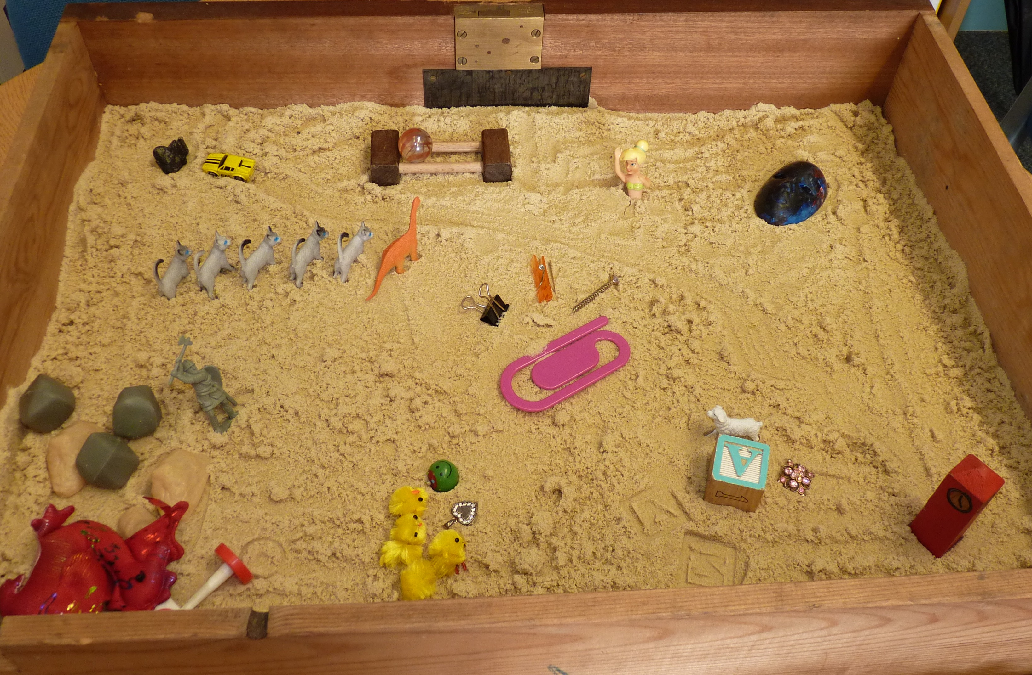
Dr Dawn Mannay and Victoria Edwards
Cardiff University, School of Social Sciences, Glamorgan Building, King Edward VII Avenue, Cardiff CF10 3WT, Wales, UK MannayDI@cardiff.ac.uk

