Covalently functionalized SWCNTs as tailored p-type dopants for perovskite solar cells
Tanja Miletić,†,# Eleonora Pavoni,§ Vanira Trifiletti,⊥ Aurora Rizzo,∥ Andrea Listorti,⊥,∥ Silvia Colella,*⊥,∥ Nicola Armaroli,*§ and Davide Bonifazi*†,#
†Department of Chemical and Pharmaceutical Sciences, INSTM UdR Trieste, University of Trieste, Piazzale Europa 1, 34127 Trieste, Italy
§Istituto per la Sintesi Organica e la Fotoreattività, Consiglio Nazionale delle Ricerche, Via Gobetti 101, 40129 Bologna, Italy, nicola.armaroli@isof.cnr.it
⊥Dipartimento di Matematica e Fisica “E. De Giorgi”, Università del Salento, Via per Arnesano, 73100 Lecce, Italy, silvia.colella@unisalento.it
∥Istituto di Nanotecnologia CNR-Nanotec, Polo di Nanotecnologia c/o Campus Ecotekne, via Monteroni, 73100 Lecce, Italy
#New address: Cardiff University, School of Chemistry, Main building, Park Place, CF10 3AT Cardiff, UK, bonifazid@cardiff.ac.uk

ABSTRACT: The covalent functionalization of (7, 6)-enriched single-walled carbon nanotubes (SWCNTs) with oligophenylenevinylene (OPV) moieties terminating with a dimethylamino group is proposed as an efficient way to enhance the affinity of CNTs with Spiro-MeOTAD in perovskite-based solar cells. The evidence of SWCNTs functionalization and the degree of OPV substitution on SWCNTs are established from TGA, XPS, TEM and Raman techniques. Our tailored doping materials display photovoltaic performances in line with conventional Li-doped spiro-MeOTAD system, showing at the same time a significantly improved chemical stability of the perovskite component over time. Furthermore, the comparison of the photovoltaic performances with those obtained with non-functionalized SWCNTs clearly suggest that the presence of the organic appends ensures highly reproducible PV performances. Our results demonstrate the suitability of this material as a valid doping agent for spiro-MeOTAD, representing a viable alternative to the conventional Li-salt.
KEYWORDS: photovoltaics, perovskite solar cells, SWCNTs, covalent functionalization, p-type doping, hole-transport materials, chemical stability.
INTRODUCTION
Organometal halide perovskites by virtue of exceptional optical and other physical properties are becoming prominent materials for several optoelectronic applications.¹ Facile processing enables low-cost manufacturing and makes them attractive for lasing, light-emitting and, particularly, photovoltaic (PV) applications,² with the latter having reached record efficiencies as high as 22.1%.^{3,4} Various PV device structures have been explored,^{5–11} differing for the morphological and structural properties of the perovskite material, which ultimately affect the PV performances.^{9,12–15} The conventional perovskite solar cell architecture has a sandwich-like design comprising a layer of hybrid halide perovskite, typically CH₃NH₃PbI₃, acting as light absorbing material between a semiconducting oxide and organic hole transporting material (HTM). The former, typically titanium dioxide (TiO₂), is deposited onto a conductive glass (fluorine-doped tin oxide, FTO) and acts as electron transporting layer, while the HTM extracts the generated holes from the active CH₃NH₃PbI₃ layer. The device is completed with the evaporation of a metal anode atop of the HTM.⁵ Among all the HTMs, Spiro-MeOTAD (2,2′,7,7′-Tetrakis(N,N-di-p-methoxyphenylamine)-9,9′-spirobifluorene) has been largely explored, leading to the best PV performances.^{16,17} However, this popular HTM exhibits low charge mobility and needs to be doped for being integrated in solar cells.¹⁸
The most common way to improve the hole mobility of Spiro-MeOTAD entails the partial oxidation by LiTFSI^{16,18,19} (lithium bis(trifluoromethanesulfonyl)imide) which promotes an oxidative reaction in the presence of O₂.^{20,21} However, this oxidation process is not easily controllable and the concentration variability of oxidized Spiro-MeOTAD is one of the major sources of instability and irreproducibility of the performance of the resulting devices.²² In order to overcome this limitation, alternative doping agents have been tried.^{23–27} Recently, due to their remarkable charge mobility^{28–30} properties and unique dual charge carrier ability,^{31–37} multi walled and single walled carbon nanotubes (MWCNTs and SWCNTs) have been integrated in perovskite solar cells as stand-alone hole transporting materials or as p-type dopants in P3HT, (Poly(3-hexylthiophene-2,5-diyl)) and Spiro-MeOTAD.^{38–44} As a further evolution of NTs as dopants for HTM, in this work we propose the chemical functionalization of enriched semiconducting (7,6)-SWCNTs as a versatile approach to enhance their physical and chemical affinity with the hosting matrix. Herein, we present the synthesis of a new class of functionalized SWCNTs (f-SWCNT), their photophysical properties in solution and their use as doping agents for spiro-MeOTAD in a flat perovskite solar cell geometry based on CH₃NH₃PbI₃. Our design concept encompasses the use of an oligophenylenevinylene (OPV) bearing alkoxy groups in the central ring and amine residues at the extremities (Figure 1a).
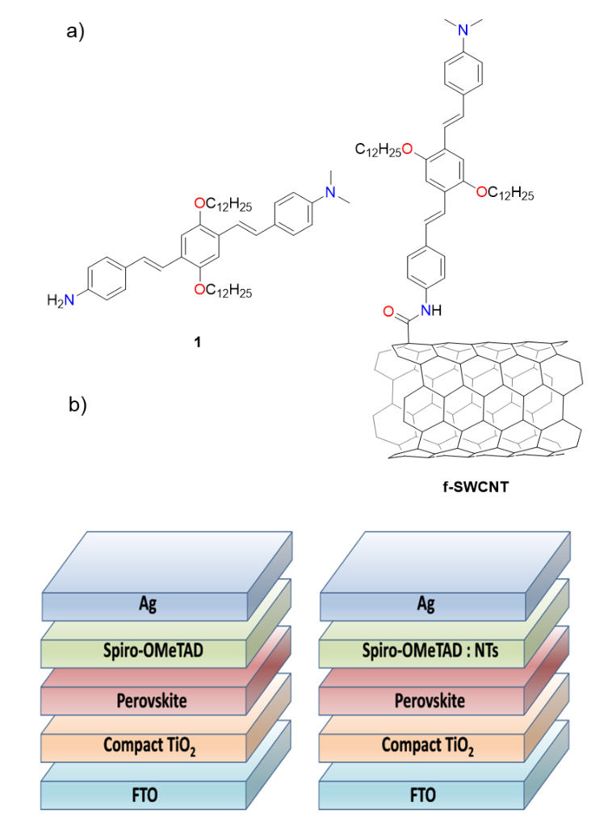
Figure 1. (a) Molecule 1 used for this study and OPV-decorated semiconducting SWCNTs enriched in (7, 6) chirality (f-SWCNT). (b) Sketch of photovoltaic devices.
These were chosen to improve the compatibility with spiro-MeOTAD relative to non-functionalized nanotubes (Ox-SWCNTs) and to enhance the affinity of the HTM mixture with the perovskite active layer at the interface, thanks to the presence of the polar amine moiety. To improve the electronic and structural properties of the materials, the SWCNTs are enriched in the chiral semiconducting (7,6) form and do not contain metallic tubes (see Supporting Information). This choice enhances the intrinsic quality of the doping material and favors the reproducibility of the observed electronic properties in solution and in the working devices. Our results show that the OPV functionalization prompts a better dispersion of SWCNTs within the HTM and affords highly reproducible PV activity. The validity of our approach for spiro-MeOTAD doping is validated by the fact that photoconversion efficiency achieved by SWCNT covalently functionalized with OPV as dopants is comparable with that of the standard doping and it overcomes the hygroscopicity of the Li-salt that dramatically affects the device lifetimes. The PV cell structure is schematized in Figure 1b.

RESULTS AND DISCUSSION
Synthesis. The synthesis of trimeric OPV 1 is outlined in Schemes S1 and S2 (Supporting Information) and it commenced with the preparation of phosphonate 4 following a protocol reported in the literature⁴⁵ (Scheme S1, Supporting Information). OPV 5⁴⁶ was synthesized through a Horner–Emmons–Wittig (HEW) coupling reaction^{47,48} of suitably para functionalized benzaldehyde (p-nitrobenzaldehyde) with diethylphosphonate 4 in the presence of t-BuONa in DMF in 63% yield. A selective mono-reduction reaction of the dinitro compound 5 in the presence of a NaS₂ aq. sol. gave amino-nitro derivative 6 in 80 % yield. The mono-reduction reaction was achieved following a reported procedure used for the preparation of similar π-extended conjugated chromophores.⁴⁹ The nitro-amino intermediate 6 was thus selectively protected by treatment with (CHO)_{n} and NaBH₃CN, in AcOH.⁵⁰ Final reduction of the nitro group of compound 7 with SnCl₂⁵¹ yielded desired amine 1 in 59 % yield (Scheme S2, Supporting Information). The trans-trans configuration of the double bonds in 1 was confirmed via ¹H-NMR spectroscopy (see Supporting Information). The presence of the dodecyloxy groups confers to compound 1 a good solubility in most of the common organic solvents. Target amine 1 was reacted with benzoyl chloride in the presence of Et₃N in acetone to prepare reference amido-compound 8 (Scheme S3, Supporting Information). All the synthesized compounds were characterized by ¹H- and ¹³C-NMR spectroscopy, IR and HRMS (Figures S1−S10, Supporting Information).
The preparation of OPV functionalized material f-SWCNT was accomplished by covalent attachment of the trimeric OPV 1 onto the surface of previously oxidized SWCNTs (7,6) by amidation reaction (Scheme 1). Ox-SWCNT were obtained by reaction of high purity pristine CoMoCat p-SWCNTs (7,6) with a 3:1 aq. solution of 3M H₂SO₄ : 3M HNO₃ at 80 °C for 2 h, following a modified protocol described in the literature.^{52–55} The resulting oxidized material was treated with SOCl₂ to give a SWCNT-acid chloride intermediate^{53,56} that was allowed to react with aminostyryl-N,N-dimethylaniline 1 in the presence of Et₃N in DMF, to give aminostyryl-N,N-dimethylaniline decorated SWCNTs enriched in (7,6) chirality (f-SWCNT). The OPV-SWCNT hybrid was characterized by UV-Vis-NIR spectroscopy, photoluminescence spectroscopy for chirality determination, thermogravimetric analysis (TGA), Raman spectroscopy, X-ray photoelectron spectroscopy (XPS) and transmission electron microscopy (TEM).
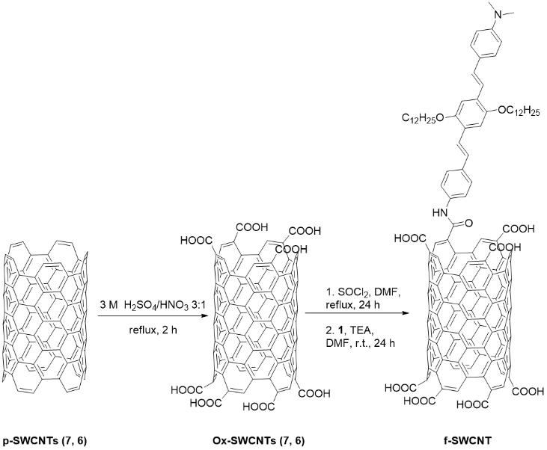
Scheme 1. Preparation of OPV-decorated SWCNTs (7,6) (f-SWCNT).
Characterization of the OPV functionalized SWCNT. The comparison of the TGA profiles of pristine and functionalized SWCNTs gave a first evidence of the sidewall functionalization of nanotubes (Figure S11, Supporting Information). The weight loss plots relative to p–SWCNTs and Ox–SWCNTs display the pyrolytic step of oxygenated functionalities in the range between 100 and ≈ 500 °C, with a weight loss of 4.5 % for Ox-SWCNTs with respect to p-SWCNTs (calculated at 500 °C). A mass content of 1000 µmol of –COOH per g of nanotube is estimated. An additional 5.0 % weight loss is observed for f-SWCNTs, resulting in one OPV moiety approximately every 914 carbon atoms, corresponding to 71 µmol of OPV per g of nanotube (see Supporting Information for calculating the functionalization degree).⁵⁷ Raman spectroscopy was used to confirm the SWCNTs functionalization (Figure S12 Supporting Information). The relative increase of the intensity of the D band is commonly used as a fingerprint to confirm the SWCNTs functionalization, as it reflects the rehybridization of the carbon atoms involved in the functionalization, suggesting the considerable alteration of the sp² carbon network.⁵⁸ The Raman spectrum of the Ox-SWCNT sample (λ_{exc}=532 nm) reveals an increased D band around 1330 cm⁻¹ (I_{D}/I_{G} = 0.21) in comparison to that of pristine SWCNTs, where the intensity of the defect band is very low (I_{D}/I_{G} = 0.086). The amidation reaction used for linking 1 onto the Ox-SWCNTs surface does not significantly modify the intensity of the D band (Figure S12, Supporting Information), where the I_{D}/I_{G} ratio for f-SWCNT is 0.22.
X-ray photoelectron spectroscopy (XPS) was performed to assess the surface composition of SWCNTs before and after functionalization. XPS studies show an increase of O content in the oxidized sample (9.27 at% for O 1s at 532.7 eV meaning a 2.52 at% with respect to p-SWCNTs). Compositional data obtained from the XPS analysis of SWCNTs are reported in Table 1 (Figures S13-S14, Supporting Information). As expected, the presence of dimethylamino derivative groups on the SWCNTs surface leads to the appearance of a N signature in the XPS spectrum of samples containing f-SWCNT (1.83 at % for N1s at 400.1 eV), supporting the idea for which the OPV 1 is linked to the SWCNT surface. This is in full agreement with the TGA results for f-SWCNT that show a weight-loss profile very similar to that of the OPV alone. Surprisingly, a small presence of N was also detected in the Ox-SWCNTs (0.54 at % for N1s at 400 eV), which can be attributed to the sulfo-nitric oxidation treatment.
Table 1. Compositional data obtained from the XPS analysis of the SWCNTs derivatives.
Sample | C at% | N at% | O at%
p-SWCNT (7,6) | 92.82±0.24 | - | 6.74 ±0.27
Ox-SWCNT (7,6) | 89.31±0.71 | 0.54±0.12 | 9.26±0.47
f-SWCNT | 86.73±0.45 | 1.83±0.22 | 8.00±0.42

Finally, visualization of p-, Ox- and f-SWCNTs was achieved by means of TEM analyses providing the most direct evidence that the soluble samples contain carbon nanotubes. The TEM images of a carbon-coated copper grid after the deposition of few drops of a 0.1 mg/mL dispersion of p-, Ox- and f-SWCNTs as well as of 1 in DMF are reported in the Supporting Information (Figures S15-S16, Supporting Information).
Spectroscopic characterization of SWCNTs enriched in (7,6). UV-Vis-NIR absorption and luminescence spectroscopy is the most powerful tool to identify the variety of semiconducting species occurring in samples of single walled carbon nanotubes, which are classified according to their (n,m) indices. In particular, photoluminescence mapping (PLM) provides emission spectra recorded as a function of the excitation wavelength and the resulting three-dimensional plot exhibits a distribution of spots representing the signals of specific (n,m) species.⁵⁹ Accordingly, our SWCNTs sample was investigated by recording the absorption spectra and the photoluminescence maps, so as to verify the enrichment in the (7,6) species (see Supporting Information). According to the literature,⁶⁰ SWCNTs (7,6) have two characteristic absorption features at 648 nm and 1120 nm, corresponding to the transitions E₂₂ and E₁₁ respectively. The experimental absorption spectrum (Figure S17, Supporting Information) clearly exhibits the peak at about 650 nm, while the weaker NIR transition is less evident, due to the overlapping with other species absorbing in the same region.⁴⁵ The PLM of the SWCNT sample (Figure S18, Supporting Information) shows some emission features with different intensity, the highest being found at λ_{exc} = 650 nm and λ_{em} = 1120 nm, which is unambiguously assigned to SWCNTs (7,6). In fact, the excitation wavelength corresponds to the E₂₂ transition while the emission maximum is centred at about 1120 nm, which corresponds to the lowest energy transition E₁₁.⁵⁹ The situation is completely different for SWCNTs which have undergone chemical treatment. Upon oxidation, the electronic features of SWCNTs (7,6) are substantially altered due to a rehybridization of the carbon atoms from sp² to sp³, leading to a loss of conjugation. Accordingly, the sample of oxidized-SWCNTs (7,6), dispersed in DMF, does not exhibit any luminescence.
Photophysical Properties of OPV-SWCNTs Derivatives. The electronic absorption spectra of 1 and f-SWCNT in DMF are reported in Figure 2 (molar extinction coefficients were assessed only for 1). The reference 1 exhibits two absorption maxima at 467 nm (ε = 57000 M⁻¹ cm⁻¹) and 381 nm (ε = 20000 M⁻¹ cm⁻¹). The absorption spectrum of f-SWCNT is featureless and it is not possible to single out the UV–Vis absorption bands of the reference OPV molecule, due to an overwhelming absorption of Ox-SWCNTs in the same spectral region. In addition, the absence of marked features of SWCNTs is ascribable to the oxidative functionalization, because the electronic structure of SWCNTs is increasingly modified by enhancing the presence of the defects onto the carbon scaffold.⁵³ Only at a low extent of covalent derivatization the E₁₁ and E₂₂ transitions can still be discerned.^{53,61,62}
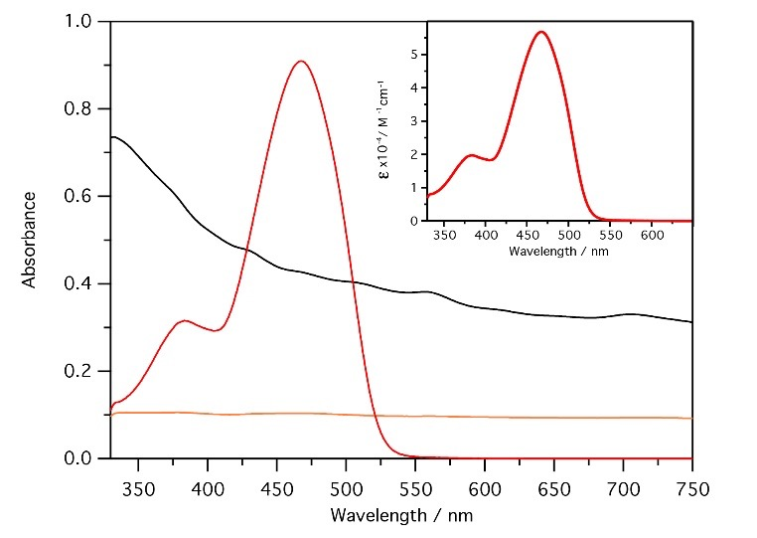
Figure 2. Absorption spectra of 1 (red), f-SWCNT (orange), Ox-SWCNT (black) in DMF. Inset: molar extinction coefficients of 1 in DMF.
In order to verify the presence of photoinduced processes between the carbon nanotube and the OPV-type moieties, luminescence studies were made for f-SWCNT (in DMF), in comparison with the related reference compound 1. Spectra are displayed in Figure 3 and key photophysical data are collected in Table 2. It has to be emphasized that, typically, photophysical studies of samples containing SWCNTs are affected by high uncertainty. In particular, it is not possible to determine absorbance values and, accordingly, to make quantitative luminescence assessments. This is due to: (i) the nanometric nature of the SWCNTs causing extensive light scattering and (ii) poor solubility in any medium and tendency to self-aggregate. However, f-SWCNT form stable and optically transparent dispersions in DMF, allowing comparative studies with the reference compound and quantitative luminescence assessments.
The reference compound 1 exhibits a relatively strong fluorescence band in the green region, with quantum yield (Φ_{FL}) of about 38%. Such emission is also detectable in the functionalized carbon nanomaterial, but it is strongly quenched in intensity (Table 2), indicating substantial electronic interactions between the nanotubes and the anchored organic conjugated moieties. This finding is in line with previous reports by Langa and co-workers, who reported strong chromophoric interactions of nanohorns and carbon nanotubes with oligo(thienylenevinylenes) moieties.^{63–65} The fluorescence decay profiles of 1 and f-SWCNT are fitted monoexponentially, yielding singlet lifetimes of 1.3 and 1.5 ns, respectively. The latter value suggests the presence of very small amounts of free 1 in the f-SWCNT sample. No shorter lifetimes were detected for f-SWCNT with the single photon counting spectrometer, which has a time resolution of 40 ps. Therefore, intercomponent photoinduced processes (energy or electron transfer) must take place at earlier times. Attempts to determine the quenched OPV lifetimes of f-SWCNT at shorter time scales with a streak camera apparatus (1 ps resolution) did not afford significant results, as the OPV moieties undergo photodegradation upon intensive irradiation with a Ti:Sa ultrafast laser.
Table 2. Luminescence band maxima, fluorescence quantum yields and excited state lifetimes of 1 and f-SWCNTs (in DMF).
Sample | λ_{max} (nm) | Φ (%) | τ (ns)
1 | 510 | 38.5 | 1.37
f-SWCNT | 530 | (a) | 1.51
^{(a)}Φ_{FL} of the hybrid material could not be determined as the light partitioning among the OPV and CNT moieties is not known. However, the quenching of the luminescence intensity of solution of f-SWCNTs vs 1 is above 99%. The excitation wavelengths used in these experiments correspond to the absorption maxima of 1 (467 nm).

Figure 3. Excitation spectra at λ_{em} = 520 nm (dashed line) and emission spectra at λ_{ex} = 350 nm (full line) of 1 (red) and f-SWCNT (orange) in DMF.
SWCNTs-doping of spiro-OMeTAD in CH₃NH₃PbI₃-based solar cell. Ox-SWCNTs and functionalized f-SWCNT dispersions in chlorobenzene (CB) have been used to prepare solutions of Spiro-MeOTAD to be employed as hole transporter in perovskite solar cells with a planar architecture FTO/TiO₂/perovskite/spiro-MeOTAD/Ag (sketch in Figure 1b). SWCNTs doped devices have been compared with undoped (HTM) and conventionally-doped devices with LiTFSI (HTM STD), having comparable spiro-MeOTAD thickness (~ 90 nm). Characteristic curves of best performing devices are shown in Figure 4, while the corresponding PV parameters with the statistical distribution of PCE are reported in Table 3.
Table 3. PV parameters for the best performing devices (average PCE in brackets, calculated on a statistical sample of minimum 11 cells).
 | PCE (%) | FF | V_{oc}  (V) | J_{sc}  (mA cm⁻²)
HTM | 7.1 (6.5±0.6) | 0.53 | 1.02 | 13.2
HTM + f-SWCNT | 9.6 (7.9±1.0) | 0.58 | 1.00 | 16.6
HTM + Ox-SWCNTs | 9.0 (6.4±2.1) | 0.52 | 0.97 | 17.7
HTM STD | 10.9 (9.8±1.1) | 0.65 | 1.03 | 16.4
A comparison between the performance obtained with the undoped HTM and both the SWCNT-doped materials highlights that the carbon doping significantly enhances the short-circuit current (16.6 and 17.7 mA/cm² for f-SWCNT and Ox-SWCNTs, respectively, versus 13.2 mA/cm² for HTM), resulting in a generally improved PCE with respect to the undoped system, likely due to a better charge extraction at the electrode thanks to the presence of the carbon nanotubes framework. A maximum PCE of 9.6% was achieved for f-SWCNT, with respect to 7.1% with the undoped spiro-MeOTAD. In order to unravel the role of the organic functionalization, we compared f-SWCNT with the non-functionalized Ox-SWCNT, both as doping agents of HTM. Devices including Ox-SWCNTs show lower performances, in average, and an extremely scattered PCE (6.4±2.1) with respect to the functionalized ones (7.9±1.0), which is attributed to a non-homogenous distribution of the nanotubes within the film. Furthermore, an improved FF (0.58) of f-SWCNTs, higher than both HTM (0.53) and Ox-SWCNTs (0.52), suggests and improved charge transport within the spiro-MeOTAD layer (standard deviations calculated for FF are reported in Table S1, Supporting Information). We calculate the series resistance (Rs) (Table S1) for the pristine spiro-MeOTAD and the differently doped HTM, and found that Rs reaches the lowest value for the standard doping with LiTFSI. However, the series resistance significantly decreases also for the SWCNTs doping with respect to the pristine spiro-OMeTAD, indicating an improvement of the overall charge transport properties of the doped HTM. Additionally, all the devices embedding doped HTM show similarly reduced hysteresis with respect to the undoped spiro-MeOTAD (Table S2, Supporting Information). Noticeably, the HTM doped with f-SWCNT allows the achievement of performances very close to the spiro-MeOTAD standard doping with LiTFSI (9.6% vs 10.9%), also in terms of statistical distribution (1.0 vs 1.1). Besides the comparable efficiency, the most relevant advantage conferred by the SWCNTs doping is the improved chemical stability of the perovskite material, with respect to the one underneath the Li-doped spiro-MeOTAD. We compare the effect of the two different dopings (NTs vs LiTFSI) on the stability of perovskite ﬁlms by exposing them continuously for 45 days to the environment (ambient air ≈ 70% relative humidity, room temperature = 25±1 °C).^{68,69} We monitored perovskite degradation by recording XRD spectra of the complete devices doped with NTs and with the standard Li salt (Figures 4b-c) and found that the perovskite active layer is severely damaged by moisture and by the possible migration of Li⁺ from the HTM (Figure 4b). The final products of the degradation process contain large amounts of PbI₂, as evidenced by the appearance of its characteristic (001) peak at 12.65° and the yellowish device color (inset Figure 4b). The intensity of MAPbI₃ main reﬂection at 14.1° is massively reduced after 45 days exposure. It can also be noticed the appearance of a broad background in the 2Ө window between 20 and 30°, ascribable to the evolution of the crystalline perovskite phase into an amorphous form. For the aged devices doped with f-SWCNTs, instead, the PbI₂ peak is significantly smaller and the perovskite XRD peaks maintain the same shape and intensity, indicating a negligible degree of decomposition. The improved moisture resistance combined to the comparable efficiency with the standard doping demonstrates the suitability of this material as a valid doping agent for spiro-MeOTAD, representing a viable alternative to the conventional Li-salt.

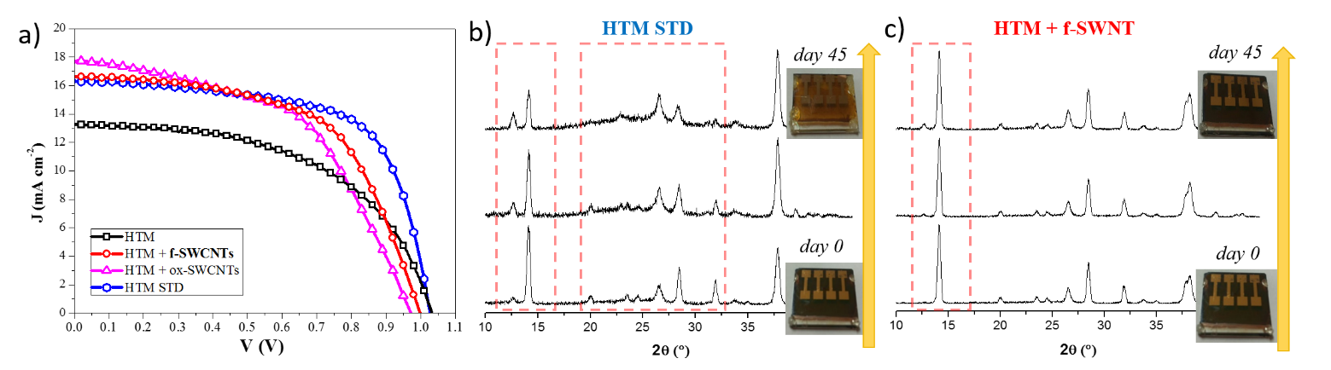
Figure 4. (a) Characteristic curves of the best performing devices; XRD patterns of (b) HTM STD and (c) HTM + f-SWCNT device from 0 to 45 days exposition at ambient conditions (rt, RH% = 70%). The combination of the (002)/(110) planes is found at ∼14.1° and that of the (004)/(220) planes at ∼28.4°. The other low-intense diffraction peaks at ∼ 23.5°, 31.9°, 40.5° and 43.20° are assigned to the (211), (312), (224) and (006)/(330) planes.¹⁴ Peaks at 26.5°, 33.8° and 37.9° are assigned to FTO.

The morphology of the hole transporting layers used for the solar cell fabrication was studied by means of Atomic Force Microscopy (AFM, Figure 5), which reasonably explains the performance of the cells. The pristine spiro-MeOTAD shows a very smooth and homogeneous morphology (Rq = 1.1 nm), whereas the LiTFSI doping induces the formation of big aggregates and pinholes in the film, due to the poor solubility of the Li-salt. Overall, the SWCNT doping increases the spiro-MeOTAD roughness, while keeping a homogeneous film morphology if compared to that of LiTFSI. The Ox-SWCNT and f-SWCNT doped samples show a roughness Rq of 2.6 and 2.2 nm respectively. Such a slight difference could be due to a more homogeneous dispersion of f-SWCNT in the spiro-MeOTAD matrix conferred by the organic chromophore. The photophysical characterization of the modified SWCNTs demonstrates that the derivatization strongly affects the excited state properties of the molecules. In fact, an efficient quenching of the SWCNT luminescence is recorded when OPVs terminals are introduced. On the other hand, the OPV insertion is necessary to enhance the solubility of the nanocarbon material and favor the interactions with the hosting hole transporting matrix. Notably, the perturbation of the SWCNT excited states does not affect the charge transport capability of the HTMs. In fact, unmodified SWCNT exhibit poorer performances when included in PV devices due to worst dispersion in spiro-MeOTAD. This result can be relevant for researchers working on the synthesis of new doping materials for HTMs, as it shows that the excited state behavior of such materials has little or no impact on the final HTM carrier mobility.
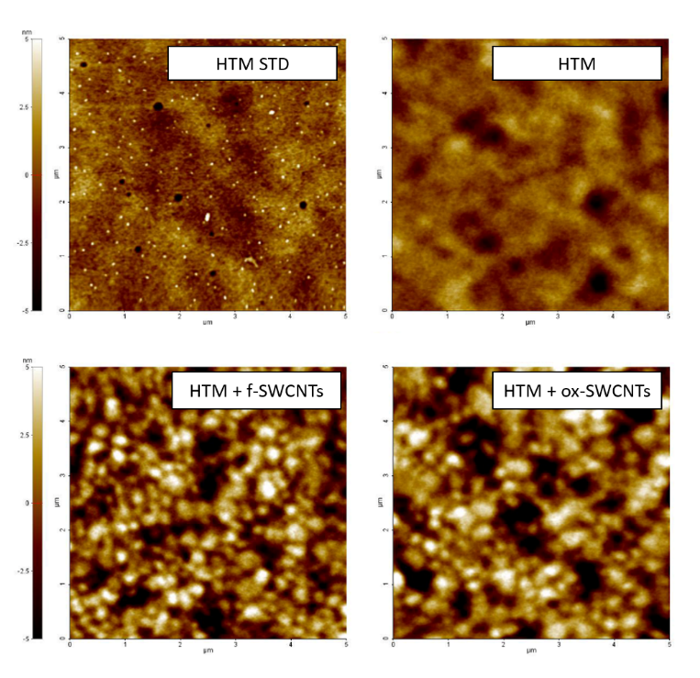
Figure 5. AFM characterization of the spiro-MeOTAD films.

CONCLUSIONS
Here we report on a new covalently functionalized SWCNT as dopant for spiro-MeOTAD to i) reduce the chemical instability of perovskite material embedded in the common perovskite solar cell configuration, bearing LiTFSI doped HTM; ii) enhance the affinity of CNTs with Spiro-MeOTAD. The selected material, (7,6)-enriched SWCNTs functionalized with oligophenylenevinylenes bearing alkoxy groups in the central ring and amine residues at the extremities, allows the fabrication of well performing and reproducible perovskite-based solar cells, with respect to the pristine SWCNT, the latter undergoing a large scattering of the PCE values. Noticeably, our results demonstrate a maximum PCE value of 9.6%, which is in line with the Li-doped spiro-MeOTAD system but significantly improved in terms of chemical stability of perovskite layer.
ASSOCIATED CONTENT
Supporting Information
Technical and experimental details along with all the synthetic procedures. Device fabrication and characterization and morphological and structural analyses. This material is available free of charge via the Internet at http://pubs.acs.org.
AUTHOR INFORMATION
Corresponding Author
silvia.colella@unisalento.it
nicola.armaroli@isof.cnr.it
bonifazid@cardiff.ac.uk

Author Contributions
T.M. performed all the synthesis and prepared all the materials for the different studies. E.P. performed all the photophysical studies in solution. The fabrication and characterization of the flat perovskite solar cell based on f-SWCNTs-doped spiro-MeOTAD and the XRD characterization has been performed by V.T., A.R. A.L and S.C. S.C., N.A. and D.B. programmed, designed and coordinated all the scientific activities and wrote the paper through contributions of all authors. All authors have given approval to the final version of the manuscript.

Notes
The authors declare no competing financial interest.

ACKNOWLEDGMENT
This work was supported by the Italian Ministry of Research (MIUR) (FIRB Futuro in Ricerca SUPRACARBON, Contract No. RBFR10DAK6; PRIN 2010 INFOCHEM, Contract No. CX2TLM), the Consiglio Nazionale delle Ricerche (CNR) (Progetto Bandiera N-CHEM, Bilateral Project CNR-CONICET). Also, we acknowledge Progetto di ricerca PON R&C 2007-2013 (Avviso n. 713/Ric. del 29 ottobre 2010) MAAT-Molecular NAnotechnology for HeAlth and EnvironmenT (Project Number: PON02_00563_3316357). AR gratefully acknowledges SIR project “Two-Dimensional Colloidal Metal Dichalcogenides based Energy-Conversion Photovoltaics” (project number RBSI14FYVD, ‘2D ECO’) for funding. SC and AL acknowledge Regione Puglia and ARTI for founding FIR - future in research projects “PeroFlex” project no. LSBC6N4 and” HyLight” project no. GOWMB21. TM thanks Dr. Agnieszka Gajewska for the help with TEM images acquisition. Moreover, Dr. Riccardo Marega is kindly acknowledged for the help with the TEM imaging and XPS analyses and Dr. Barbara Ventura (ISOF-CNR) for the attempts to determine the time resolved emission behavior of the CNT hybrid with a fs laser system. The Authors acknowledge Denis Dundović for the artwork used in the TOC figure.
REFERENCES
(1) Stranks, S. D.; Snaith, H. J. Metal-Halide Perovskites for Photovoltaicand Light-Emitting Devices. Nat. Nanotechnol. 2015, 10, 391–402.
(2) Green, M. A.; Emery, K.; Hishikawa, Y.; Warta, W.; Dunlop, E. D. Solar Cell Efficiency Tables (Version 47). Prog. Photovolt: Res. Appl. 2016, 24, 3–11.
(3) Zhang, W.; Eperon, G. E.; Snaith, H. J. Metal Halide Perovskites for Energy Applications. Nat. Energy 2016, 16048.
(4) NREL. Best Research-Cell Efficiencies. http://www.nrel.gov/ncpv/images/efficiency_chart.jpg (accessed Jul 10, 2016)
(5) Salim, T.; Sun, S.; Abe, Y.; Krishna, A.; Grimsdale, A. C.; Lam, Y. M. Perovskite-Based Solar Cells: Impact of Morphology and Device Architecture on Device Performance. J. Mater. Chem. A 2015, 3, 8943–8969.
(6) Burschka, J.; Pellet, N.; Moon, S. J.; Humphry-Baker, R.; Gao, P.; Nazeeruddin, M. K.; Grätzel, M. Sequential Deposition as a Route to High-Performance Perovskite-Sensitized Solar Cells. Nature 2013, 499, 316–319.
(7) Zhang, W.; Saliba, M.; Moore, D. T.; Pathak, S. K.; Hörantner, M. T.; Stergiopoulos, T.; Stranks, S. D.; Eperon, G. E.; Alexander-Webber, J. A.; Abate, A.; Sadhanala, A.; Yao, S.; Chen, Y.; Friend, R. H.; Estroff, L. A.; Wiesner, U.; Snaith, H. J. Ultrasmooth Organic–inorganic Perovskite Thin-Film Formation and Crystallization for Efficient Planar Heterojunction Solar Cells. Nat. Commun. 2015, 6, 1–10.
(8) Chen, W.; Wu, Y.; Liu, J.; Qin, C.; Yang, X.; Islam, A.; Cheng, Y.-B.; Han, L. Hybrid Interfacial Layer Leads to Solid Performance Improvement of Inverted Perovskite Solar Cells. Energy Environ. Sci. 2015, 8, 629–640.
(9) Trifiletti, V.; Roiati, V.; Colella, S.; Giannuzzi, R.; De Marco, L.; Rizzo, A.; Manca, M.; Listorti, A.; Gigli, G. NiO/MAPbI3-xClx/PCBM: A Model Case for an Improved Understanding of Inverted Mesoscopic Solar Cells. ACS Appl. Mater. Interfaces 2015, 7, 4283–4289.
(10) Masi, S.; Colella, S.; Listorti, A.; Roiati, V.; Liscio, A.; Palermo, V.; Rizzo, A.; Gigli, G. Growing Perovskite into Polymers for Easy-Processable Optoelectronic Devices. Sci. Rep. 2015, 5, 7725.
(11) Masi, S.; Rizzo, A.; Aiello, F.; Balzano, F.; Uccello-Barretta, G.; Listorti, A.; Gigli, G.; Colella, S. Multiscale Morphology Design of Hybrid Halide Perovskites through a Polymeric Template. Nanoscale 2015, 7, 18956–18963.
(12) Listorti, A.; Juarez-Perez, E. J.; Frontera, C.; Roiati, V.; Garcia-Andrade, L.; Colella, S.; Rizzo, A.; Ortiz, P.; Mora-Sero, I. Effect of Mesostructured Layer upon Crystalline Properties and Device Performance on Perovskite Solar Cells. J. Phys. Chem. Lett. 2015, 6, 1628–1637.
(13) Colella, S.; Mosconi, E.; Pellegrino, G.; Alberti, A.; Guerra, V. L. P.; Masi, S.; Listorti, A.; Rizzo, A.; Condorelli, G. G.; De Angelis, F.; Gigli, G. Elusive Presence of Chloride in Mixed Halide Perovskite Solar Cells. J. Phys. Chem. Lett. 2014, 5, 3532–3538.
(14) Pellegrino, G.; Colella, S.; Deretzis, I.; Condorelli, G. G.; Smecca, E.; Gigli, G.; La Magna, A.; Alberti, A. Texture of MAPbI3 Layers Assisted by Chloride on Flat TiO2 Substrates. J. Phys. Chem. C 2015, 119, 19808–19816.
(15) Guerra, V. L. P.; Altamura, D.; Trifiletti, V.; Colella, S.; Listorti, A.; Giannuzzi, R.; Pellegrino, G.; Condorelli, G. G.; Giannini, C.; Gigli, G.; Rizzo, A. Implications of TiO₂ Surface Functionalization on Polycrystalline Mixed Halide Perovskite Films and Photovoltaic Devices. J. Mater. Chem. A 2015, 3, 20811–20818.
(16) Bach, U.; Lupo, D.; Comte, P.; Moser, J. E.; Weissörtel, F.; Salbeck, J.; Spreitzer, H.; Grätzel, M. Solid-State Dye-Sensitized Mesoporous TiO2 Solar Cells with High Photon-to-Electron Conversion Efficiencies. Nature 1998, 395, 583–585.
(17) Shirota, Y.; Kageyama, H. Charge Carrier Transporting Molecular Materials and Their Applications in Devices. Chem. Rev. 2007, 107, 953–1010.
(18) Leijtens, T.; Lim, J.; Teuscher, J.; Park, T.; Snaith, H. J. Charge Density Dependent Mobility of Organic Hole-Transporters and Mesoporous TiO₂ Determined by Transient Mobility Spectroscopy: Implications to Dye-Sensitized and Organic Solar Cells. Adv. Mater. 2013, 25, 3227–3233.
(19) Snaith, H. J.; Grätzel, M. Enhanced Charge Mobility in a Molecular Hole Transporter via Addition of Redox Inactive Ionic Dopant: Implication to Dye-Sensitized Solar Cells. Appl. Phys. Lett. 2006, 89, 262114.
(20) Cappel, U.; Daeneke, T.; Bach, U. Oxygen-Induced Doping of Spiro-MeOTAD in Solid State Dye-Sensitized Solar Cells and Its Impact on Device Performance Supporting. Nano Lett. 2012, 12, 4925–4931.
(21) Abate, A.; Leijtens, T.; Pathak, S.; Teuscher, J.; Avolio, R.; Errico, M. E.; Kirkpatrik, J.; Ball, J. M.; Docampo, P.; McPherson, I.; Snaith, H. J. Lithium Salts As “redox Active” p-Type Dopants for Organic Semiconductors and Their Impact in Solid-State Dye-Sensitized Solar Cells. Phys. Chem. Chem. Phys. 2013, 15, 2572–2579.
(22) Nguyen, W. H.; Bailie, C. D.; Unger, E. L.; McGehee, M. D. Enhancing the Hole-Conductivity of Spiro-OMeTAD without Oxygen or Lithium Salts by Using spiro(TFSI)2 in Perovskite and Dye-Sensitized Solar Cells. J. Am. Chem. Soc. 2014, 136, 10996–11001.
(23) Burschka, J.; Dualeh, A.; Kessler, F.; Baranoff, E.; Cevey-Ha, N.-L.; Yi, C.; Nazeeruddin, M. K.; Grätzel, M. Tris(2-(1H-Pyrazol-1-yl)pyridine)cobalt(III) as P-Type Dopant for Organic Semiconductors and Its Application in Highly Efficient Solid-State Dye-Sensitized Solar Cells. J. Am. Chem. Soc. 2011, 133, 18042–18045.
(24) Noh, J. H.; Jeon, N. J.; Choi, Y. C.; Nazeeruddin, M. K.; Grätzel, M.; Seok, S. Il. Nanostructured TiO2/CH3NH3PbI3 Heterojunction Solar Cells Employing Spiro-OMeTAD/Co-Complex as Hole-Transporting Material. J. Mater. Chem. A 2013, 1, 11842–11847.
(25) Xu, B.; Huang, J.; Ågren, H.; Kloo, L.; Hagfeldt, A.; Sun, L. AgTFSI as P-Type Dopant for Efficient and Stable Solid-State Dye-Sensitized and Perovskite Solar Cells. ChemSusChem 2014, 7, 3252–3256.
(26) Jung, M.-C.; Raga, S. R.; Ono, L. K.; Qi, Y. Substantial Improvement of Perovskite Solar Cells Stability by Pinhole-Free Hole Transport Layer with Doping Engineering. Sci. Rep. 2015, 5, 9863.
(27) Molina-Ontoria, A.; Zimmermann, I.; Garcia-Benito, I.; Gratia, P.; Roldán-Carmona, C.; Aghazada, S.; Graetzel, M.; Nazeeruddin, M. K.; Martín, N. Benzotrithiophene-Based Hole-Transporting Materials for 18.2 % Perovskite Solar Cells. Angew. Chem. Int. Ed. 2016, 55, 6270–6274.
(28) Chun, K.-Y.; Oh, Y.; Rho, J.; Ahn, J.-H.; Kim, Y.-J.; Choi, H. R.; Baik, S. Highly Conductive, Printable and Stretchable Composite Films of Carbon Nanotubes and Silver. Nat. Nanotechnol. 2010, 5, 853–857.
(29) Lee, J. M.; Park, J. S.; Lee, S. H.; Kim, H.; Yoo, S.; Kim, S. O. Selective Electron- or Hole-Transport Enhancement in Bulk-Heterojunction Organic Solar Cells with N- or B-Doped Carbon Nanotubes. Adv. Mater. 2011, 23, 629–633.
(30) Ma, R.; Kwon, S.; Zheng, Q.; Kwon, H. Y.; Kim, J.; Choi, H. R.; Baik, S. Carbon-Nanotube/Silver Networks in Nitrile Butadiene Rubber for Highly Conductive Flexible Adhesives. Adv. Mater. 2012, 24, 3344–3349.
(31) Aurisicchio, C.; Marega, R.; Corvaglia, V.; Mohanraj, J.; Delamare, R.; Vlad, D. A.; Kusko, C.; Dutu, C. A.; Minoia, A.; Deshayes, G.; Coulembier, O.; Melinte, S.; Dubois, P.; Lazzaroni, R.; Armaroli, N.; Bonifazi, D. CNTs in Optoelectronic Devices: New Structural and Photophysical Insights on Porphyrin-DWCNTs Hybrid Materials. Adv. Funct. Mater. 2012, 22, 3209–3222.
(32) Romero-Nieto, C.; García, R.; Herranz, M. Á.; Ehli, C.; Ruppert, M.; Hirsch, A.; Guldi, D. M.; Martín, N. Tetrathiafulvalene-Based Nanotweezers—Noncovalent Binding of Carbon Nanotubes in Aqueous Media with Charge Transfer Implications. J. Am. Chem. Soc. 2012, 134, 9183–9192.
(33) Wurl, A.; Goossen, S.; Canevet, D.; Sallé, M.; Pérez, E. M.; Martín, N.; Klinke, C. Supramolecular Interaction of Single-Walled Carbon Nanotubes with a Functional TTF-Based Mediator Probed by Field-Effect Transistor Devices. J. Phys. Chem. C 2012, 116, 20062–20066.
(34) Sgobba, V.; Guldi, D. M. Carbon Nanotubes as Integrative Materials for Organic Photovoltaic Devices. J. Mater. Chem. 2008, 18, 153–157.
(35) Jariwala, D.; Sangwan, V. K.; Lauhon, L. J.; Marks, T. J.; Hersam, M. C. Carbon Nanomaterials for Electronics, Optoelectronics, Photovoltaics, and Sensing. Chem. Soc. Rev. 2013, 42, 2824–2860.
(36) Ehli, C.; Oelsner, C.; Guldi, D. M.; Mateo-Alonso, A.; Prato, M.; Schmidt, C.; Backes, C.; Hauke, F.; Hirsch, A. Manipulating Single-Wall Carbon Nanotubes by Chemical Doping and Charge Transfer with Perylene Dyes. Nat. Chem. 2009, 1, 243–249.
(37) Romero-Nieto, C.; García, R.; Herranz, M. Á.; Rodríguez-Pérez, L.; Sánchez-Navarro, M.; Rojo, J.; Martín, N.; Guldi, D. M. Stable Electron Donor-Acceptor Nanohybrids by Interfacing N- Type TCAQ with P-Type Single-Walled Carbon Nanotubes. Angew. Chem. Int. Ed. 2013, 52, 10216–10220.
(38) Chen, H.; Pan, X.; Liu, W.; Cai, M.; Kou, D.; Huo, Z.; Fang, X.; Dai, S. Efficient Panchromatic Inorganic-Organic Heterojunction Solar Cells with Consecutive Charge Transport Tunnels in Hole Transport Material. Chem. Commun. 2013, 49, 7277–7279.
(39) Li, Z.; Kulkarni, S. A.; Boix, P. P.; Shi, E.; Cao, A.; Fu, K.; Batabyal, S. K.; Zhang, J.; Xiong, Q.; Wong, L. H.; Mathews, N.; Mhaisalkar, S. G. Laminated Carbon Nanotube Networks for Metal Electrode-Free Efficient Perovskite Solar Cells. ACS Nano 2014, 8, 6797–6804.
(40) Habisreutinger, S. N.; Leijtens, T.; Eperon, G. E.; Stranks, S. D.; Nicholas, R. J.; Snaith, H. J. Carbon Nanotube/Polymer Composite as a Highly Stable Charge Collection Layer in Perovskite Solar Cells. Nano Lett. 2014, 14, 5561–5568.
(41) Habisreutinger, S. N.; Leijtens, T.; Eperon, G. E.; Stranks, S. D.; Nicholas, R. J.; Snaith, H. J. Enhanced Hole Extraction in Perovskite Solar Cells Through Carbon Nanotubes. J. Phys. Chem. Lett. 2014, 5, 4207–4212.
(42) Li, H.; Cao, K.; Cui, J.; Liu, S.; Qiao, X.; Shen, Y.; Wang, M. 14.7% Efficient Mesoscopic Perovskite Solar Cells Using Single Walled Carbon Nanotubes/carbon Composite Counter Electrodes. Nanoscale 2016, 8, 6379–6385.
(43) Lee, J.; Menamparambath, M. M.; Hwang, J.-Y.; Baik, S. Hierarchically Structured Hole Transport Layers of Spiro-OMeTAD and Multiwalled Carbon Nanotubes for Perovskite Solar Cells. ChemSusChem 2015, 8, 2358–2362.
(44) Aitola, K.; Sveinbjörnsson, K.; Correa-Baena, J.-P.; Kaskela, A.; Abate, A.; Tian, Y.; Johansson, E. M. J.; Grätzel, M.; Kauppinen, E. I.; Hagfeldt, A.; Boschloo, G. Carbon Nanotube-Based Hybrid Hole-Transporting Material and Selective Contact for High Efficiency Perovskite Solar Cells. Energy Environ. Sci. 2016, 9, 461–466.
(45) Egbe, D. A. M.; Tillmann, H.; Birckner, E.; Klemm, E. Synthesis and Properties of Novel Well-Defined Alternating PPE/PPV Copolymers. Macromol. Chem. Phys. 2001, 202, 2712–2726.
(46) Varghese, R.; George, S. J.; Ajayaghosh, A. Anion Induced Modulation of Self-Assembly and Optical Properties in Urea End-Capped Oligo(p-Phenylenevinylene)s. Chem. Commun. 2005, 593–595.
(47) Romero-Nieto, C.; Merino, S.; Rodríguez-López, J.; Baumgartner, T. Dendrimeric Oligo(phenylenevinylene)-Extended Dithieno[3,2- B :2′,3′- D ]Phospholes-Synthesis, Self-Organization, and Optical Properties. Chem. Eur. J. 2009, 15, 4135–4145.
(48) Jiu, T.; Li, Y.; Liu, H.; Ye, J.; Liu, X.; Jiang, L.; Yuan, M.; Li, J.; Li, C.; Wang, S.; Zhu, D. Brightly Full-Color Emissions of Oligo(p-Phenylenevinylene)s: Substituent Effects on Photophysical Properties. Tetrahedron 2007, 63, 3168–3172.
(49) Caruso, U.; Casalboni, M.; Fort, A.; Fusco, M.; Panunzi, B.; Quatela, A.; Roviello, A.; Sarcinelli, F. New Side-Chain Polyurethanes with Highly Conjugated Push–pull Chromophores for Second Order NLO Applications. Opt. Mater. 2005, 27, 1800–1810.
(50) Zhang, W.; Oya, S.; Kung, M.-P.; Hou, C.; Maier, D. L.; Kung, H. F. F-18 Stilbenes as PET Imaging Agents for Detecting Beta-Amyloid Plaques in the Brain. J. Med. Chem. 2005, 48, 5980–5988.
(51) Lu, C.; Guo, Y.; Yan, J.; Luo, Z.; Luo, H.; Yan, M.; Huang, L.; Li, X. Design, Synthesis, and Evaluation of Multitarget-Directed Resveratrol Derivatives for the Treatment of Alzheimer ’ S Disease. J. Med. Chem. 2013, 56, 5843–5859.
(52) Giordani, S.; Colomer, J.; Cattaruzza, F.; Alfonsi, J.; Meneghetti, M.; Prato, M.; Bonifazi, D. Multifunctional Hybrid Materials Composed of [60]fullerene-Based Functionalized-Single-Walled Carbon Nanotubes. Carbon 2009, 47, 578–588.
(53) Bonifazi, D.; Nacci, C.; Marega, R.; Campidelli, S.; Ceballos, G.; Modesti, S.; Meneghetti, M.; Prato, M. Microscopic and Spectroscopic Characterization of Paintbrush-like Single-Walled Carbon Nanotubes. Nano Lett. 2006, 6, 1408–1414.
(54) Ansón-Casaos, A.; González-Domínguez, J. M.; Lafragüeta, I.; Carrodeguas, J. a.; Martínez, M. T. Optical Absorption Response of Chemically Modified Single-Walled Carbon Nanotubes upon Ultracentrifugation in Various Dispersants. Carbon 2014, 66, 105–118.
(55) Marega, R.; Accorsi, G.; Meneghetti, M.; Parisini, A.; Prato, M.; Bonifazi, D. Cap Removal and Shortening of Double-Walled and Very-Thin Multi-Walled Carbon Nanotubes under Mild Oxidative Conditions. Carbon 2009, 47, 675–682.
(56) Andersson, C.-H.; Grennberg, H. Reproducibility and Efficiency of Carbon Nanotube End-Group Generation and Functionalization. Eur. J. Org. Chem. 2009, 26, 4421–4428.
(57) González-Domínguez, J. M.; Santidrián, A.; Criado, A.; Hadad, C.; Kalbáč, M.; Da Ros, T. Multipurpose Nature of Rapid Covalent Functionalization on Carbon Nanotubes. Chem. Eur. J. 2015, 21, 18631–18641.
(58) Kim, U. J.; Furtado, C. A.; Liu, X.; Chen, G.; Eklund, P. C. Raman and IR Spectroscopy of Chemically Processed Single-Walled Carbon Nanotubes. J. Am. Chem. Soc. 2005, 127, 15437–15445.
(59) Bachilo, S. M.; Strano, M. S.; Kittrell, C.; Hauge, R. H.; Smalley, R. E.; Weisman, R. B. Structure-Assigned Optical Spectra of Single-Walled Carbon Nanotubes. Science 2002, 298, 2361–2366.
(60) Weisman, R. B.; Bachilo, S. M. Dependence of Optical Transition Energies on Structure for Single-Walled Carbon Nanotubes in Aqueous Suspension: An Empirical Kataura Plot. Nano Lett. 2003, 3, 1235–1238.
(61) O’Connell, M. J.; Bachilo, S. M.; Huffman, C. B.; Moore, V. C.; Strano, M. S.; Haroz, E. H.; Rialon, K. L.; Boul, P. J.; Noon, W. H.; Kittrell, C.; Ma, J.; Hauge, R. H.; Weisman, R. B.; Smalley, R. E. Band Gap Fluorescence from Individual Single-Walled Carbon Nanotubes. Science 2002, 297, 593–596.
(62) Peng, H.; Alemany, L. B.; Margrave, J. L.; Khabashesku, V. N. Sidewall Carboxylic Acid Functionalization of Single-Walled Carbon Nanotubes. J. Am. Chem. Soc 2003, 125, 15174–15182.
(63) Vizuete, M.; Gómez-Escalonilla, M. J.; Barrejón, M.; Fierro, J. L. G.; Zhang, M.; Yudasaka, M.; Iijima, S.; Atienzar, P.; García, H.; Langa, F. Synthesis, Characterization and Photoinduced Charge Separation of Carbon Nanohorn–oligothienylenevinylene Hybrids. Phys. Chem. Chem. Phys. 2016, 18, 1828–1837.
(64) Oswald, F.; Islam, D.-M. S.; El-Khouly, M. E.; Araki, Y.; Caballero, R.; de la Cruz, P.; Ito, O.; Langa, F. Photoinduced Electron Transfer of Zinc porphyrin–oligo(thienylenevinylene)–fullerene[60] Triads; Thienylenevinylenes as Efficient Molecular Wires. Phys. Chem. Chem. Phys. 2014, 16, 2443–2451.
(65) Oswald, F.; Islam, D.-M. S.; Araki, Y.; Troiani, V.; de la Cruz, P.; Moreno, A.; Ito, O.; Langa, F. Synthesis and Photoinduced Intramolecular Processes of Fulleropyrrolidine–Oligothienylenevinylene–Ferrocene Triads. Chem. Eur. J. 2007, 13, 3924–3933.
(66) Llanes-Pallas, A.; Palma, C.-A.; Piot, L.; Belbakra, A.; Listorti, A.; Prato, M.; Samorì, P.; Armaroli, N.; Bonifazi, D. Engineering of Supramolecular H-Bonded Nanopolygons via Self-Assembly of Programmed Molecular Modules. J. Am. Chem. Soc. 2009, 131, 509–520.
(67) Van der Made, A. W.; Van der Made, R. H. A Convenient Procedure for Bromomethylation of Aromatic Compounds. Selective Mono-, Bis-, or Trisbromomethylation. J. Org. Chem. 1993, 58, 1262–1263.
(68) Eperon, G. E.; Habisreutinger, S. N.; Leijtens, T.; Bruijnaers, B. J.; van Franeker, J. J.; deQuilettes, D. W.; Pathak, S.; Sutton, R. J.; Grancini, G.; Ginger, D. S.; Janssen, R. A. J.; Petrozza, A.; Snaith, H. J. The Importance of Moisture in Hybrid Lead Halide Perovskite Thin Film Fabrication. ACS Nano 2015, 9, 9380–9393.
(69) Yang, J.; Siempelkamp, B. D.; Liu, D.; Kelly, T. L. Investigation of CH3NH3PbI3 Degradation Rates and Mechanisms in Controlled Humidity Environments Using in Situ Techniques. ACS Nano 2015, 9, 1955–1963.

Figure to the Table of Content
